*Florida International University*

*School of Computing and Information Sciences*

Software Engineering Focus

Final Deliverable

Project Title:

**Life Management Mobile App 2.0**

**Team Members: Lazaro Fernandez, Natalia Filippova, Eric Rado**

**Product Owner(s)**: Ranjeet Deshmukh

**Mentor(s)**: Ravi Kiran Agarthi

**Instructor**: Masoud Sadjadi

The MIT License (MIT)

Copyright (c) *2016 Florida International University*

Permission is hereby granted, free of charge, to any person obtaining a copy of this software and associated documentation files (the "Software"), to deal in the Software without restriction, including without limitation the rights to use, copy, modify, merge, publish, distribute, sublicense, and/or sell copies of the Software, and to permit persons to whom the Software is furnished to do so, subject to the following conditions:

The above copyright notice and this permission notice shall be included in all copies or substantial portions of the Software.

THE SOFTWARE IS PROVIDED "AS IS", WITHOUT WARRANTY OF ANY KIND, EXPRESS OR IMPLIED, INCLUDING BUT NOT LIMITED TO THE WARRANTIES OF MERCHANTABILITY, FITNESS FOR A PARTICULAR PURPOSE AND NONINFRINGEMENT. IN NO EVENT SHALL THE AUTHORS OR COPYRIGHT HOLDERS BE LIABLE FOR ANY CLAIM, DAMAGES OR OTHER LIABILITY, WHETHER IN AN ACTION OF CONTRACT, TORT OR OTHERWISE, ARISING FROM, OUT OF OR IN CONNECTION WITH THE SOFTWARE OR THE USE OR OTHER DEALINGS IN THE SOFTWARE.

***Abstract***

*This document provides the required information to understand the purpose of the Life Management 2.0 app. This mobile application will help the users perform weekly activities and set goals for a certain period of time, allowing them to engage more in life and become a better person. Android Studio, Xcode and Firebase were used to develop this application. All data is stored in a Firebase Database synchronized with both versions (Android and IOS). For certain screens, Sketch was used to design the user interface. In addition we used mobile frameworks for UI elements such as ICarousel, KDCircular Progress, and more.*

**Table of Contents**

**Abstract 2**

**Table of Contents 3**

**1. Introduction 5**

1.1. Previous System **5**

1.2. Current System **5**

**2. User Stories 6**

2.1. Implemented User Stories **6**

2.1.1. Android User Stories **6**

2.1.2. IOS User Stories **24**

2.2 Pending User Stories **31**

2.2.1. Android and IOS User Stories **31**

**3. Project Plan 31**

3.1. Hardware and Software Resources **32**

3.2. Sprints Plan **33**

**4. System Design 41**

4.1. Architectural and Design Patterns **41**

4.2. System and Subsystem Decomposition **41**

4.3 Deployment Diagram **42**

**5. System Validation 43**

**6. Glossary 44**

**7. Appendix 45**

7.1. Appendix A - UML Diagrams **45**

7.1.1. Static UML Diagrams **46**

7.1.2. Dynamic UML Diagrams **48**

7.2. Appendix B. **82**

7.2.1. Sprint Review Reports **82**

7.3. Appendix C. **88**

7.3.1. User Manual **88**

7.3.2. Installation/Maintenance Document **143**

7.3.3. Shortcomings/Wishlist Document **170**

**8. References** **171**

**1.Introduction**

Many people feel lack of purpose, fulfillment and contentment in their life. Life challenges and distractions prevent people from doing things that really matter, therefore leaving them feel unsatisfied deep inside. There is a need to help people find happiness and meaning in life. Life Management mobile app provides a solution to help people progressively build better version of themselves through finding joy in what they do, doing things that they are passionate about and finding a meaningful way to give back to others in a fun and engaging way.

Life Management mobile app helps people select and stay focused on activities that help them find sense of joy, passion and contribution. Through this easy to use interactive app users can set up goals, and then update and track their progress. Progress visualization features help people stay motivated towards achieving their goals, as well as assess their progress and identify areas that need more work. Reviewing past history helps people make necessary adjustments to live a better happier life. Users can also have access to life coaches for support and guidance. Life Management mobile app brings people closer towards living the life they always wanted.

**1.1 Previous System**

The first version of the product was a web-based system, and it consisted of the following parts. First, users need to fill out a quick questionnaire that helps them find out what they want in life through a compelling vision and a set of matching activities that tie to their vision. Then, they are able to visualize their progress in real time, by keeping track of the activities they perform in their dashboard. Finally, the application provides a social platform that helps users connect with mentors that can guide them through their journey.

**1.2 Current System**

The current system is the first version of mobile application (Android and iOS), and users can interact with the system in the following way. Upon reviewing introduction pages and registering within the application, users set up a new sprint, where they choose activities they would like to perform during 1, 2 or 3 weeks period that will help them to find a sense of joy, passion and contribution. Users also have to set up goals for each activity. Then during the selected sprint period users update their progress for the performed activities in the dashboard, where they can see their actual scores and progress. Previous cycle feature is also available for the users to see their progress in the past sprints. At any moment users need support and guidance, they can view the life coaches and their qualifications, and they can communicate with them through chat feature of the application.

**2.User Stories**

The following section provides the detailed user stories that were implemented in this iteration of the Life Management Mobile App project. These user stories served as the basis for the implementation of the project’s features. This section also shows the user stories that are to be considered for future development.

**2.1 Implemented User Stories**

These are all the user stories that were implemented for this project.

**2.1.1. Android User Stories**

**User Story Name: Initial Landing Page (#782)**

### **Description:**

● As a first time Life-Energize user, I would like to be able to get a quick overview of what this app is about so that I can decide whether or not to use this app first.

### **Acceptance Criteria:**

* When clicking on the next button, it should navigate to the next screen.
* The screen should have a good representation of the purpose of the app.

**User Story Name: Basic Needs Intro Screen (#783)**

### **Description:**

● As a Life Energize user, I would like to understand the 6 basic needs so that I can better understand my motivations and desires to lead a fulfilled and meaningful life.

### **Acceptance Criteria:**

* The 6 basic needs should be located in the middle so it catches user's attention
* I should be able to go back to previous screen in case I forget to read some information.
* I should be able to go to the next page to continue reading.

**User Story Name: Basic Needs Intro Screen (Detail View) (#784)**

### **Description:**

● As a Life Energize user, I would like to understand the 6 basic needs in a brief detail view so that I can fully understand each need.

### **Acceptance Criteria:**

* When clicking on any of the 6 needs button, then I should read more information about that need.
* When clicking on any of the 6 needs button, then I should be able to go back to that screen.
* I should stay in the same screen but the content should be slightly different.

**User Story Name: Joy, Passion and Contribution Intro Screen (#785)**

### **Description:**

● As a Life Energize user, I would like to understand how the 6 basic needs translate into Joy, Passion and Giving back so that I can relate this to my life.

### **Acceptance Criteria:**

* When clicking on the right hand arrow, I should be able to go to the next screen.
* When clicking on the left-hand arrow, I should be able to return to the previous screen.
* I should not click 2 buttons at the same time.

**User Story Name: Getting Ready To Sign Up Screen (#786)**

### **Description:**

● As a Life Energize user, I would like to present users the option to sign up for Life Energized so that they have can have a fulfilled and meaningful life.

### **Acceptance Criteria:**

* When clicking on the 'Watch 2 min intro video', I should be able to watch that video.
* When clicking on the right-hand arrow, I should navigate to the next screen.
* When clicking on the 'Watch 2 min intro video', I should not leave the application.
* When clicking on the left-hand arrow, I should navigate to the previous screen.

**User Story Name: Sign Up/Login Screen (#790)**

### **Description:**

● As a Life Management user, I would like to create an account and login with my credentials so that I can schedule and meet my goals.

### **Acceptance Criteria:**

* Users can login with their username and password.
* Users can create account where they will enter their contact information.
* Users cannot create multiple accounts with the same email address.

**User Story Name: Joy Category Selection (#791)**

### **Description:**

● As a Life Energize user, i would like to be able to select 2 activities in the Joy category so that I can take one step closer to having a fulfilled life.

### **Acceptance Criteria:**

* Users can select 2 activities for Joy.
* Users cannot select the same activity.
* This selection must be saved for later use.

**User Story Name: Passion Category Selection (#792)**

### **Description:**

● As a Life Energize user, I would like to be able to select 2 activities in the Passion category so that I can take one step closer to having a fulfilled life.

### **Acceptance Criteria:**

* Users can select 2 activities for Passion.
* Users cannot select the same activity.
* This selection must be saved for later use (Database).

**User Story Name: Contribution Activities Selection (#794)**

### **Description:**

● As a Life Management user, I would like to be able to select 2 activities in the Contribution category so that I can take one step closer to have a fulfilled life.

### **Acceptance Criteria:**

* A page with activities for Contribution category is displayed.
* Users can select only 2 activities
* Users can not select 2 activities that are the same.
* Users can only go to the next screen after they selected 2 different activities.

**User Story Name: Database Creation (#793)**

### **Description:**

● As a Life Energize user, I would like to be able to save and retrieve my personal information that I can rearrange and schedule goals.

### **Acceptance Criteria:**

* Realtime Firebase Database implementation.
* JSON implementation file for database schema.
* Database should be compatible for both Android and iOS apps.

**User Story Name: Dashboard Screen (#795)**

### **Description:**

● As a Life Management user,I would like to be presented with a dashboard screen so that I can see all the information related to the sprint, categories, activities.

### **Acceptance Criteria:**

* All the information related to the current sprint is presented to the user in a single screen.
* User can switch between 3 categories (joy, passion, contribution) to view corresponding information by clicking on the corresponding tab.
* Corresponding tab icon is highlighted when clicked on.
* User is presented with a menu options to view past, current, future sprints and coach related activities.

### **Related Tasks:**

* Task #796: Dashboard page drop-down menu.
* Task #797: Dashboard page joy category.
* Task #798: Dashboard page passion category.
* Task #799: Dashboard page contribution category.

**User Story Name: Dashboard Page Drop-Down Menu (#796)**

### **Description:**

● As a Life Management user,I would like to be presented with left navigation panel in drop-  
down menu so that I can have options to view past, current, future sprints, and coach related activities grouped together.

### **Acceptance Criteria:**

* Left navigation panel is presented when clicked on drop-down menu.
* Menu options include to view past, current, future sprints, and coach related activities
* grouped together.
* On the top of the menu options there is a place to display user’s profile image and name.

**User Story Name: Dashboard Page Joy Category (#797)**

### **Description:**

● As a Life Management user,I would like to be presented with a dashboard screen for Joy  
category so that I can see all the corresponding information for Joy category for the current sprint when clicked on Joy tab.

**Acceptance Criteria:**

* Dashboard page for Joy category is presented when clicked on Joy tab.
* All the information is presented to the user in a single screen.
* Joy tab icon is highlighted when clicked on.

**User Story Name: Dashboard Page Passion Category (#798)**

### **Description:**

● As a Life Management user, I would like to be presented with a dashboard screen for Passion category so that I can see all the corresponding information for Passion category for the current sprint when clicked on Passion tab.

**Acceptance Criteria:**

* Dashboard page for Passion category is presented when clicked on Passion tab.
* All the information is presented to the user in a single screen.
* Passion tab icon is highlighted when clicked on.

**User Story Name: Dashboard Page Contribution Category (#799)**

### **Description:**

● As a Life Management user, I would like to be presented with a dashboard screen for  
Contribution category so that I can see all the corresponding information for Contribution category for the current sprint when clicked on Contribution tab.

**Acceptance Criteria:**

* Dashboard page for Contribution category is presented when clicked on Contribution tab.
* All the information is presented to the user in a single screen.
* Contribution tab icon is highlighted when clicked on.

**User Story Name: Firebase Database Connection (#801)**

### **Description:**

● As a developer, I would like to set up Firebase database connection from my application project for future data retrievals and updates

**Acceptance Criteria:**

* Application should connect to Firebase database without crashes.

**User Story Name: Dashboard Selection Time Period (#809)**

### **Description:**

● As a Life-Energize user, I would like to be able to view a goal for the selected time period so that I know how far I need to go.

### **Acceptance Criteria:**

* The user must be logged in.
* Displayed data must match data stored in database.

### **Related Tasks:**

* Task 1: Updating the Database for that category.
* Task 2: Validate type and length of each answer.

**User Story Name: Dashboard Date Selection (#810)**

### **Description:**

● As a Life-Energize user, I would like to be able to select dates that I worked and updated totals / scores so that I can view my progress.

### **Acceptance Criteria:**

* Retrieve dates according to data stored in database.
* Update database with current information.
* Rearrange columns in dashboard according to the number of weeks the user chose.

**User Story Name: Dashboard Goal Questions (#811)**

### **Description:**

● As a Life Energize user, I would like to be able to view and answer questions about this time period so that I can review my progress and evaluate what worked and what did not work enabling me to continuously improve on each area of my life.

### **Acceptance Criteria:**

* User must able to write at most 180 characters per answer.
* Database must be updated after these changes.

**User Story Name: Dashboard Selection Time Period in Sprint Setting Activity (#816)**

### **Description:**

● As a Life Management user, I would like to be able to set up my dashboard for a 1, 2 or 3 week period so that i break up my work into smaller more manageable components.

### **Acceptance Criteria:**

* User is is presented with Sprint Settings page.
* User selects sprint period as 1,2 or 3 weeks.
* User selects start and end dates for the sprint.
* User input should be validated.
* Data entered by the user is saved to the database.

**User Story Name: Dashboard Target Goal Numbers for Sprint (#818)**

### **Description:**

● As a Life Management user, I would like to be able to enter target goal numbers for this period so that I know exactly how far I need to go on each individual activity to meet my goals.

### **Acceptance Criteria:**

* User is presented with Sprint Settings page.
* User selects target goal numbers for activities that user chose previously for 3 categories.
* User input should be validated.

**User Story Name: Dashboard Visual Indicator of Progress (#820)**

### **Description:**

● As a Life Management user, I would like to have a visual indicator of progress within the specific category as well as overall progress across all the areas of my life so that I have a clear idea of where I am.

### **Acceptance Criteria:**

* The visual indicator of progress for each of the activities in each category is calculated and displayed on the dashboard and saved to the database.
* The visual indicator of progress for each category is calculated and displayed on the dashboard and saved to the database.
* The visual indicator of progress for overall progress across all the categories is calculated and displayed on the dashboard.

**User Story Name: Activity Points Implementation (#812)**

### **Description:**

● As a Life-Energize user, I would like to be able to save my activity points so that I can review them.

### **Acceptance Criteria:**

* Users are able to see their activity points in Dashboard screen
* Users are able to update their activity points.
* Once the user clicks on any day for an activity, it updates the Database and screen.

### **Related Tasks:**

* Update the Database with current information.

**User Story Name: Current Cycle Implementation (#814)**

### **Description:**

● As a Life-Energize user, I would like to be able to view my current cycle so that I can decide what to do in the next cycle.

### **Acceptance Criteria:**

* User must have at least 1 cycle.
* Current cycle should be saved in database.

### **Related Tasks:**

* Task 1: Retrieve user’s data from database.
* Task 2: Display user’s information on screen.

**User Story Name: Previous Cycle Implementation (#815)**

### **Description:**

● As a Life-Energize user, I would like to be able to view my previous cycle so that I can see my previous progresses.

### **Acceptance Criteria:**

* User must have at least 1 cycle.
* Current cycle should be saved in database.

### **Related Tasks:**

* Task 1: Retrieve user’s data from database.
* Task 2: Display user’s information on screen based on previous cycles.

**User Story Name: Store Activities Selection and 3 Sprints to Database (#823)**

### **Description:**

● As a Life Management user, i would like to have my sprints and activities selected for Joy, Passion, Giving back categories for the current sprint cycle to be stored in the database, so that I can work on them later.

### **Acceptance Criteria:**

* Joy sprint is saved to the database.
* Passion sprint is saved to the database.
* Giving back sprint is saved to the database.
* Joy activities selected by the user are stored in the database for the current sprint.
* Passion activities selected by the user are stored in the database for the current sprint.
* Giving back activities selected by the user are stored in the database for the current sprint.
* 3 sprints and activities selected by the user are stored in the database for the current user.

**User Story Name: Store Activities Goals to Database (#825)**

### **Description:**

● As a Life Management user, I would like to have activities goals information that I have entered to be saved to the database, so that I know how far I need to go when working on my activities for the current sprint.

### **Acceptance Criteria:**

* Activities goals information entered by the user is stored in the database.
* Activities goals information is stored in the database for the current sprint.
* Activities goals information is stored in the database for the current user.

**User Story Name: New Cycle Implementation (#826)**

### **Description:**

● As a Life Management user, I would like to be able to start a new cycle (sprint) so that I can continue make and track progress in my daily activities.

### **Acceptance Criteria:**

* User has an option to start a new sprint from dashboard.
* Joy activities selection page is displayed where user can start setting up new sprint.
* User can not start a new sprint until user has finished current sprint.

**User Story Name: Dashboard Complete Implementation (Passion and Contribution) (#827)**

### **Description:**

● As a Life Energize user, I would like to be presented with a dashboard screen so that I can see all the information related to the sprint, categories, activities.

### **Acceptance Criteria:**

* All the information related to the current sprint is presented to the user in a single screen.
* User can switch between 3 categories (joy, passion, contribution) to view corresponding information by clicking on the corresponding tab.
* Corresponding tab icon is highlighted when clicked on.

**User Story Name: Finish Implementation of user story #820 (#828)**

### **Description:**

● As a Life Management user, I would like to have a visual indicator of progress within the specific category as well as overall progress across all the areas of my life so that I have a clear idea of where I am (finish implementing user story #820).

### **Acceptance Criteria:**

* User’s progress for each activity for each category is calculated and displayed correctly on the dashboard and saved to the database.
* User’s progress for each category is calculated and displayed correctly on the dashboard and saved to the database.
* User’s progress for overall life score is calculated and displayed correctly on the dashboard.

**User Story Name: Dashboard Date Selection Fix (#834)**

### **Description:**

● As a Life Management User, I would like to be able to see the weeks my cycle according to the starting date I chose.

### **Acceptance Criteria:**

* Validate the day I selected and display the cycle dates according to that day.

**User Story Name: Change Sprint Starting Date Selection in Sprint Setting Page (#835)**

### **Description:**

● As a Life Management user, I would like to have an ability to start a sprint on any day of the week, so that I have flexibility to choose the date.

### **Acceptance Criteria:**

* User has an ability to start sprint on any day of the week.
* User has a choice to start sprint today or on later day.

**User Story Name: Drop-Down Menu Profile Picture (#836)**

### **Description:**

● As a Life Management user, I would like to be able to view my profile picture so I can differentiate my account.

### **Acceptance Criteria:**

* Picture should be retrieved from Database.
* Every picture must contain a unique identification to differentiate the user.

**User Story Name: Validate Selection of Joy Activities (#837)**

### **Description:**

● As a Life Management user, I would like to have my selection of Joy activities to be validated so that my sprint is set up correctly.

### **Acceptance Criteria:**

* User is only allowed to select 2 different Joy activities.
* User has an option to reselect 2 different Joy activities.
* User can go to the next screen only after selecting 2 different Joy activities.

**User Story Name: Validate Selection of Passion Activities (#840)**

### **Description:**

● As a Life Management user, I would like to have my selection of Passion activities to be validated so that my sprint is set up correctly.

### **Acceptance Criteria:**

* User is only allowed to select 2 different Passion activities.
* User has an option to reselect 2 different Passion activities.
* User can go to the next screen only after selecting 2 different Passion activities.

**User Story Name: Landing Page Fix Screen (#841)**

### **Description:**

● As a first time Life-Energize user, I would like to be able to get a quick overview of what this app is about so that I can decide whether or not to use this app first.

### **Acceptance Criteria:**

* When clicking on the next button, it should navigate to the next screen.
* The screen should have a good representation of the purpose of the app.

**User Story Name: Previous Cycle Fix (#842)**

### **Description:**

● As a Life Management user, I would like to see my activity score using a progress bar so that I can visualize better my goal path.

### **Acceptance Criteria:**

* User must have at least 1 cycle
* Current cycle should be saved in database.
* Activity Score, name, starting date, ending date should contain the correct values for that previous cycle.

**User Story Name: Current Cycle Fix (#843)**

### **Description:**

● As a Life-Energize user, I would like to see my activity score as a progress bar so that I can visualize better my current cycle.

### **Acceptance Criteria:**

* User must have at least 1 cycle.
* Current cycle should be saved in database.

### **Related Tasks:**

1. Task 1: Retrieve user’s data from database.
2. Task 2: Display user’s information on screen.

**User Story Name: Change in Dashboard New Cycle (#844)**

### **Description:**

● As a Life Management user, i would like to have an ability to start a new cycle before or after finishing current cycle, so that I can have more flexibility in managing my life.

### **Acceptance Criteria:**

* User can start new cycle after finishing current cycle.
* User can start new cycle before finishing current cycle.
* User is alerted by the system if the current cycle has not been finished.
* If the user decides to start a new cycle, Joy activities selection page is displayed.
* Information for current and new cycles are saved to the database to reflect its current state.

**User Story Name: Add Visual Effect in Activities Selection (#845)**

### **Description:**

● As a Life Management user, I would like to see a visual effect when I select an activity in Activities Selection pages, so that I can see clearly which activities I have chosen.

### **Acceptance Criteria:**

* User can see a visual effect when user selects activities for Joy category.
* User can see a visual effect when user selects activities for Passion category.
* User can see a visual effect when user selects activities for Giving back category.

**User Story Name: Current Coaches Tab (#838)**

### **Description:**

● As a Life-Energize user, I would like to see current coaches so that I can contact them.

### **Acceptance Criteria:**

* When clicking on the Vie Coaches tab, it should take me to a new screen.
* View Coaches screen should provide information containing all contact information about each coach like first name, last name, email, rating and skills.

**User Story Name: Coach Database Implementation (#839)**

### **Description:**

● As a Life-Energize user, I would like to save coaches information in a database so that I can store/update easily.

### **Acceptance Criteria:**

* Coaches should NOT be identified as a User.
* Coaches should contain the following information: first name, last name, email, rating, and skills.

**User Story Name: Select a Coach to Chat with (#847)**

### **Description:**

● As a Life Management user, I would like to have an ability to select a coach to chat with from the list of available coaches, so that I can communicate with the coach.

### **Acceptance Criteria:**

* User can see a list of available coaches.
* User can select a coach to chat with.
* After user selects a coach to chat with, user is redirected to chat page for the selected coach.
* If user clicks on back button, user is redirected to his/her dashboard.

**User Story Name: Chat with Coach (#846)**

### **Description:**

● As a Life Management user, I would like to have an ability to chat with coach, so that I can discuss my progress.

### **Acceptance Criteria:**

* User can see current conversations with the coach.
* User can see previous conversations with the coach.
* User can receive and send messages to coach.
* Messages are successfully retrieved and saved from/to the database.
* If user clicks on back button, user is redirected to the page with list of coaches to chat with.

**User Story Name: Sign out User (#852)**

### **Description:**

● As a Life Management user,I would like to have an ability to sign out of the application, so that I can safely finish my session.

### **Acceptance Criteria:**

* User can see an option in the dashboard to sign out of the application.
* User’s session is finished in a safe manner.
* After user has signed out of the application, user is redirected to login page.
* After user has signed out of the application, user can not return to the dashboard by pressing back button.

.

**2.1.2. IOS User Stories**

**User Story Name: IOS-Register and Login Screen (#800)**

### **Description:**

● As a Life-Energizer user, I would like to create an account and login whenever I open the app.

### **Acceptance Criteria:**

* A user can sign up to life management by inputting some information then click on register.
* A user can input their username and password in order to login
* Validations are added to registration and login screen, just in case user input any errors.

**User Story Name: IOS- Passion Activity Selection (#802)**

### **Description:**

● As a Life-Energizer user, I would like to choose joy activities for the new sprint that will be implemented.

### **Acceptance Criteria:**

* Display a carousel of joy activities so the user can choose two
* Only allow the user to select two activities before moving on the next screen

**User Story Name: IOS-Passion Activity Selection (#803)**

### **Description:**

● As a Life-Energizer user, I would like to choose passion activities for the new sprint that will be implemented.

### **Acceptance Criteria:**

* Display a carousel of passion activities so the user can choose two
* Only allow the user to select two activities before moving on to the next screen.

**User Story Name: IOS-Contribution Activity Selection(#804)**

### **Description:**

● As a Life-Energizer user, I would like to choose contribution activities for the new sprint that will be implemented

### **Acceptance Criteria:**

* Display a carousel of contribution activities so the user can choose two
* Only allow the user to select two activities before moving on the next screen.

**User Story Name: IOS-Dashboard Layout Design(#805)**

### **Description:**

● As a Unix Designer, I would like to design the dashboard which users will look at to see their progress during an active sprint

### **Acceptance Criteria:**

* Make a design that is user friendly and easy to look up sprint progress

**User Story Name: Database Creation(#806)**

### **Description:**

● As a Life-Energize user, I would like to save any changes and retreive my account to see my progress.

### **Acceptance Criteria:**

* Set up a schema for each collection model
* Model the data with dummy inputs in Firebase
* Set up object models in swift

**User Story Name: IOS-Dashboard Activity (#817)**

### **Description:**

● As a Life-Energize user, I would like to see my current sprint progress through the dashboard to see how I can improve.

### **Acceptance Criteria:**

* Display current sprint information in a neat and readable format

**User Story Name: IOS-Dashboard Display Current Time (#819)**

### **Description:**

● As a Life-Energize user, I would like to know the starting and ending date of the current sprint displayed on the dashboard.

### **Acceptance Criteria:**

* Display starting and ending date clearly
* Retrieve the correct starting and ending date from the category collection

**User Story Name: IOS-Dashboard Day Selection to keep track of Sprint Daily Points (#821)**

### **Description:**

● As a Life-Energize user, I would like to keep track of the days I engaged in the activity I selected.

### **Acceptance Criteria:**

* If a user clicks on the corresponding day button, that means the user engaged in the activity
* Total score is updated if a user clicks on one of the day buttons

**User Story Name: IOS-Display Goal Number of Activity (#822)**

### **Description:**

● As a Life-Energize user, I would like to see my target goal for the current activity in process.

### **Acceptance Criteria:**

* Display target goal in a neat and readable manner in the dashboard
* Retrieve the correct goal number from Firebase for the activity currently being displayed

**User Story Name: IOS-Dashboard Questionnaire Implementation (#824)**

### **Description:**

● As a Life-Energize user, I would like to input a small journey entry of my accomplishments for the current activities

### **Acceptance Criteria:**

* User input is saved to Firebase
* User input can be retrieved from Firebase
* Display of questions are neat and organized

**User Story Name: IOS-Save Activity Selection for Joy, Passion, and Contribution Activities (#830)**

### **Description:**

● As a Life-Energize user, I would like to pick two activities from the joy, passion, and contribution category to engage in during my sprint duration

### **Acceptance Criteria:**

* Allow users to only select two activities per category
* Store their selection correctly into firebase database
* Display the activity pictures in a nice and presentable manner

**User Story Name: IOS-Visual Indicator of the Progress for the Current Sprint (#831)**

### **Description:**

● As a Life-Energizer user, I would like to know how I am doing for my current sprint through visual images

### **Acceptance Criteria:**

* Display a visual indicator of the progress for each category through a percentage
* Display a visual indicator of the progress for the total of all activities in the sprint

**User Story Name: IOS-Enter a Target Goal for the New Sprint Activities (#832)**

### **Description:**

● As a Life-Energizer user, I would like to set a target goal for each of the activity I selected for the new sprint

### **Acceptance Criteria:**

* Store the target goal input by the user into the database
* Validate the target goal before saving it to the database

**User Story Name: IOS-Dashboard Day Selection to keep track of Sprint Daily Points (#833)**

### **Description:**

● As a Life-Energizer user, I would like to start a new sprint cycle.

### **Acceptance Criteria:**

* Must start off by selecting two activities from the different emotion categories
* Setup the sprint by specifying the duration of the sprint
* Setup the target points for each new activity

**User Story Name: IOS-Dashboard Day Selection to keep track of Sprint Daily Points (#848)**

### **Description:**

● As a Life-Energize user, I would like to see all the previous sprints I engaged in.

### **Acceptance Criteria:**

* Present the sprints from latest to oldest
* Display the starting and ending date for each sprint row
* Display the overall score for each category and the current active sprint activities

**User Story Name: IOS-Previous Sprint Summary Display (#849)**

### **Description:**

● As a Life-Energizer user, I would like to pick a previous sprint from the list and click to see more information

### **Acceptance Criteria:**

* User clicks on previous sprint to see more information
* Display data in neat and presentable manner

**User Story Name: IOS-Coach Schema Implementation (#850)**

### **Description:**

● As a Life-Energizer coach, I would like to save my information and credentials.

### **Acceptance Criteria:**

* A coach can save their information

**User Story Name: IOS-Dashboard Day Selection to keep track of Sprint Daily Points (#851)**

### **Description:**

● As a Life-Energizer user, I would like to see creatively and vibrant UI screens

### **Acceptance Criteria:**

* Fix any UI screens that are dull

**User Story Name: IOS-View Coach List (#853)**

### **Description:**

● As a Life-Energizer user, I would like to see the list of coaches who can help me achieve my life goals.

### **Acceptance Criteria:**

* Display the coach in a presentable manner
* If a coach is selected, the user is allowed to chat with the coach

**User Story Name: IOS-View Current Conversations (#821)**

### **Description:**

● As a Life-Energizer user, I would like to see the current conversations i have with the coaches i have come in contact with.

### **Acceptance Criteria:**

* Display the user current conversations with different coaches
* Display the name and image of the coach and the last message of the conversation
* If a conversation is clicked, display in another screen the chat log of the conversation selected

**User Story Name: IOS-Fix Side Screen Looks and Connections(#855)**

### **Description:**

● As a Life-Energizer user, I would like to see all the screen options available in my side menu.

### **Acceptance Criteria:**

* Make side menu easy to understand
* Add connections to each button to segue to the selected screen

**User Story Name: IOS-Enable Transfer of Messages Among User and Coach (#856)**

### **Description:**

● As a Life-Energizer user, I would like to send messages to my coach.

### **Acceptance Criteria:**

* User sends the message to the correct coach
* Messages are displayed in the order they were sent

## **Pending User Stories**

These are the pending stories for this release that were not implemented due to time constraint and lower priority. This includes both Android and IOS versions.

**2.1.1 Android and IOS User Stories**

**User Story Name: Retrieve Forgotten Password (#807)**

### **Description:**

● As a Life Management user, i would like to have the option to retrieve my forgotten password so that I can continue to use the application.

### **Acceptance Criteria:**

* There is a link to retrieve forgotten password on Login screen.
* User receives his/her password through the email.
* User receives his/her password immediately upon request.

**User Story Name: Settings Screen (#813)**

### **Description:**

● As a Life Management user, i would like to have the option to edit my information so that I can have my account updated.

### **Acceptance Criteria:**

* User edits first name, last name, dob, password, profile picture.
* User edits their information.
* Database must be updated after these changes.

**3. Project Plan**

This section describes the planning that went into the realization of this project. This project incorporated the agile development techniques and as such required the sprints to be planned. These sprint plannings are detailed in the section. This section also describes the components, both software and hardware, chosen for this project.

**3.1. Hardware and Software Resources**

The following is a list of all hardware and software resources that were used in this application:

**Android**:

* The application was developed using Android Studio 2.3.3 IDE
* Java for programming language in combination with Android SDK tools
* XML for defining user interface
* Firebase Realtime Database for data storage and synchronization across Android and iOS mobile devices.
* Agile project management using Mingle

**IOS**:

* The application was developed using XCode 8.3
* Swift for programming language in combination with IOS SDK
* XIB and storyboard for user interface objects
* Firebase Realtime Database for data storage and synchronization across Android and iOS mobile devices
* Sketch for some of the screen designs
* Agile project management using Mingle
* Cocoapods to install any dependencies for the project

**3.2. Sprints Plan**

Below is a list of all sprint planning meetings for each sprint.

**Sprint 1:**

**08/30/2017 Sprint Planning Meeting Minutes:**

Attendees:Ranjeet Deshmukh,Ravi Kiran Agarthi, Natalia Filippova, Lazaro Fernandez, Eric Rado

Start time: 5:00 PM

End time: 6:00 PM

After discussion, the velocity of the team were estimated to be <32 points>.

The product owner chose the following user stories to be done during the next sprint. They are ordered based on their priority.

* Story # 1 - Initial Landing Page
* Story # 2 - 6 Basic Needs Intro
* Story # 3 - Joy, Passion and Contribution Intro
* Story # 4 - Getting ready to sign up

The team members indicated their willingness to work on the following user stories.

Natalia Filippova

* Story # 3 - Joy, Passion and Contribution Intro

Lazaro Fernandez

* Story # 1 - Initial Landing Page
* Story # 2 - 6 Basic Needs Intro
* Story #4 - Getting Ready to sign up

Eric Rado

* Story # 1 - Initial Landing Page
* Story # 2 - 6 Basic Needs Intro
* Story # 3 - Joy, Passion and Contribution Intro

**Sprint 2:**

**09/13/2017 Sprint Planning Meeting Minutes:**

Attendees:Ranjeet Deshmukh,Ravi Kiran Agarthi, Natalia Filippova, Lazaro Fernandez, Eric Rado

Start time: 2:00 PM

End time: 3:00 PM

After discussion, the velocity of the team were estimated to be < 73 points>.

The product owner chose the following user stories to be done during the next sprint. They are ordered based on their priority.

* Story # 790 - Sign Up/Login Screen
* Story # 791 - Joy Category Selection
* Story # 792 - Passion Category Selection
* Story # 794 - Contribution Activities Selection
* Story # 795 - Dashboard Screen
* Story # 793 - Database Creation
* Story # 808 - Retrieve Forgotten Password

The team members indicated their willingness to work on the following user stories.

Natalia Filippova

* Story # 794 - Contribution Activities Selection
* Story # 795 - Dashboard Screen
  + Task #796: Create layout of the left vertical navigation panel in drop-down menu
  + Task #797: Create dashboard page for joy category
  + Task #798: Create dashboard page for passion category
  + Task #799: Create dashboard page for contribution category
* Story # 801 - Database Connection

Lazaro Fernandez

* Story # 790 - Sign Up/Login Screen
  + Task 1: Create New User
  + Task 2: Login User
* Story # 791 - Joy Activity Selection
* Story # 792 - Passion Category Selection
* Story # 793 - Database Creation.

Eric Rado

* Story # 800 - Create Account/Login Screen
  + Task 1: Create New User
  + Task 2: Login User

* Story # 802 - Joy Activity Selection
* Story # 803- Passion Activity Selection
* Story # 804 - Giving Back Activity Selection
* Story # 805 - Dashboard Screen
  + Task 1: Create initial dashboard layout
* Story # 806 - Database Creation.
  + Task 1: Setup a schema for each collection model
  + Task 2: Model the data with dummy inputs in Firebase
  + Task 3: Set up object models in swift

**Sprint 3:**

**10/03/2017 Sprint Planning Meeting Minutes:**

Attendees: Ranjeet Deshmukh,Ravi Kiran Agarthi, Natalia Filippova, Lazaro Fernandez, Eric Rado

Start time: 7:30 PM

End time: 8:00 PM

After discussion, the velocity of the team were estimated to be < 47 points>.

The product owner chose the following user stories to be done during the next sprint. They are ordered based on their priority.

* Story # 817 - Dashboard activity(IOS)
* Story # 809 - Dashboard selection time period
* Story # 810 - Dashboard date selection for total scores
* Story # 818 - Dashboard target goal numbers for sprint
* Story # 816 - Dashboard selection time period in Sprint Settings activity
* Story # 811 - Dashboard answer questions
* Story # 820 - Dashboard visual indicator of the progress
* Story # 819 - Settings functionality(IOS)
* Story # 821 - Dashboard day selection implemented activity update(IOS)
* Story # 822 - Display goal number activity(IOS)
* Story # 823 - Dashboard Question Implementation(IOS)

The team members indicated their willingness to work on the following user stories.

Natalia Filippova

* Story # 816 Dashboard selection time period in Sprint Settings activity.
* Story # 818 - Dashboard target goal numbers for sprint.
* Story # 820 - Dashboard visual indicator of the progress.

Lazaro Fernandez

* Story # 809 - Dashboard selection time period (With implementation)
  + Task 1: Updating the Database for that category.
* Story # 810 - Dashboard date selection for total scores (With implementation)
  + Task 1: Update the Database with current information.
  + Task 2: Able to show the number of weeks according to what the user chose.
  + Task 3: Retrieve data from the database.
* Story # 811 - Dashboard answer questions (With implementation).

Eric Rado

* Story # 817 - Dashboard activity (With implementation)
  + Task 1: Setup retrieval methods to get user’s activities
  + Task 2: Setup store methods to store user activity
* Story # 819 - Dashboard selection time period (With implementation)
  + Task 1: Display current sprint period dates
* Story # 821 - Dashboard day selection implemented activity update (With implementation)
  + Task 1: Creating a settings page
  + Task 2: Allow user to set a starting day for sprint
* Story # 822 - Display goal number activity(With implementation)
  + Task 1: Display goal numbers by retrieving data from database
* Story # 823 - Dashboard Question Implementation (With implementation)
  + Task 1: Add a scrollview to the dashboard page
  + Task 2: Create a questionnaire

**Sprint 4**

**10/17/2017 Sprint Planning Meeting Minutes:**

Attendees: Ranjeet Deshmukh,Ravi Kiran Agarthi, Natalia Filippova, Lazaro Fernandez, Eric Rado

Start time: <7:30 PM>

End time: <8:00 PM>

After discussion, the velocity of the team were estimated to be <56 points>.

The product owner chose the following user stories to be done during the next sprint. They are ordered based on their priority.

* Story # 812 - Joy Activity Selection Implementation (Database)
* Story # 813 - Passion Activity Selection Implementation (Database)
* Story # 814- Current cycle Implementation.
* Story # 815 - Previous cycle Implementation
* Story # 811 - Dashboard answer questions
* Story # 827 - Dashboard complete implementation (Passion and Giving back Category)
* Story # 828 - Finish implementation of user story #820 (Dashboard visual indicator of the progress)
* Story # 17 - Settings functionality
* Story # 823 - Store activities selection and 3 sprints to database
* Story # 825 - Store activities goals to database
* Story # 826 - New cycle implementation
* Story # 821 - (IOS) Dashboard date selection to keep track of Sprint Daily Points
* Story # 830 - (IOS) Save activity selection for Joy, Passion, Contribution Activities
* Story # 831 - (IOS) Visual Indicator of the progress for the current sprint
* Story # 832 - (IOS) Enter a target goal for the new sprint activities
* Story # 833 - (IOS) Ability to enter a new sprint cycle

The team members indicated their willingness to work on the following user stories.

Natalia Filippova

* Story # 828 - Finish implementation of user story #820 (Dashboard visual indicator of the progress).
* Story # 823 - Store activities selection and 3 sprints to database
* Story # 825 - Store activities goals to database
* Story # 826 - New cycle implementation

Lazaro Fernandez

* Story # 812 - Joy Activity Selection Implementation (Database)
  + Task 1: Update the Database with current information.
* Story # 813 - Passion Activity Selection Implementation (Database)
  + Task 1: Update the Database with current information.
* Story # 814 - Current cycle implementation.
  + Task 1: Retrieve user’s data from database.
  + Task 2: Display user’s information on screen.
* Story # 815 - Previous Cycle implementation.
  + Task 1: Retrieve user’s data from database.
  + Task 2: Display user’s information on screen.
* Story # 827 - Story # 827 - Dashboard complete implementation (Passion and Giving back Category)

Eric Rado

* Story # 821 - (IOS) Dashboard date selection to keep track of sprint daily points
  + Task 1: Total score is updated if a user clicks on one of the day buttons
* Story # 830 - (IOS) Save activity selection for Joy, Passion, and Contribution activities
  + Task 1: Display the activity pictures in a nice and presentable manner
  + Task 2: Store their selection into the database
* Story # 831 - (IOS) Visual indicator of the progress for the current sprint
  + Task 1: Use the scores from the database to calculate the current sprint score
* Story # 832 - (IOS) Enter a target goal for the new sprint activities
  + Task 1: Validate the target goal before saving it to the database
  + Task 2: Store the target goal input by the user into the database
* Story # 833 - (IOS) Ability to enter a new sprint cycle
  + Task 1: Set up the sprint by specifying the duration of the sprint
  + Task 2 : Set the target points for each new activity

**Sprint 5**

**10/31/2017 Sprint Planning Meeting Minutes:**

Attendees: Ranjeet Deshmukh,Ravi Kiran Agarthi, Natalia Filippova, Lazaro Fernandez, Eric Rado

Start time: 7:30 PM

End time: 8:00 PM

After discussion, the velocity of the team were estimated to be <44 points>.

The product owner chose the following user stories to be done during the next sprint. They are ordered based on their priority.

* Story # 835 - Change Sprint Starting Date Selection in Sprint Setting Page
* Story # 837 - Validate selection of Joy activities
* Story # 840 - Validate selection of Passion activities
* Story # 844 - Change in Dashboard New Cycle
* Story # 845 - Add visual effect in Activities Selection
* Story # 834 - Dashboard Date Selection Fix
* Story # 836 - Drop-Down Menu Profile Picture
* Story # 841 - Landing Page Fix Screen
* Story # 843 - Current Cycle Fix
* Story # 848 - IOS-Previous Sprint Display
* Story # 849 - IOS-Previous Sprint Summary
* Story # 850 - IOS-Coach Schema Implementation
* Story # 851 - IOS-Fix UI Screen’s Design

The team members indicated their willingness to work on the following user stories.

Natalia Filippova

* Story # 835 - Change Sprint Starting Date Selection in Sprint Setting Page
* Story # 837 - Validate selection of Joy activities
* Stry # 840 - Validate selection of Passion activities
* Story #844 - Change in Dashboard New Cycle
* Story # 845 - Add visual effect in Activities Selection

Lazaro Fernandez

* Story # 834 - Dashboard Date Selection Fix
* Story # 836 - Drop-Down Menu Profile Picture
* Story # 841 - Landing Page Fix Screen
* Story # 843 - Current Cycle Fix

Eric Rado

* Story # 848 - IOS-Previous Sprint Display
  + Task 1: UI design to display all previous sprints
  + Task 2: Logic to display all data
* Story # 849 - IOS-Previous Sprint Summary
  + Task 1: UI design to display selected sprint information
  + Task 2: Logic to display correct progress information
* Story # 850 - IOS-Coach Schema Implementation
* Story # 851 - IOS-Fix UI Screen’s Design

**Sprint 6**

**11/14/2017 Sprint Planning Meeting Minutes:**

Attendees: Ranjeet Deshmukh,Ravi Kiran Agarthi, Natalia Filippova, Lazaro Fernandez, Eric Rado

Start time: 7:30 PM

End time: 8:00 PM

After discussion, the velocity of the team were estimated to be <42 points>.

The product owner chose the following user stories to be done during the next sprint. They are ordered based on their priority.

* Story # 846 - Chat with Coach
* Story # 847 - Select a Coach to Chat with
* Story # 852 - Sign Out User
* Story # 838 - View Coaches Tab
* Story # 839 - Coach Database Implementation
* Story # 853 - IOS View Coach List
* Story # 854 - IOS View Current Conversations
* Story # 855 - IOS Fix Side Screen Looks and Connections
* Story # 856 - IOS Enable Transfer of Messages Among User and Coach

The team members indicated their willingness to work on the following user stories.

Natalia Filippova

* Story # 846 - Chat with Coach
* Story # 847 - Select a Coach to Chat with
* Story # 852 - Sign Out User

Lazaro Fernandez

* Story # 838 - View Coaches Tab
* Story # 839 - Coach Database Implementation

Eric Rado

* Story # 853 - IOS View Coach List
* Story # 854 - IOS View Current Conversations
* Story # 855 - IOS Fix Side Screen Looks and Connections
* Story # 856 - IOS Enable Transfer of Messages Among User and Coach

**4. System Design**

This section contains information on the design decisions that went into this project. The architecture patterns are outlined and explained. The entire system is shown in a package diagram and the subsystems are explained. Finally, the design patterns used in the project are discussed.

**4.1. Architectural and Design Patterns**

The system was designed using Model-View-Controller (MVC) architectural pattern. Controller subsystem uses View subsystem to receive and display information to the user. Model subsystem is used by Controller subsystem to interact with the user by reading and writing data to database. Some benefits of using Model-View-Controller (MVC) architectural style is that it decouples data access and data presentation, meaning that changes made to the user interface do not force changes to be made to the entity objects.

**4.2. System and Subsystem Decomposition**

MVC model used to build the system is represented below: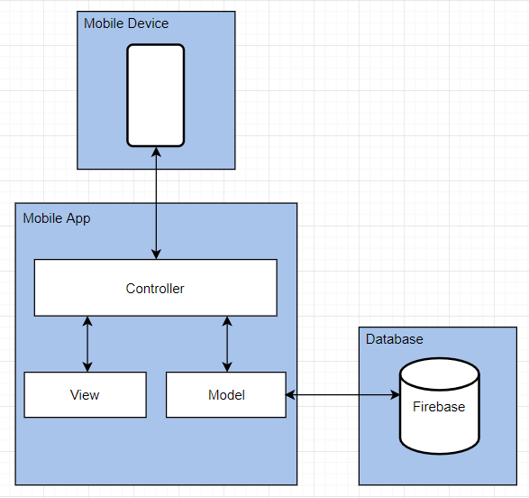

**4.3. Deployment Diagram**

Deployment diagram for Android mobile application is represented below: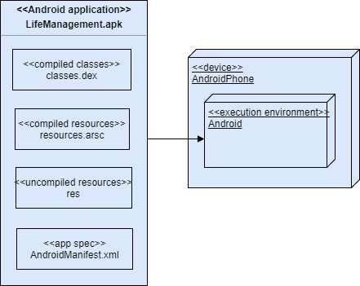

**5. System Validation**

**Android:**

Unit testing was performed in all user stories. White box testing was strictly performed in all classes and made sure no input breaks the program. The results were compared to the expected results to make sure the program is running properly. Black box testing was also used to make sure there are no missing or incorrect functions, data handling errors, database access error, behavior or performance errors. Integration tests were performed throughout the development of the application. In addition, we let the users to use the application to improve the system and gain more feedback on how accessible the application is.

**IOS:**

Unit testing was conducted for all user stories which dealt with swift code. Lldb debugger in XCode command line was used to find out the source of any errors found when running the project. White box testing was used throughout the project to test a variety of input combinations for functions that required inputs from a user. The combinations were tested to see if it will break the project. The most important tests conducted was user acceptance testing. Users were able to test out the project through an iphone simulator to check for bugs and any helpful advice that can be used to improve the app.

**6. Glossary**

Below is a list of definitions that were used throughout this document:

* ***Agile Software Development:*** *Describes a set of values and principles for software development under which requirements and solutions evolve through the collaborative effort of self-organizing cross-functional teams.*
* ***Android Studio:*** *An integrated development environment that provides the fastest tools for building apps on every type of Android device.*
* ***Class diagram****: a model that describes the static structure of the system.*
* ***Deployment diagram****: a structure diagram that describes architecture of the system as distribution of software artifacts to deployment targets.*
* ***Firebase Database****: A cloud-hosted database where the data is stored as JSON and synchronized in real time to every connected client.*
* ***iCarousel:*** *A class designed to simplify the implementation of various types of carousels.*
* ***Integration Testing:*** *The phase in software testing in which individual software modules are combined and tested as a group.*
* ***Java:*** *Programming language used to create this software (Android version).*
* ***JUnit:*** *A framework used in unit testing for the Java programming language.*
* ***Model-view-Controller (MVC)****: A software architectural pattern for implementing user interfaces on computers.*
* ***Sketch:*** *is a proprietary vector graphics editor for Apple's macOS.*
* ***Sequence diagram:*** *a model that describes the dynamic behavior between objects of the system.*
* ***Unit testing:*** *is a software development process in which the smallest testable parts of an application, called units, are individually and independently scrutinized for proper operation.*
* ***Use case diagram:*** *a model that describes the functional behavior of the system as seen by the user.*
* ***User story:*** *a detailed description of a piece of functionality of the system from the point of view of a specific user.*
* ***Xcode:*** *An integrated development environment for macOS containing a suite of software development tools developed by Apple.*
* ***XML****: A markup language that defines a set of rules for encoding documents in a format that is both human-readable and machine-readable.*

**7. Appendix**

**7.1. Appendix A**

**7.1.1. Static UML Diagrams**

**Class Diagram**

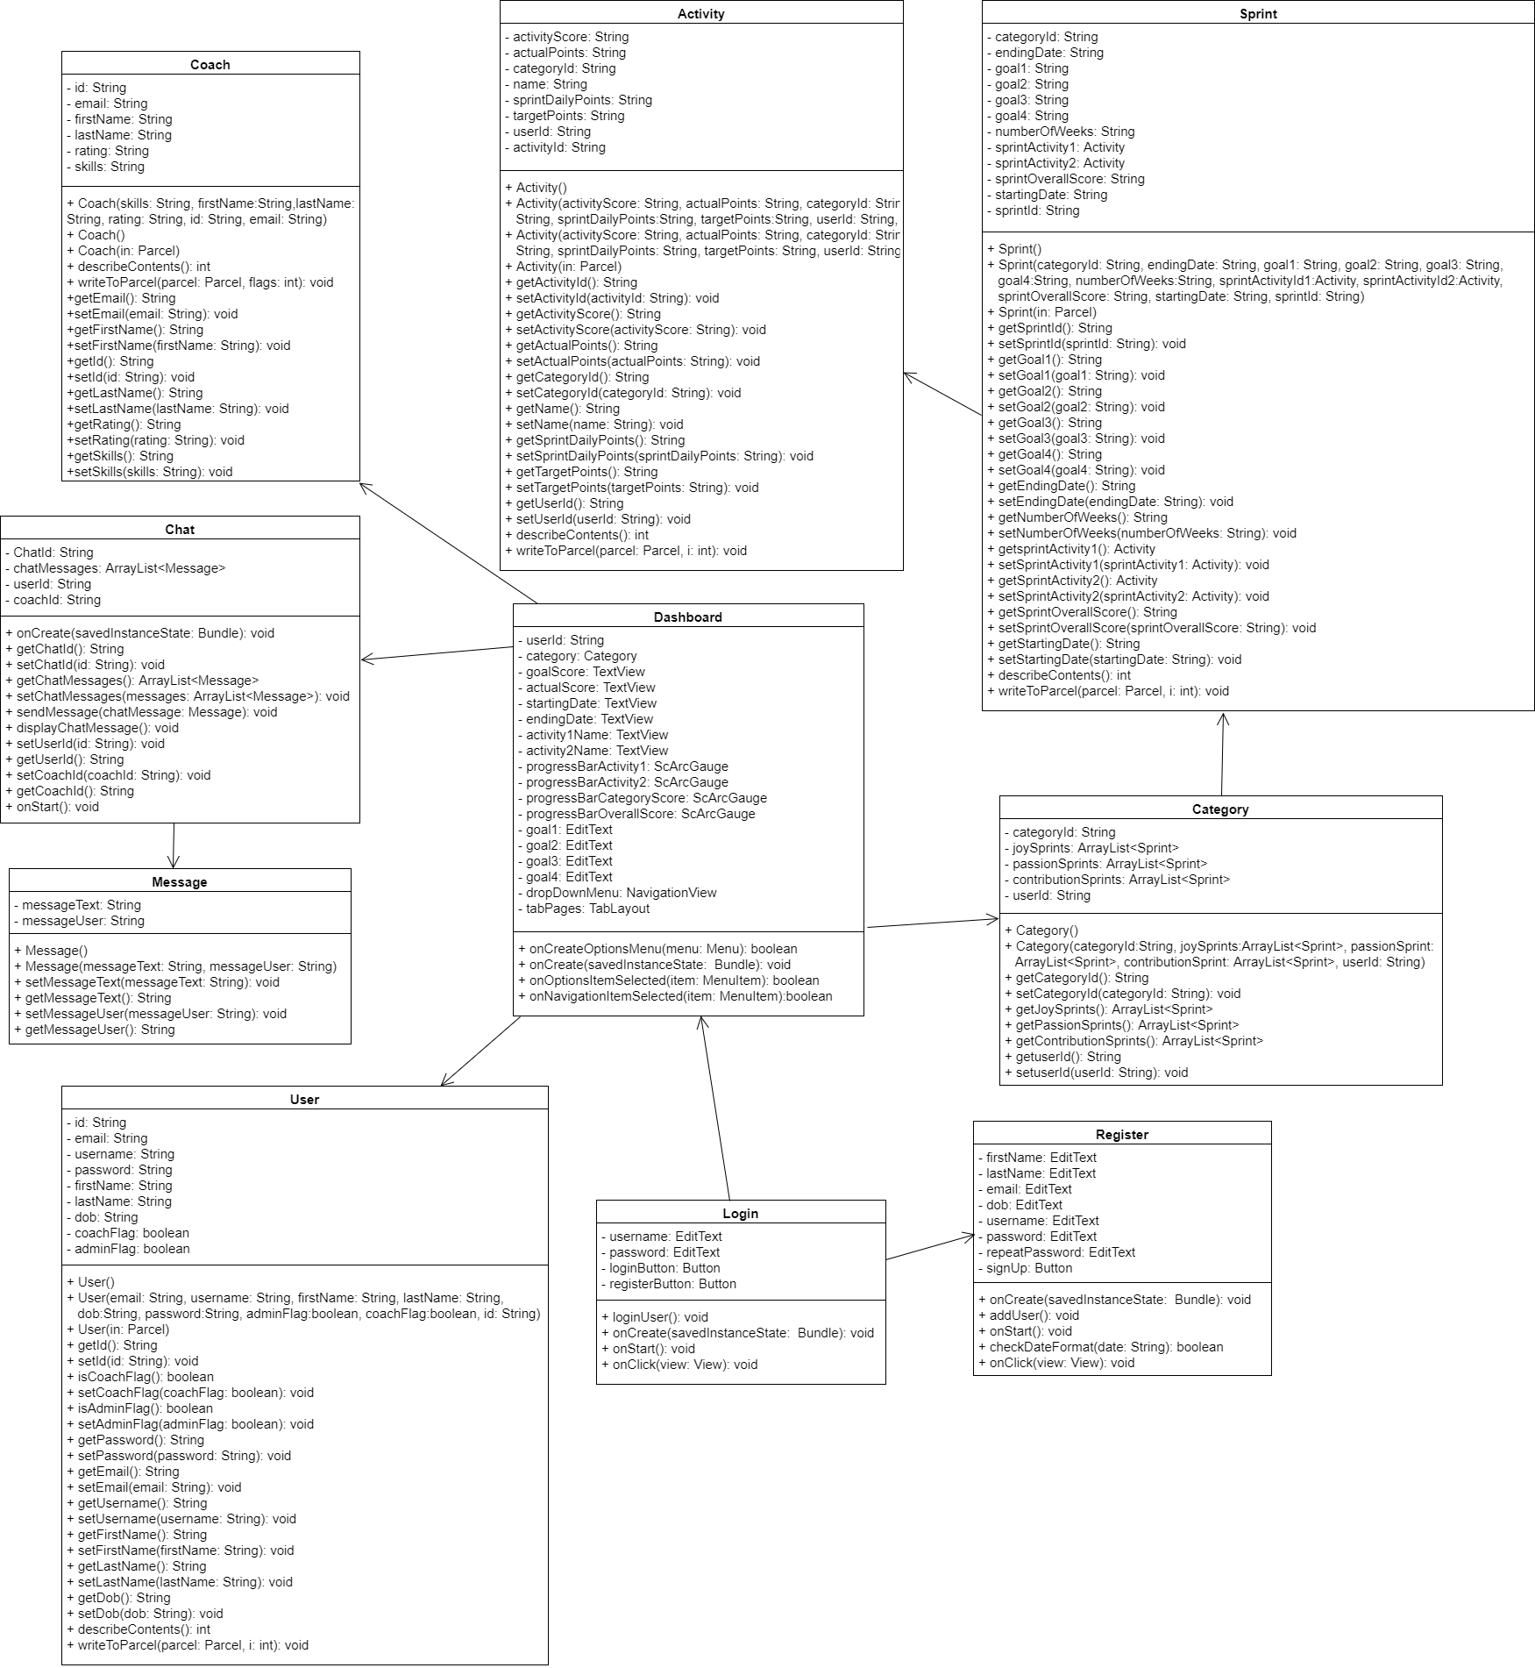

**Use Case Diagram**

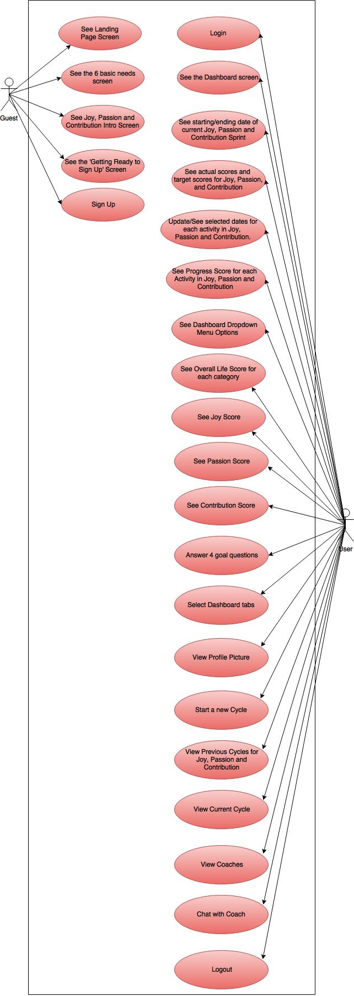

**7.1.2. Dynamic UML Diagrams**

**Sequence Diagrams**

**Android:**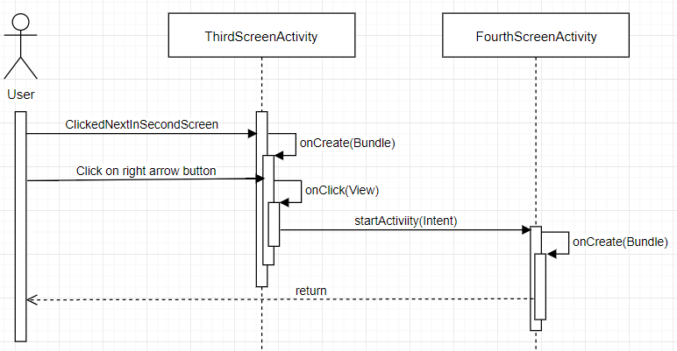

**View Joy, Passion and Contribution Intro Screen (User Story #785)**

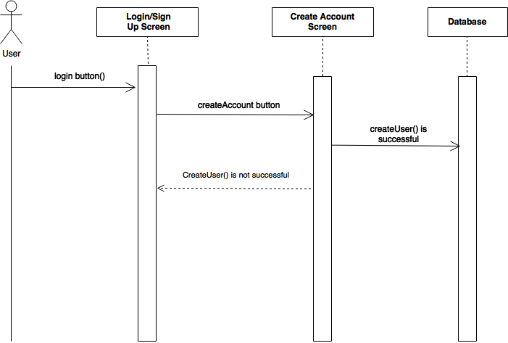

**Create New User. (User Story #790) Part 1**

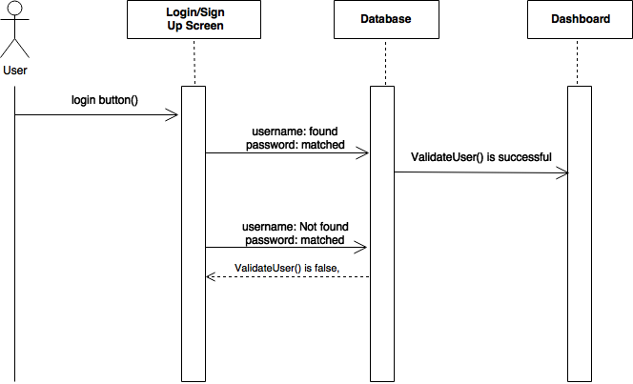

**Login User. (User Story #790) Part 2**

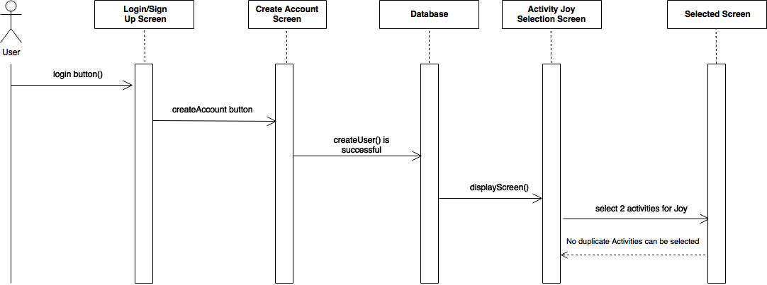

**Joy Category Selection. (User Story #791)**

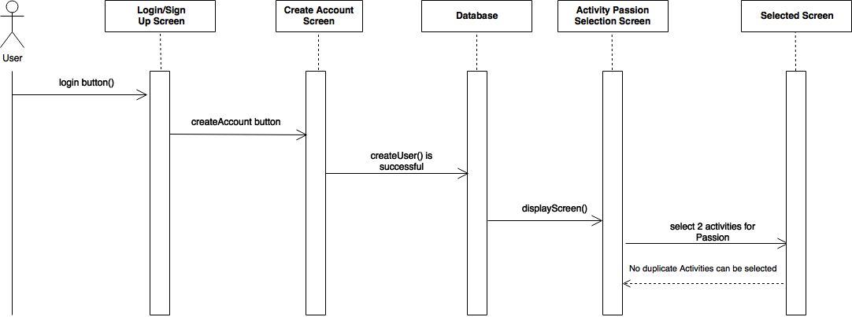

**Passion Category Selection. (User Story #792)**

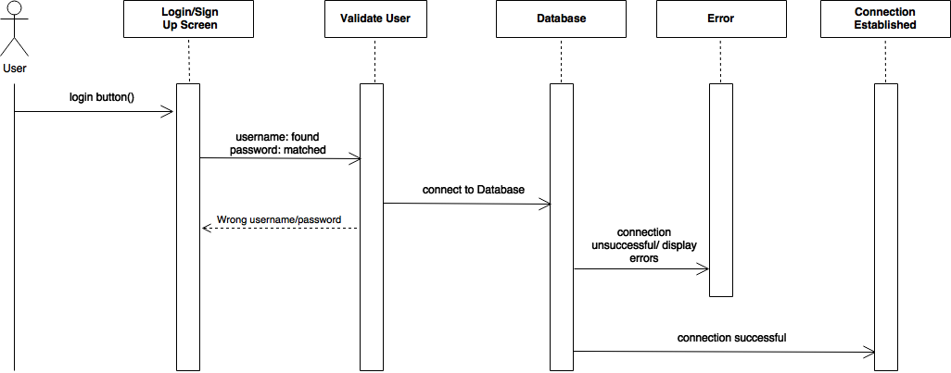

**Database Creation. (User Story #793)**

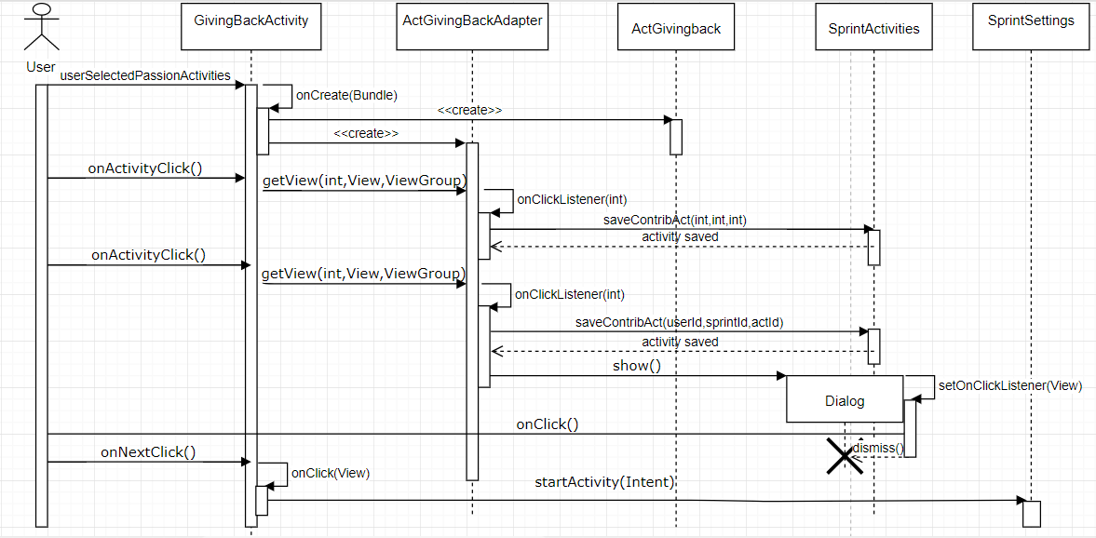**Contribution Activities Selection (User story #794)**

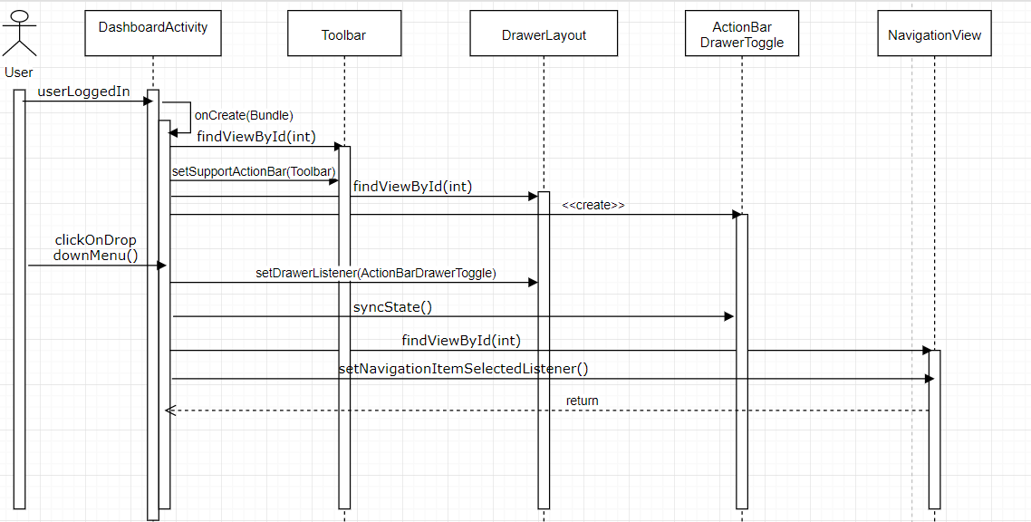

**Dashboard page drop-down menu (User story #796)**

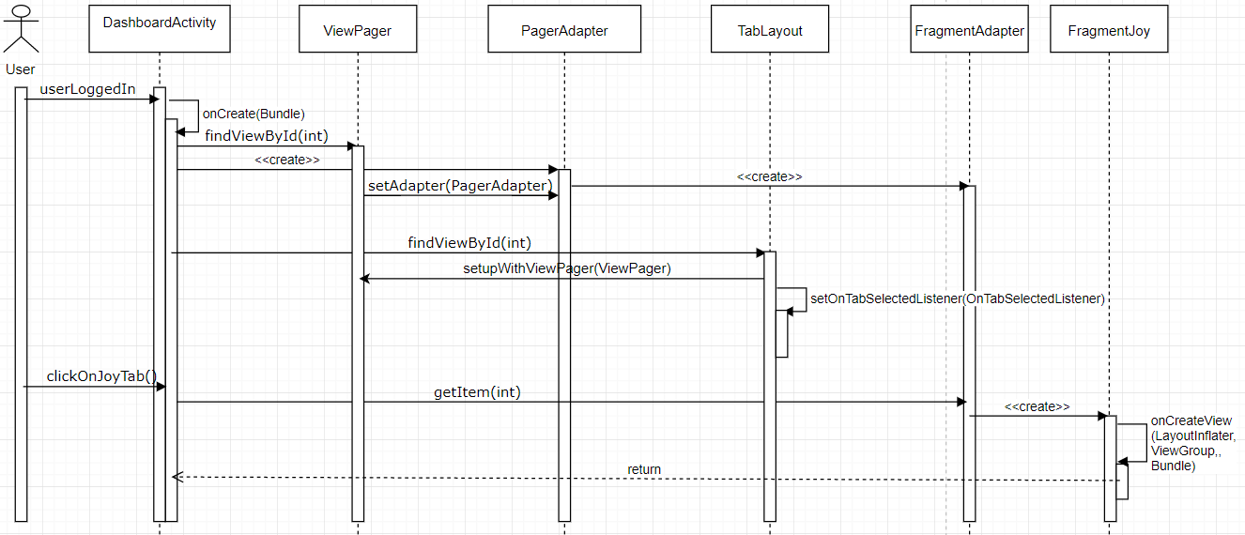

**Dashboard page joy category (User story 797)**

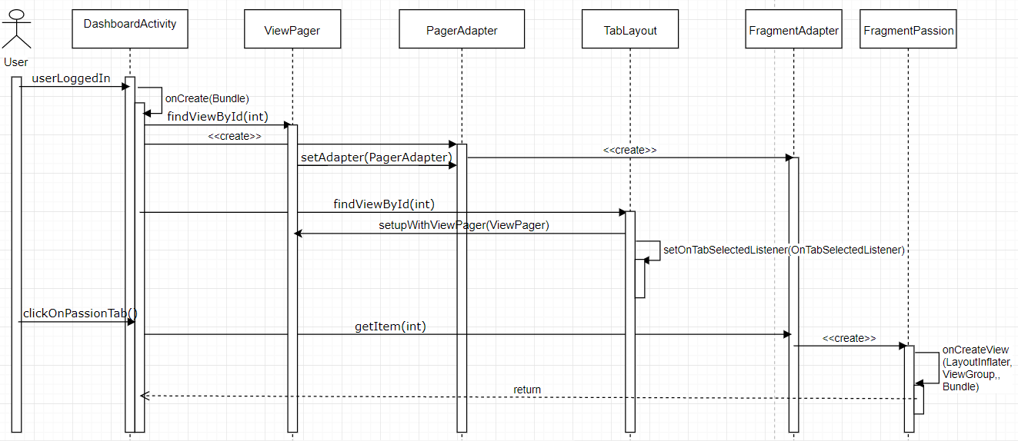

**Dashboard page passion category (User story 798)**

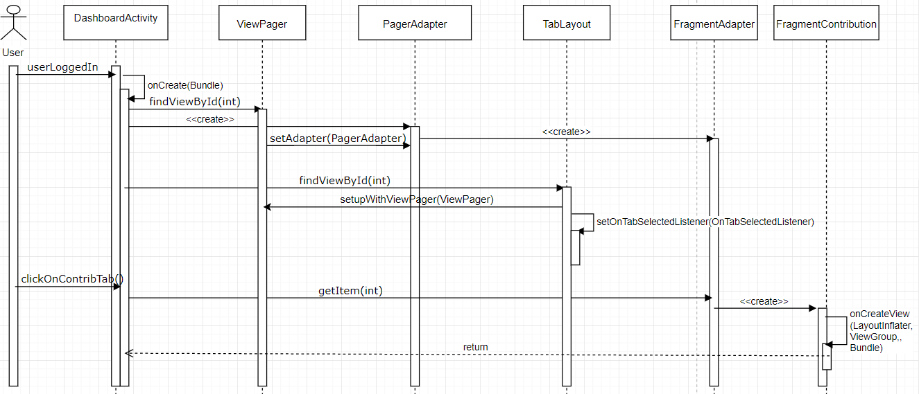

**Dashboard page contribution category (User story 799)**

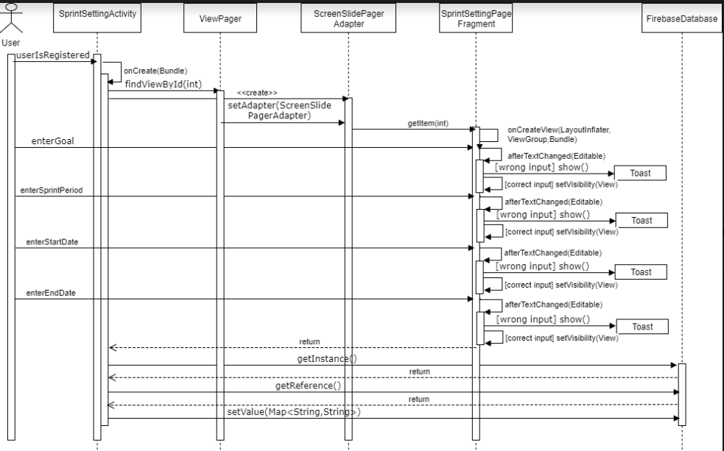

**Selection time period in Sprint Setting (User story 816)**

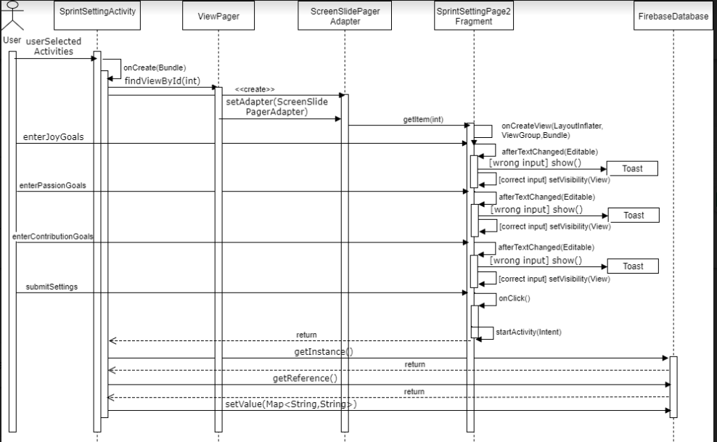

**Dashboard target goal numbers for sprint (User story 818)**

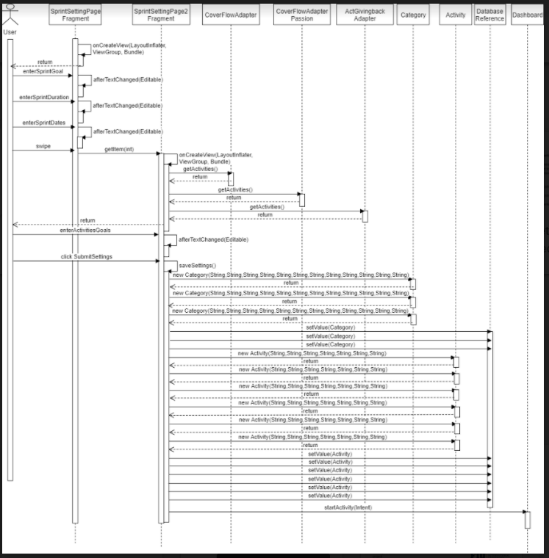

**Store activities and 3 sprints to database (User story 823)**

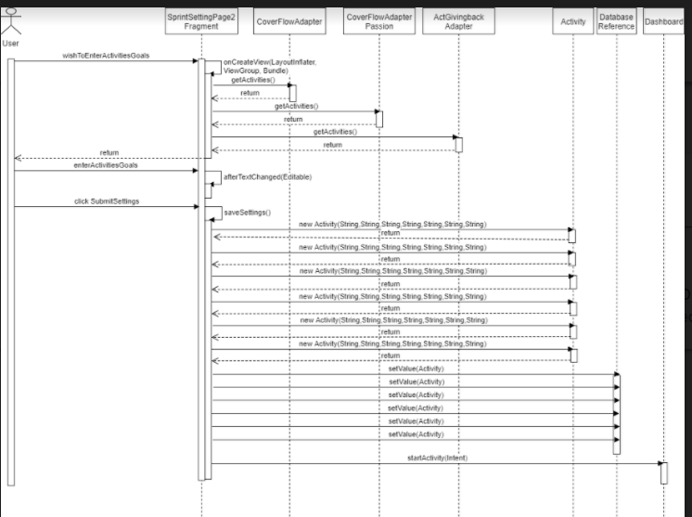

**Store activities goals to database (User story 825)**

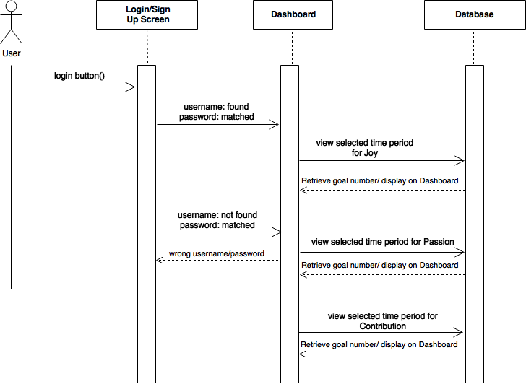

**Dashboard selected time period. (User Story #809)**

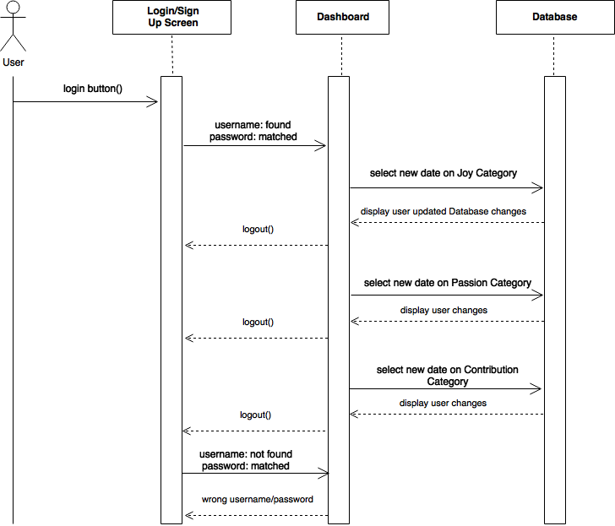

**Dashboard Date Selection. (User Story #810)**

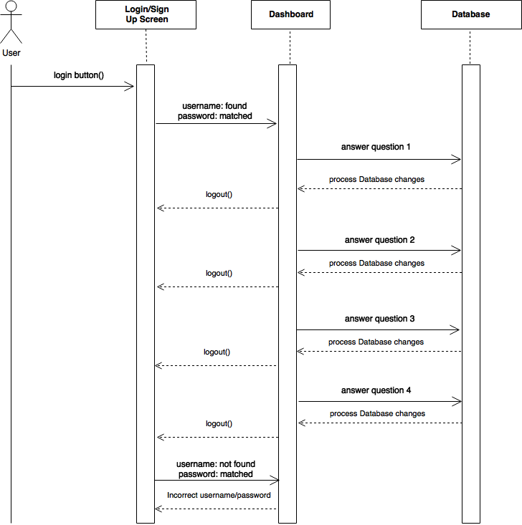

**Dashboard goal questions. (User Story #811)**

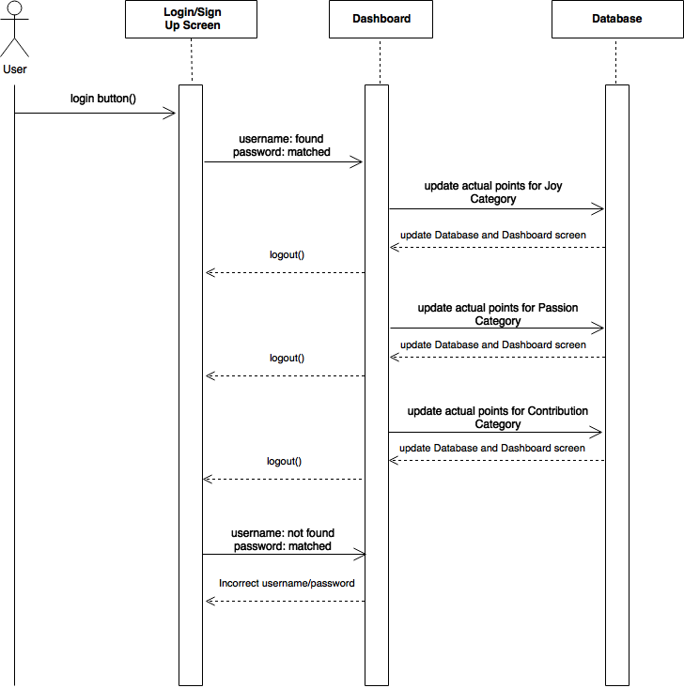

**Dashboard actual points. (User Story #812)**

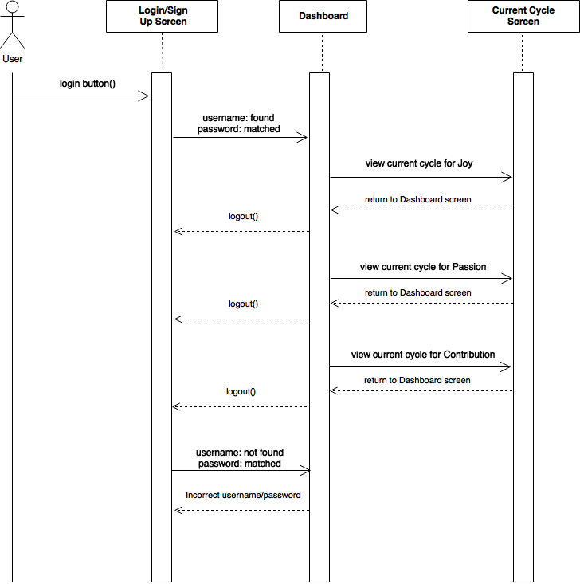

**Dashboard current cycle. (User Story #814)**

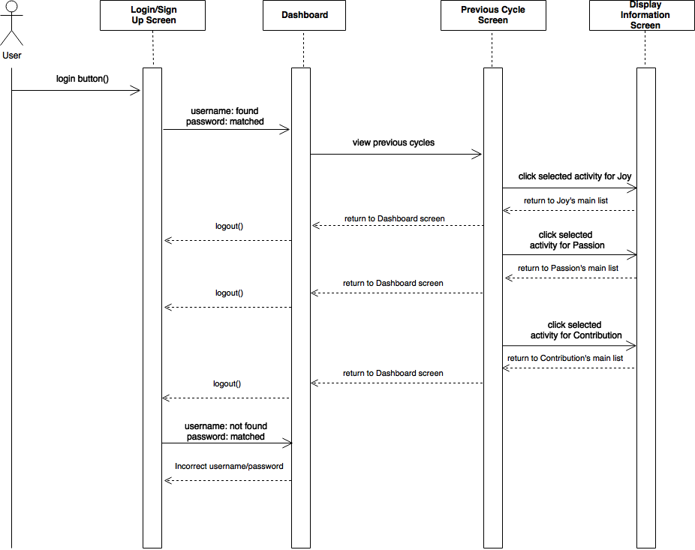

**Previous cycle. (User Story #815)**

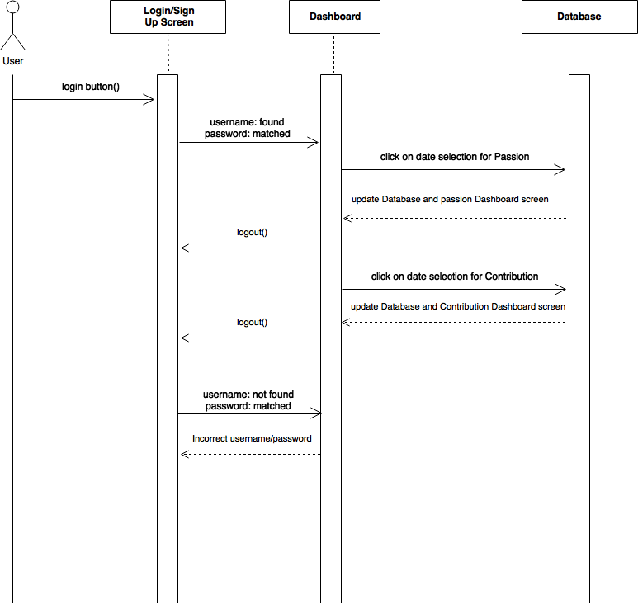

**Dashboard complete implementation. (User Story #827)**

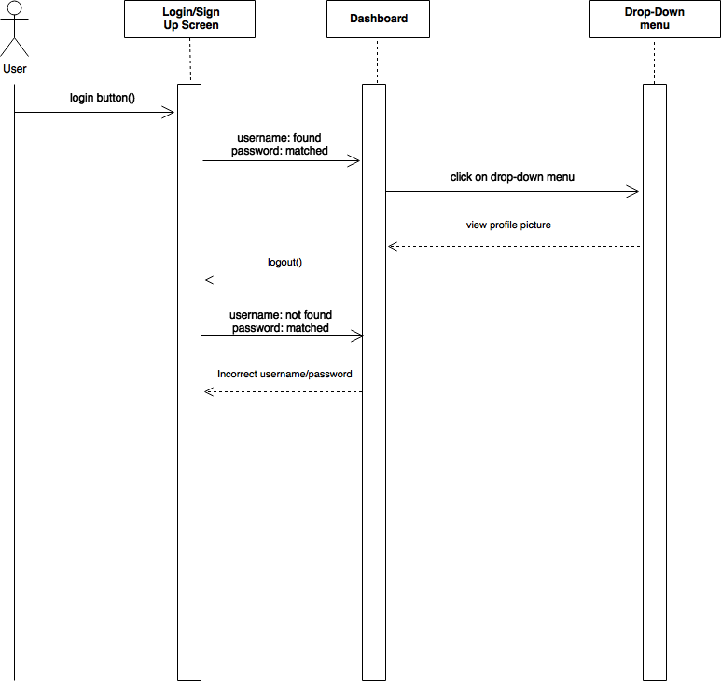

**Drop-Down Menu Profile Picture (User Stories #836)**

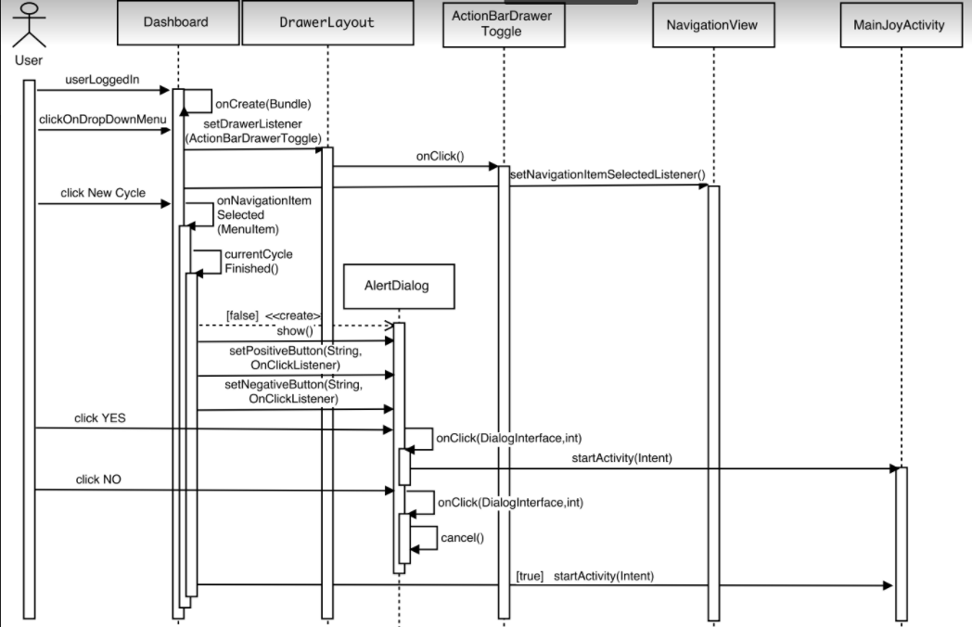

**Dashboard new cycle (User Stories #844)**

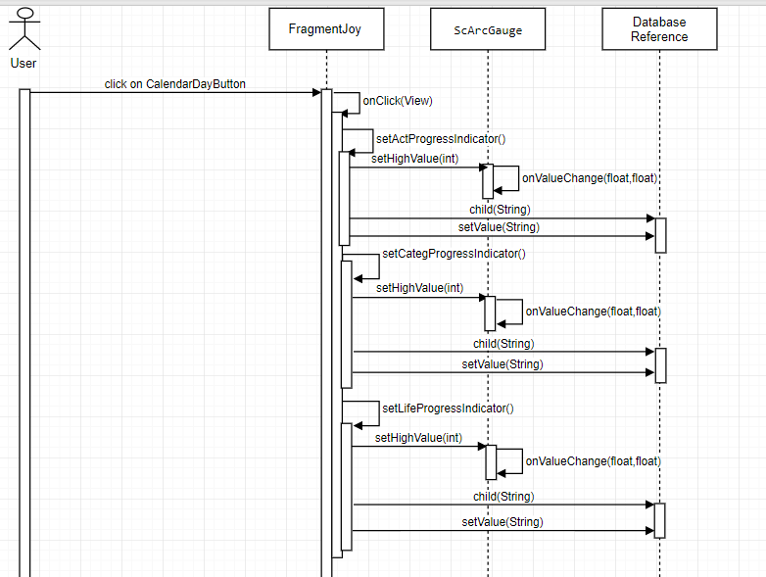

**Dashboard visual indicator of progress (User Stories #828)**

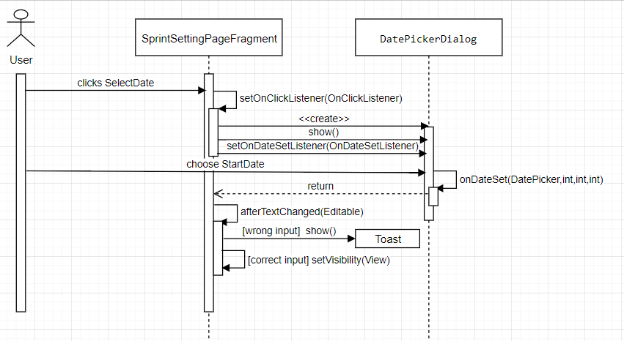

**Change sprint start date selection (User Stories #835)**

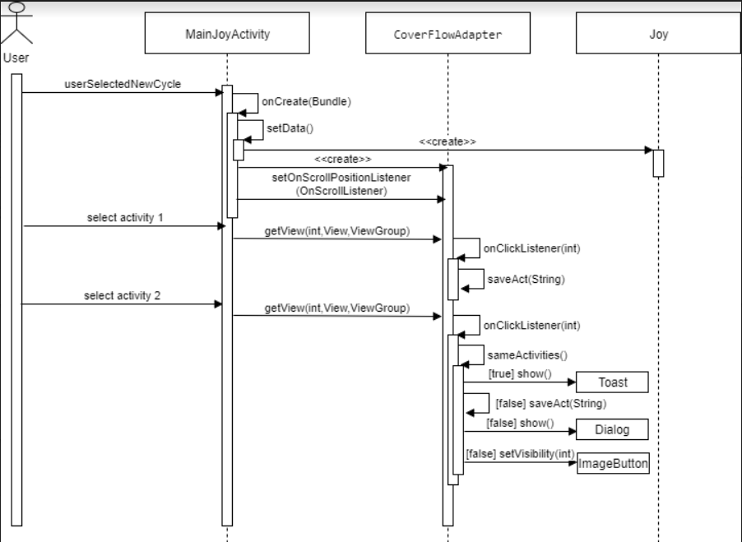

**Validate selection of joy activities (User Stories #837)**

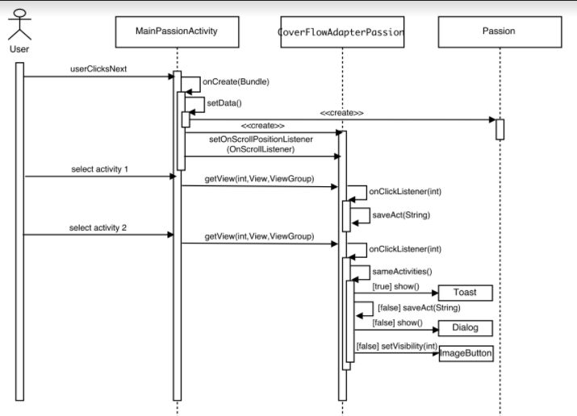

**Validate selection of passion activities (User Stories #840)**

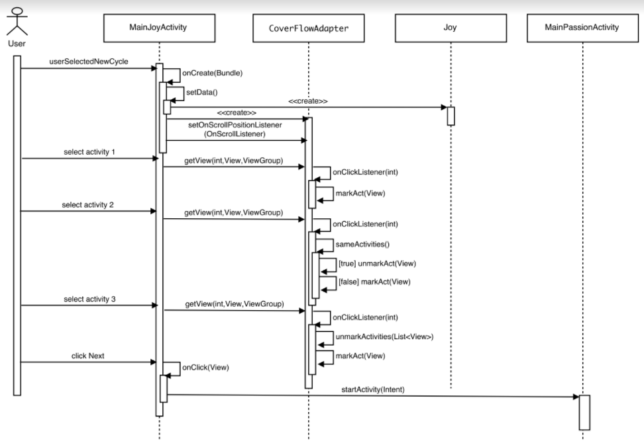

**Add visual effect in activities selection (User Stories #845)**

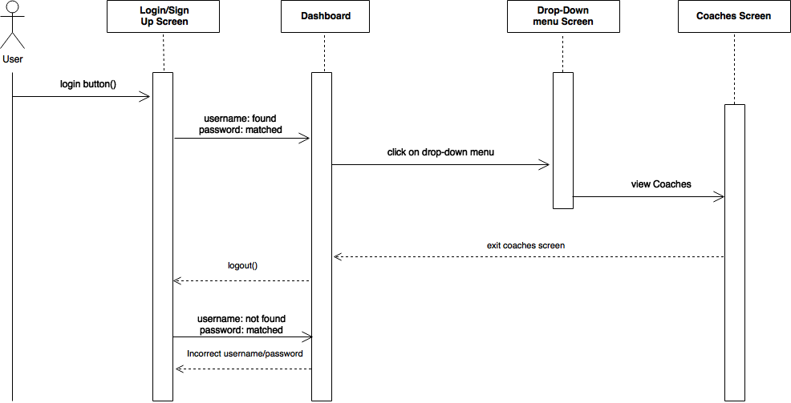

**View Coaches Tab (User Stories #838)**

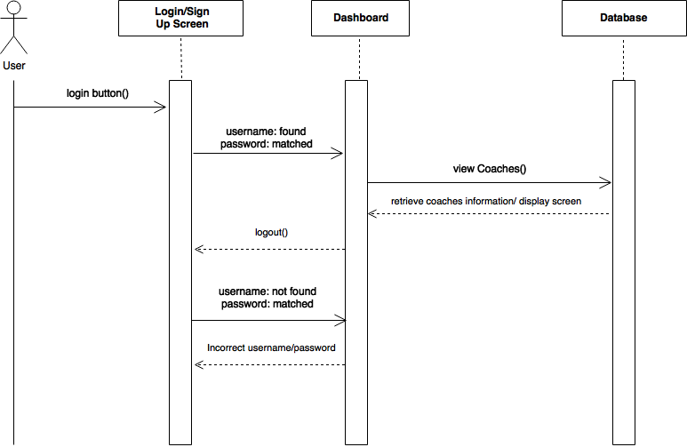**Coach Database Implementation (User Stories #839)**

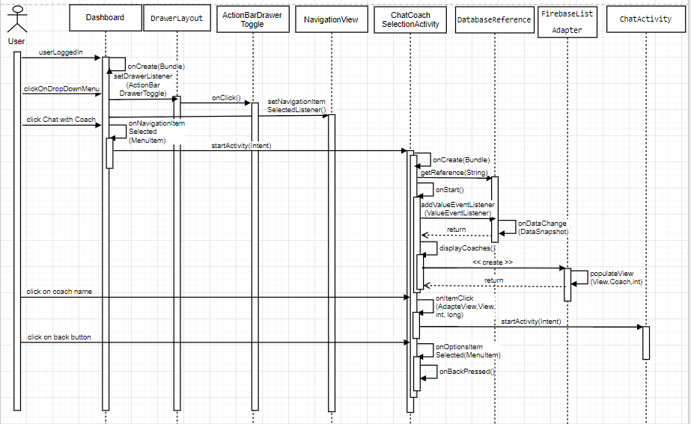

**Select coach to chat with (User Story #847)**

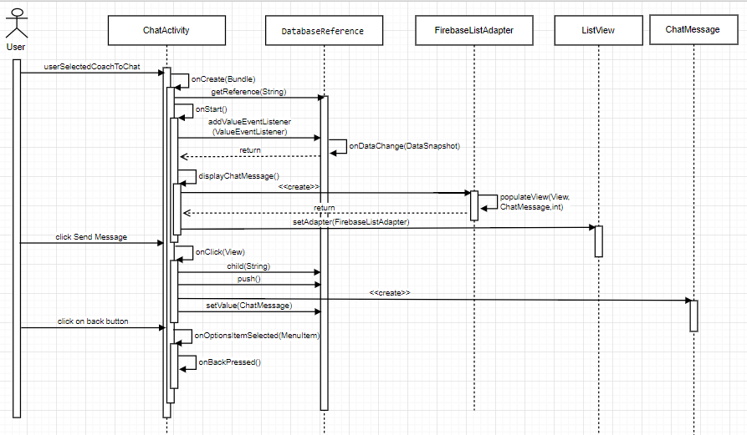

**Chat with coach (User Story #846)**

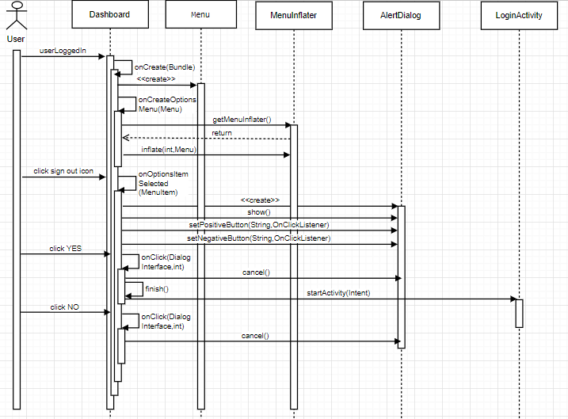

**Sign out (User Story #852)**

**IOS:**

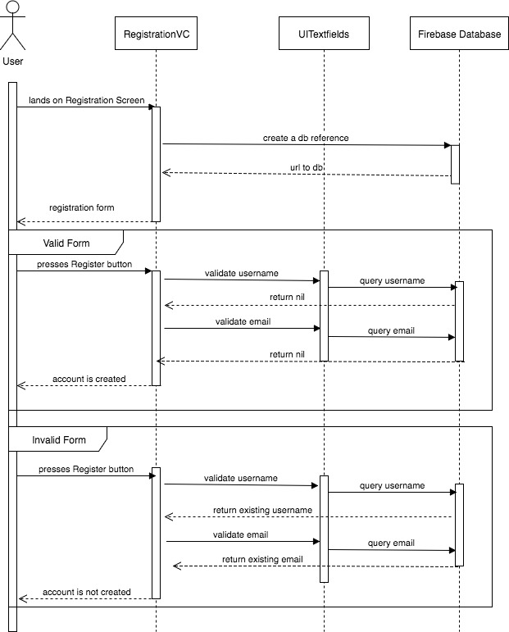

**Register and Login Screen (User Story #800)**

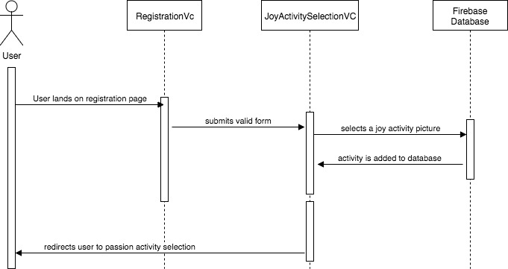

**Joy Activity Selection (User Story #802)**

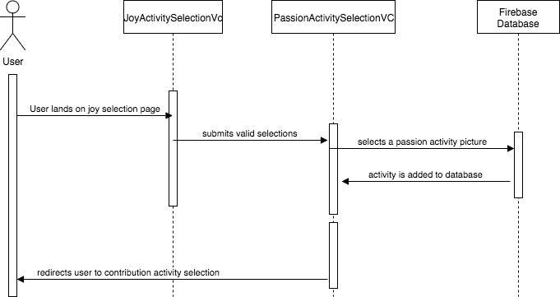

**Passion Activity Selection (User Story #803)**

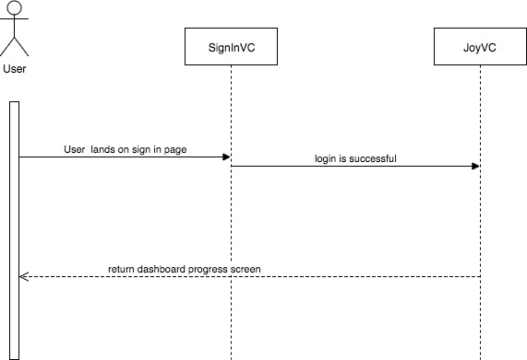

**Dashboard Layout Design (User Story #805)**

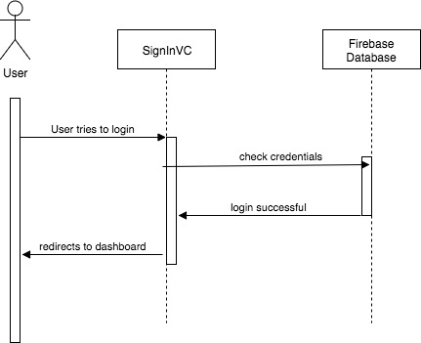

**Database Creation (User Story #806)**

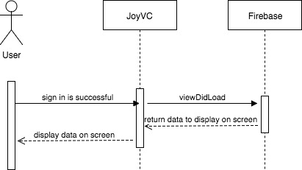

**Dashboard Activity (User Story #817)**

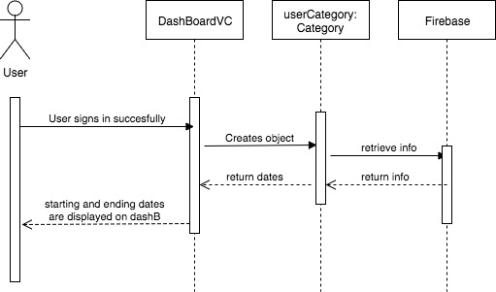

**Dashboard Display Current Time Period (User Story #819)**

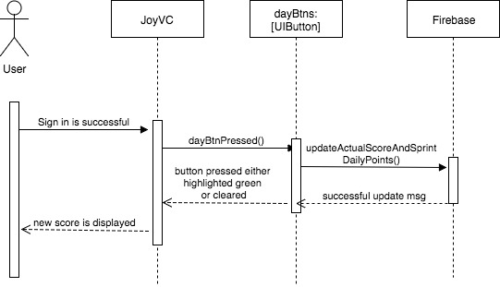

**Dashboard Day Selection (User Story #821)**

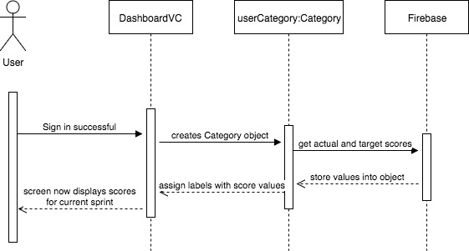

**Display Goal Number for Activity (User Story #822)**

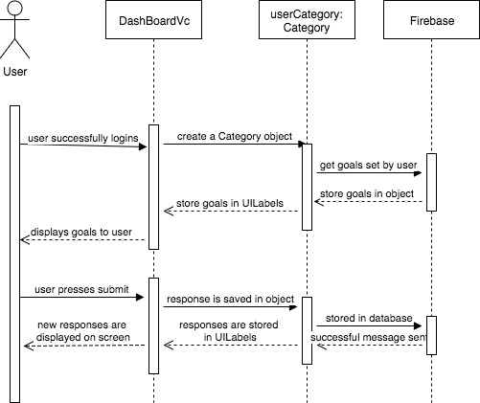

**Dashboard Questionnaire Implementation (User Story #824)**

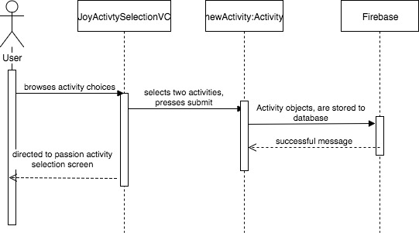

**Save Activity Selection for Joy, Passion, and Contribution Activities (User Story #830)**

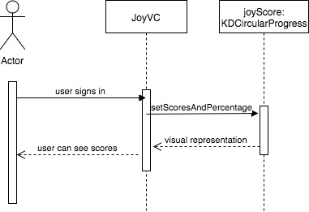

**Visual Indicator of the Progress for the Current Sprint (User Story #831)**

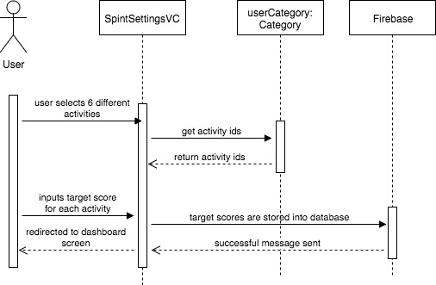

**Enter a Target Goal for the New Sprint Activities (User Story #832)**

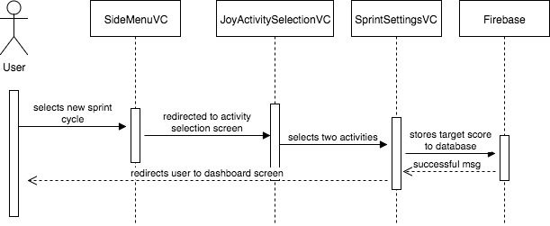

**Ability to Enter a New Sprint Cycle (User Story #833)**

**7.2. Appendix B.**

**7.2.1. Sprint Review Reports**

## **Sprint 1 Review Meeting Minutes**

Attendees:Ranjeet Deshmukh,Ravi Kiran Agarthi,Lazaro Fernandez,Natalia Filippova,Eric Rado

Start time: 7:00 PM

End time: 7:30 PM

After a show and tell presentation, the implementation of the following user stories were accepted by the product owners: All.

* User Story #1 - Initial Landing Page
* User Story #2 - 6 Basic Needs Intro
* User Story #3 - Joy, Passion and Contribution Intro
* User Story #4 - Getting ready to sign up

The following ones were rejected and moved back to the product backlog to be assigned to a future sprint at a future Spring Planning meeting: None.

## **Sprint 2 Review Meeting Minutes**

Attendees:Ranjeet Deshmukh,Ravi Kiran Agarthi,Lazaro Fernandez,Natalia Filippova,Eric Rado

Start time: 7:00 PM

End time: 7:30 PM

After a show and tell presentation, the implementation of the following user stories were accepted by the product owners: All.

* User Story # 790 - Sign Up/Login Screen
* User Story # 791 - Joy Category Selection
* User Story # 792 - Passion Category Selection
* User Story # 793 - Database Creation
* User Story # 794 - Contribution Activities Selection
* User Story # 795 - Dashboard Screen
* User Story # 800 - IOS-Register and login screen
* User Story #802 - IOS-Joy Activity Selection
* User Story #803 - IOS-Passion Activity Selection
* User Story #804 - IOS-Contribution Activity Selection
* User Story #805 - IOS-Dashboard layout session
* User Story #806 - IOS-Database Creation

The following ones were rejected and moved back to the product backlog to be assigned to a future sprint at a future Spring Planning meeting.

* User Story <807>
* How this should be reflected on the user story definition in Mingle:
  + In Release 2 -> Product Backlog

## 

## **Sprint 3 Review Meeting Minutes**

Attendees:Ranjeet Deshmukh,Ravi Kiran Agarthi,Lazaro Fernandez,Natalia Filippova,Eric Rado

Start time: 7:00 PM

End time: 7:30 PM

After a show and tell presentation, the implementation of the following user stories were accepted by the product owners:

* Story # 816 Dashboard selection time period in Sprint Settings activity.
* Story # 818 - Dashboard target goal numbers for sprint.
* Story # 809 - Dashboard selection time period
* Story # 810 - Dashboard date selection for total scores
* Story # 811 - Dashboard answer questions
* Story # 817 - Dashboard Activity(IOS)
* Story # 819 - Dashboard display current time period(IOS)
* Story # 821 - Dashboard day selection implemented activity update(IOS)
* Story # 822 - Display goal number for activity(IOS)
* Story # 824 - Dashboard questionnaire implementation(IOS)

The following ones were rejected and moved back to the product backlog to be assigned to a future sprint at a future Spring Planning meeting.

* User Story #820
* How this should be reflected on the user story definition in Mingle:

In Release 2 -> Product Backlog (as user story #829)

In Release 2 -> Sprint 4 (assigned as user story #828)

## **Sprint 4 Review Meeting Minutes**

Attendees:Ranjeet Deshmukh,Ravi Kiran Agarthi,Lazaro Fernandez,Natalia Filippova,Eric Rado

Start time: 7:00 PM

End time: 7:30 PM

After a show and tell presentation, the implementation of the following user stories were accepted by the product owners:

* Story # 812 Activity Points Implementation
* Story # 814 - Current Cycle Implementation
* Story # 815 - Previous Cycle Implementation
* Story # 827 - Dashboard complete implementation
* Story # 828 - Finish implementation of user story #820 (Dashboard visual indicator of the progress).
* Story # 823 - Store activities selection and 3 sprints to database
* Story # 825 - Store activities goals to database
* Story # 826 - New cycle implementation

No user stories were rejected.

## **Sprint 5 Review Meeting Minutes**

Attendees:Ranjeet Deshmukh,Ravi Kiran Agarthi,Lazaro Fernandez,Natalia Filippova,Eric Rado

Start time: 7:00 PM

End time: 7:30 PM

After a show and tell presentation, the implementation of the following user stories were accepted by the product owners:

* Story # 848 - IOS-Previous Sprint Display
* Story # 849 - IOS-Previous Sprint Summary
* Story # 850 - IOS-Coach Schema Implementation
* Story # 851 - IOS-Fix UI Screen’s Display
* Story # 835 - Change Sprint Starting Date Selection in Sprint Setting Page
* Story # 837 - Validate selection of Joy activities
* Story # 840 - Validate selection of Passion activities
* Story #844 - Change in Dashboard New Cycle
* Story # 845 - Add visual effect in Activities Selection
* Story # 834 - Dashboard Date Selection Fix
* Story # 836 - Drop-Drown Menu Profile Picture.
* Story # 841 - Landing Page Fix Screen
* Story # 842 - Previous Cycle Fix
* Story # 843 - Current Cycle Fix

The following user stories were rejected:

* Story # 813 - Setting Screen
* Story # 807 - Retrieve Forgotten Password

## **Sprint 6 Review Meeting Minutes**

Attendees:Ranjeet Deshmukh,Ravi Kiran Agarthi,Lazaro Fernandez,Natalia Filippova,Eric Rado

Start time: 7:00 PM

End time: 7:30 PM

After a show and tell presentation, the implementation of the following user stories were accepted by the product owners:

* Story # 838 - View Coaches Tab
* Story # 839 - Coach Database Implementation
* Story # 846 - Chat with Coach
* Story # 847 - Select a Coach to Chat with
* Story # 852 - Sign Out User

No user stories were rejected.

**7.3. Appendix C.**

**7.3.1. User Manual**

**Android Manual:**

**Guest**

1- Guest navigates the landing page screen and clicks the next arrow to continue.

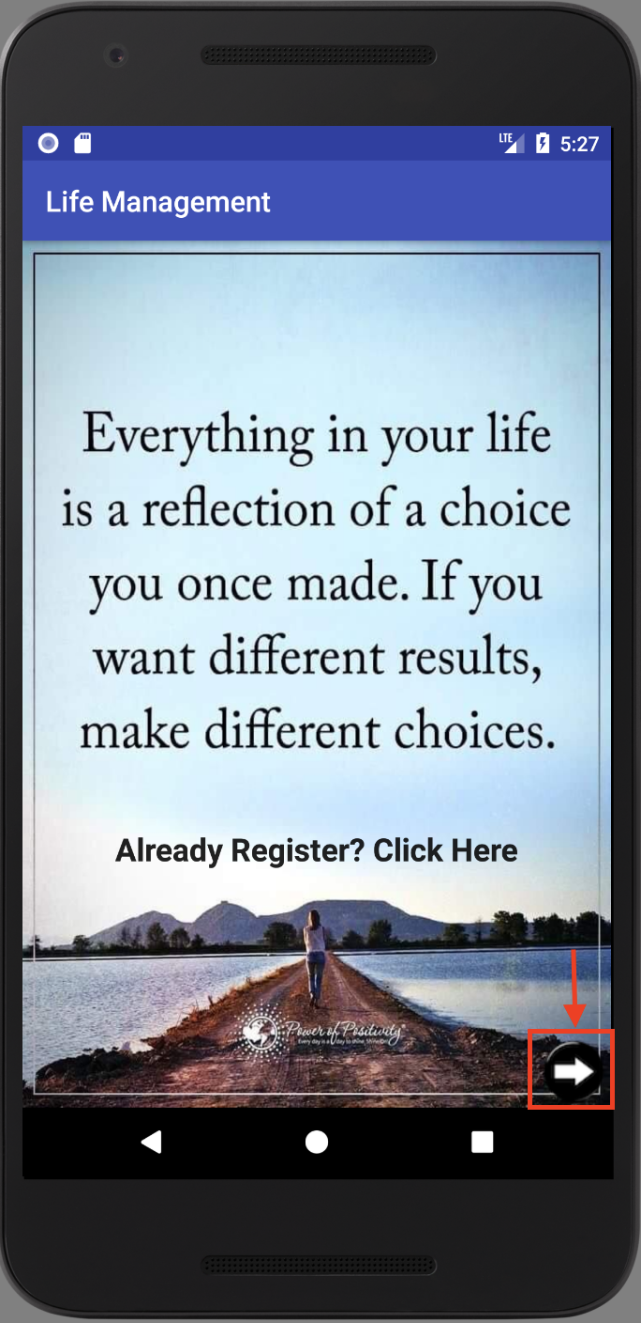

2- Inform the guest the 6 basic needs of Life. He/She can click on each need as follows.

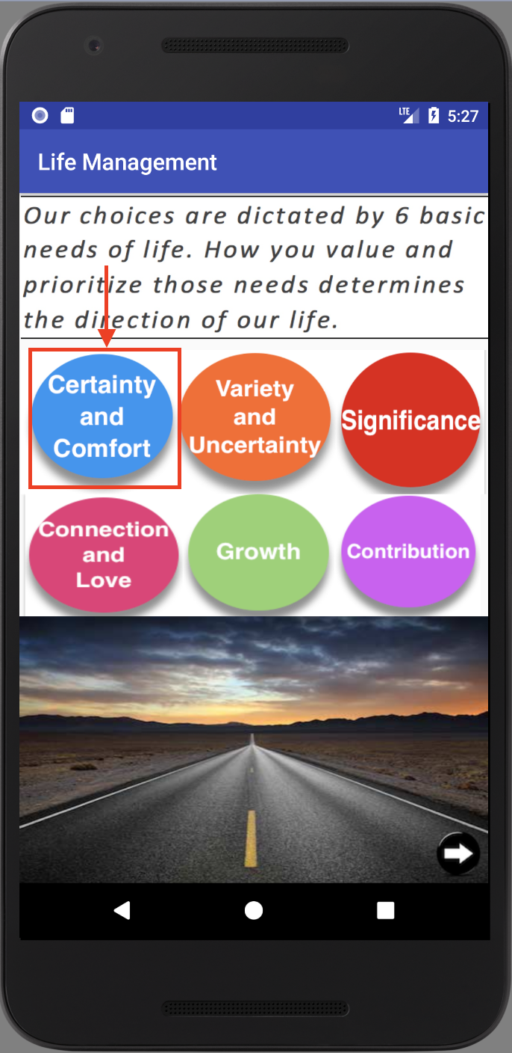

3- Information about the need Certainty and Comfort.

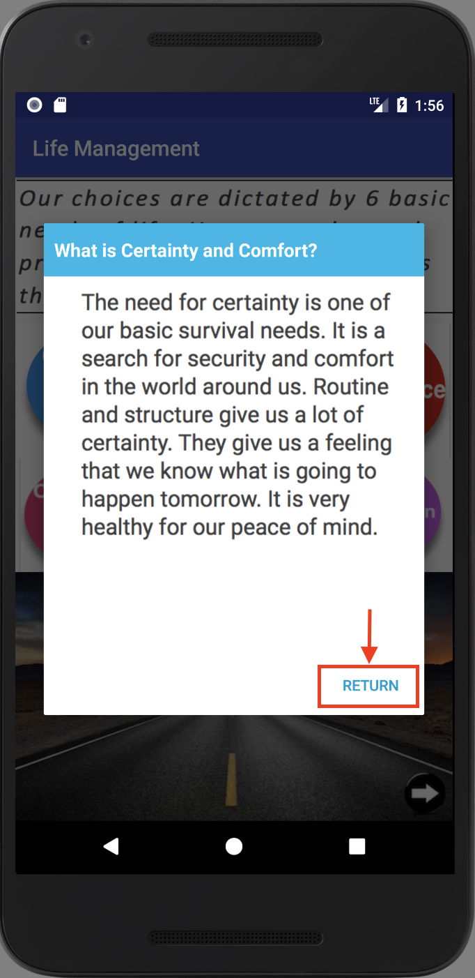

4- Guest clicks on Variety and Uncertainty need.

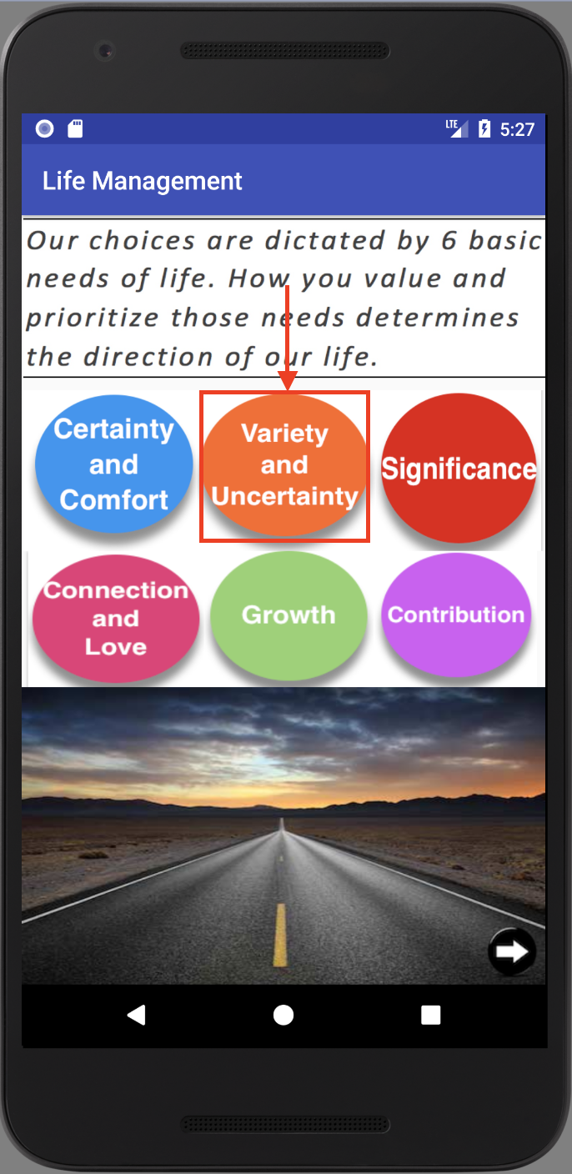

5- After reading that need, they can go back to previous screen.

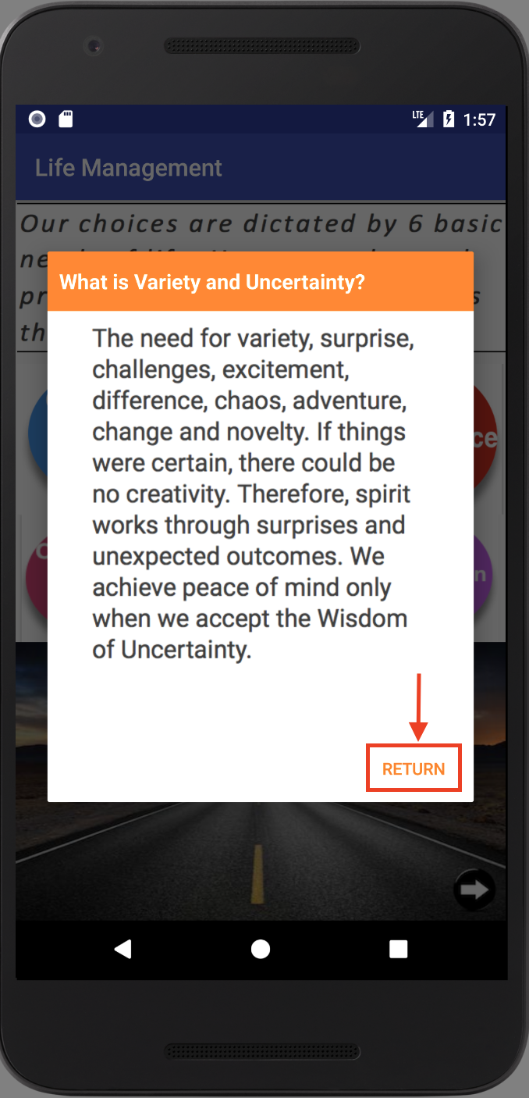

6- Guest clicks on Significance need.

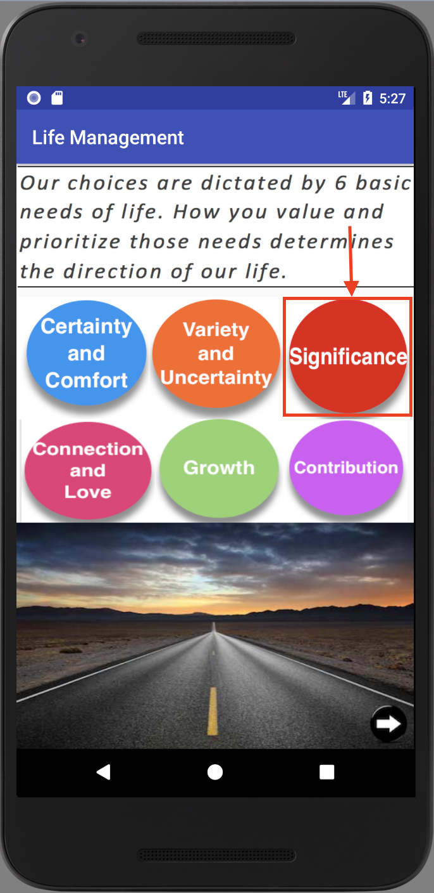

7- After reading that need, they can go back to previous screen.

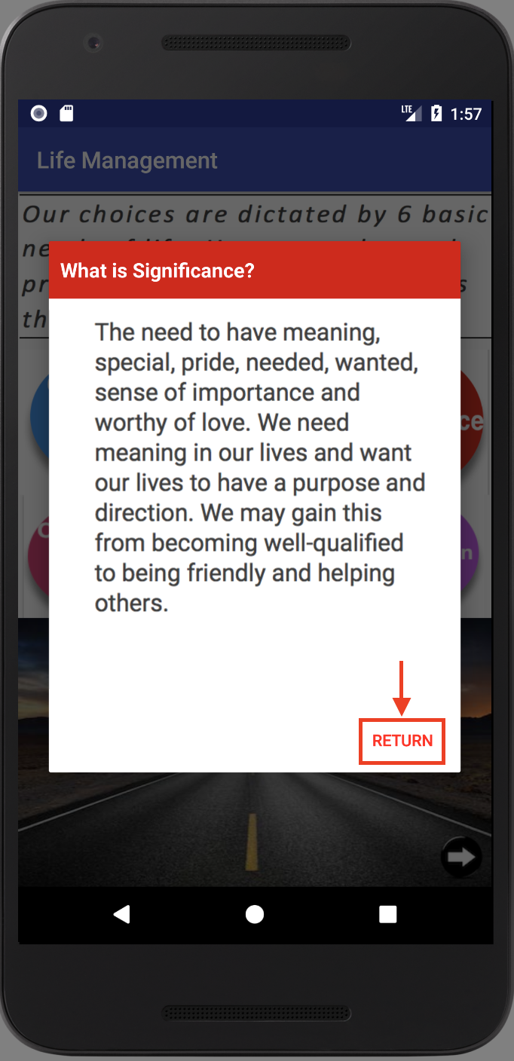

8- Guest clicks on Connection and Love need.

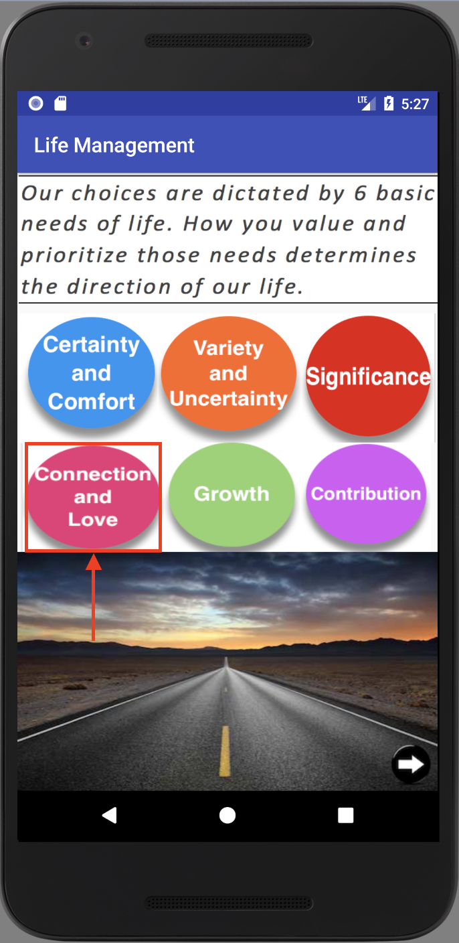

9- After reading that need, they can return to 6 needs screen.

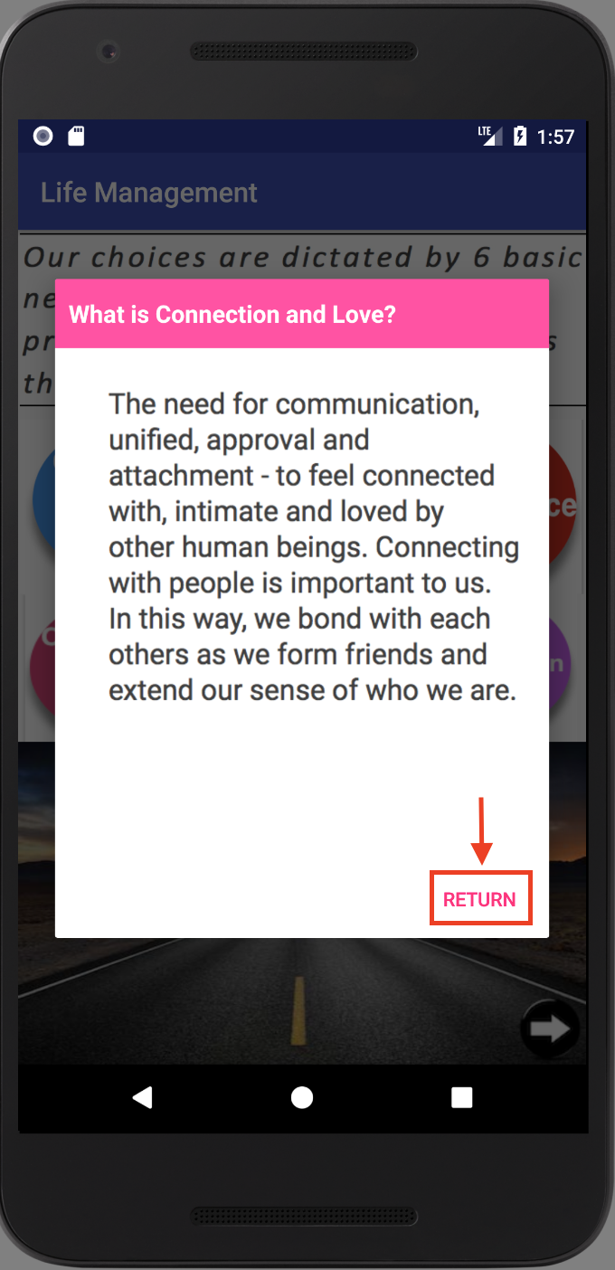

10- Guest clicks on Growth need.

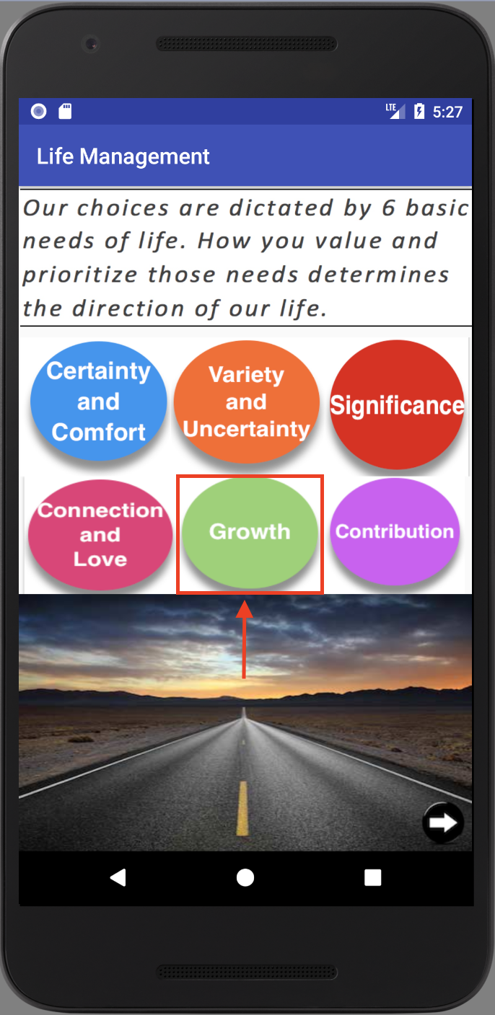

11- After reading that need, they can return to the 6 basic needs screen.

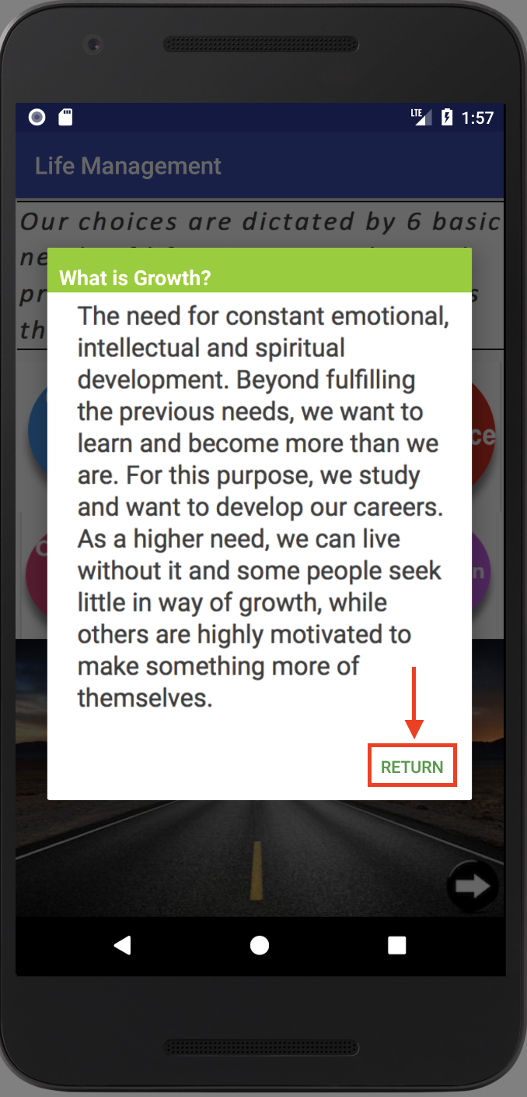

12- Guest clicks on Contribution need.

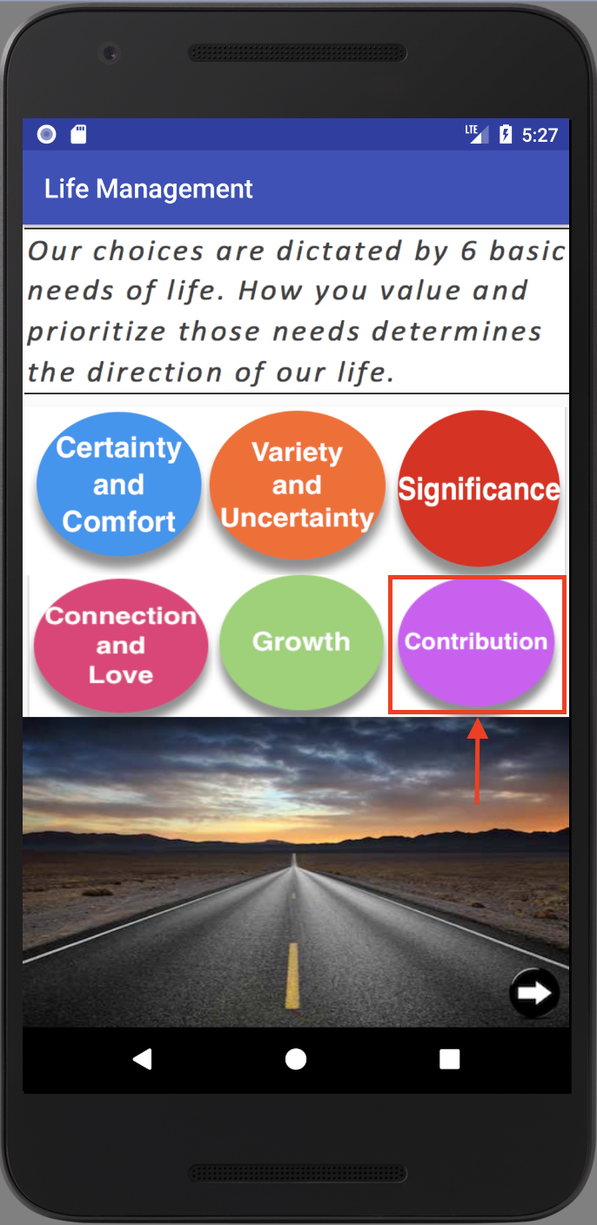

13- After reading that need, they can return to the 6 basic needs screen.

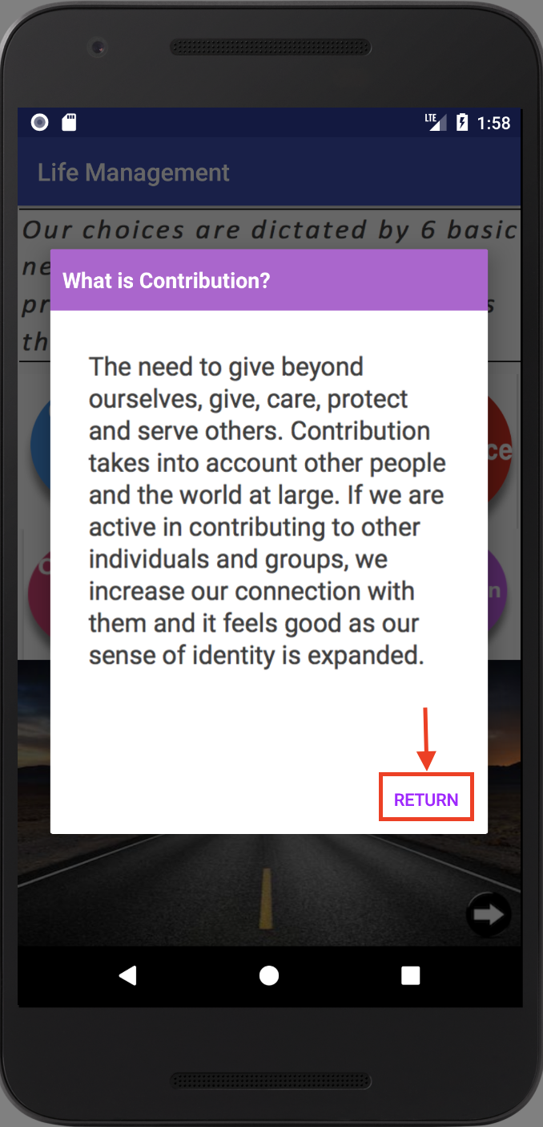

14- Guests can go to next screen

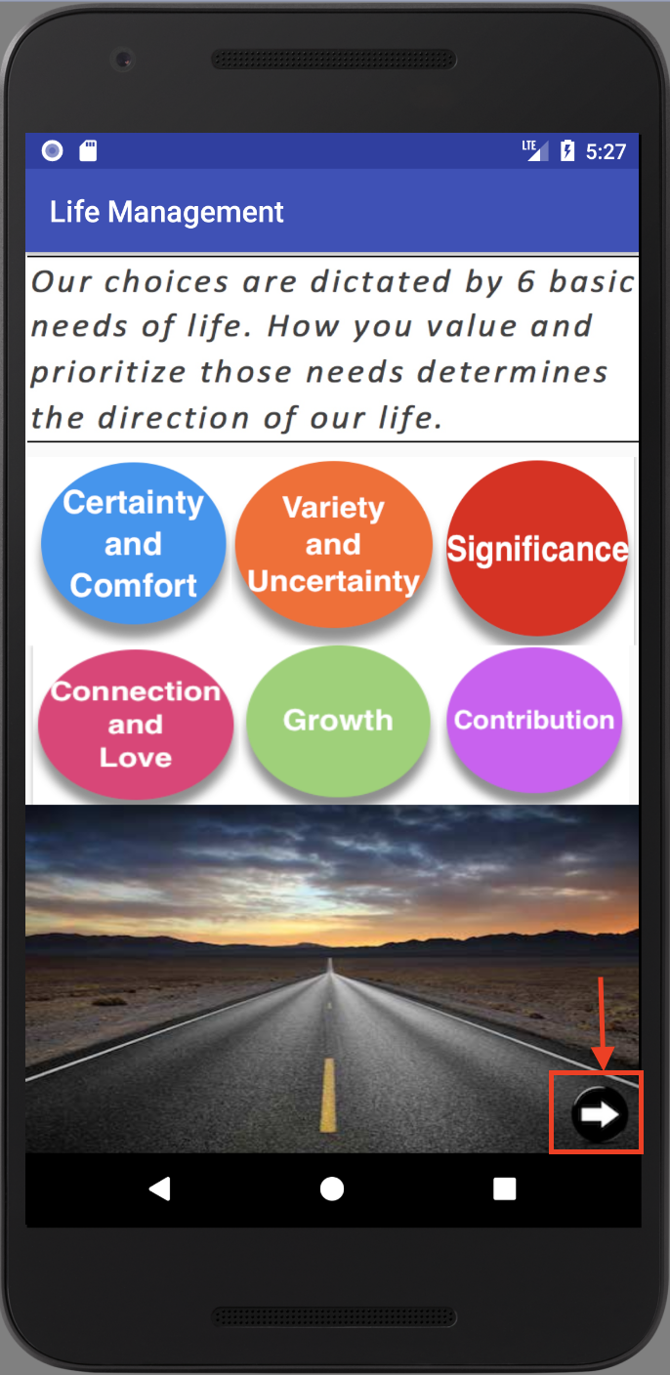

15 - Guest views joy, passion and contribution intro screen and clicks the next arrow to continue to the next page.

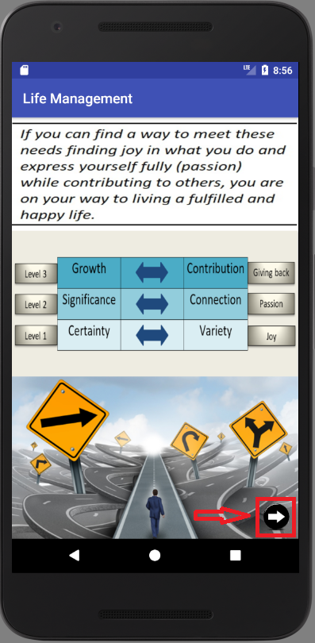

16- Guests can watch an introductory video so they can see the purpose of the app better. After that they can click on the next button to continue to the next page.

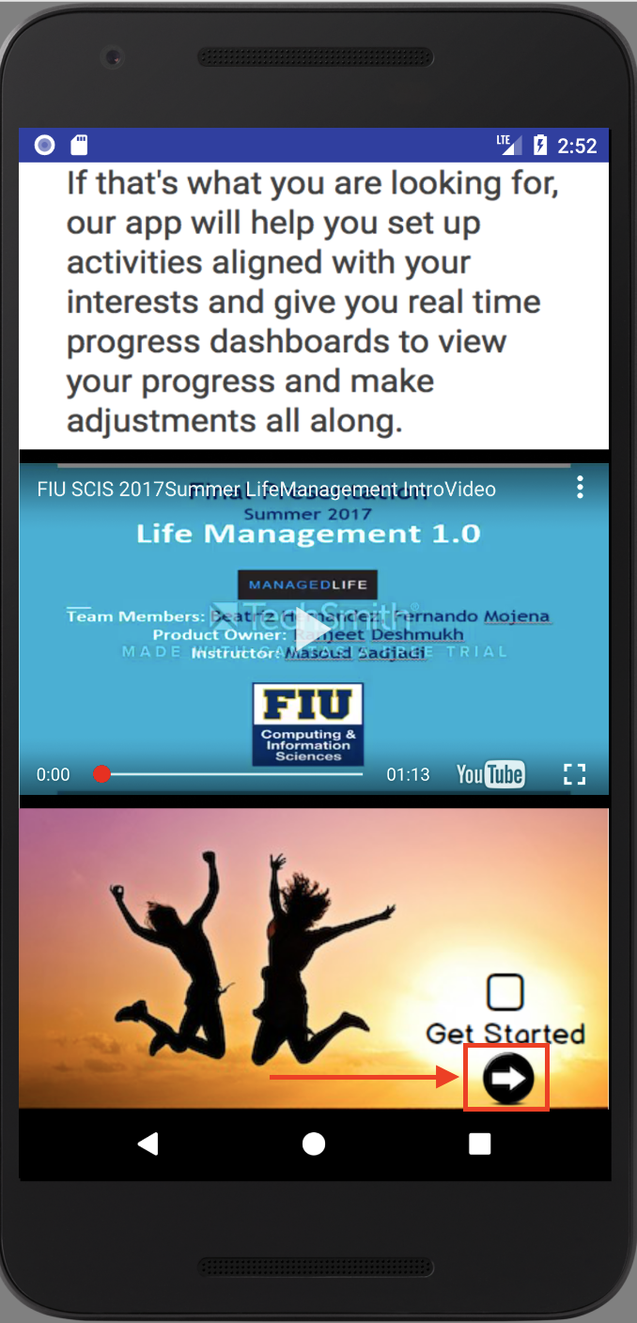

17- Guests can register by clicking on the register button.

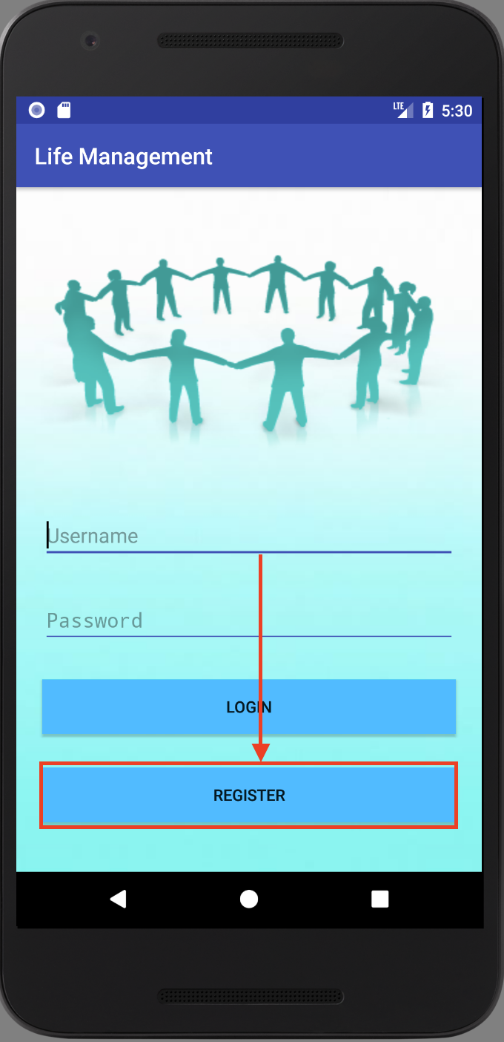

18- Guests provides the following information and click Sign Up.

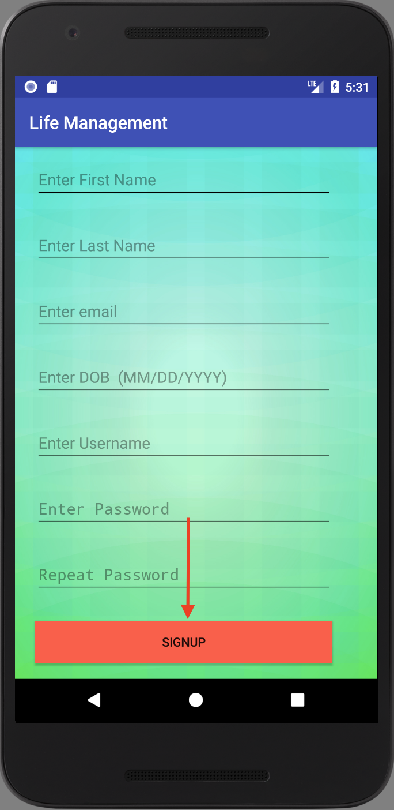

19- Guests select 2 activities for Joy.

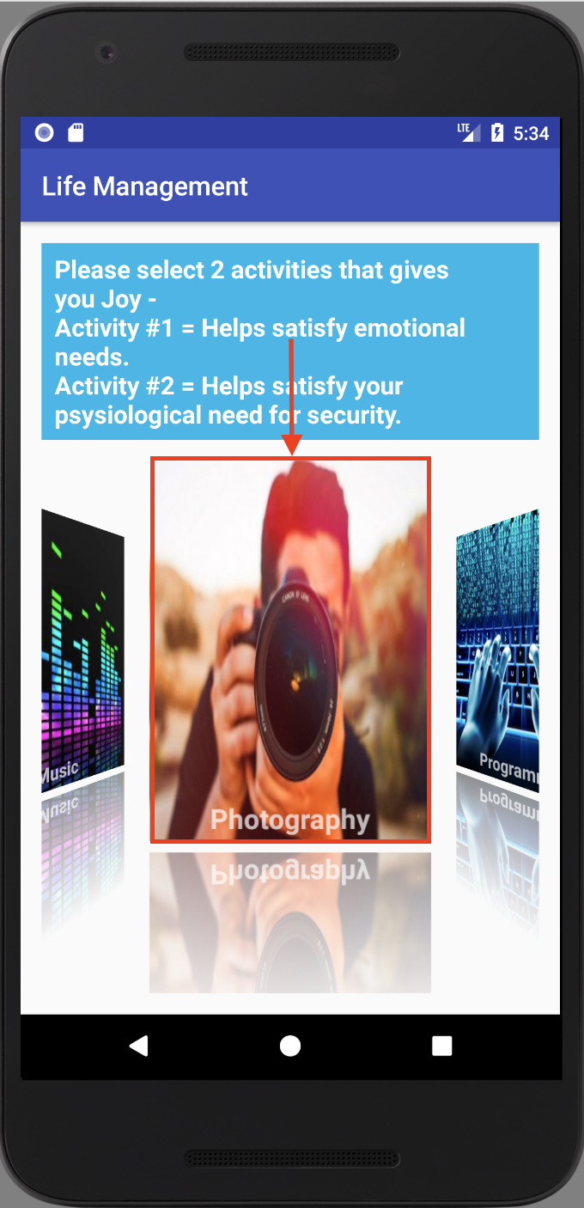

20- Guests confirm the selected activities and go to the next screen.

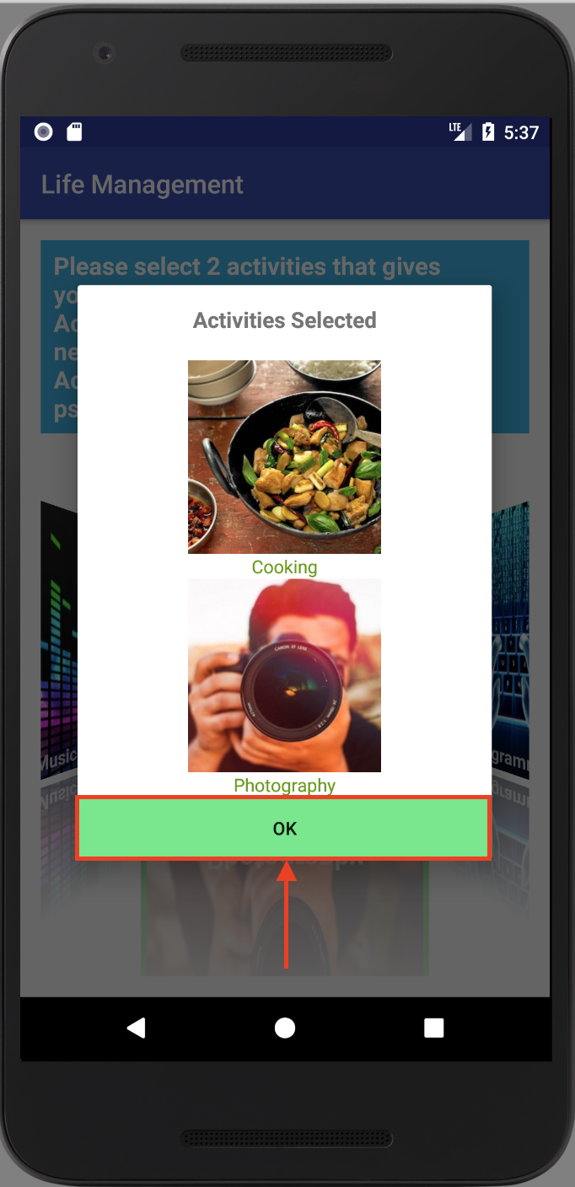

21- Guests select 2 activities for Passion.

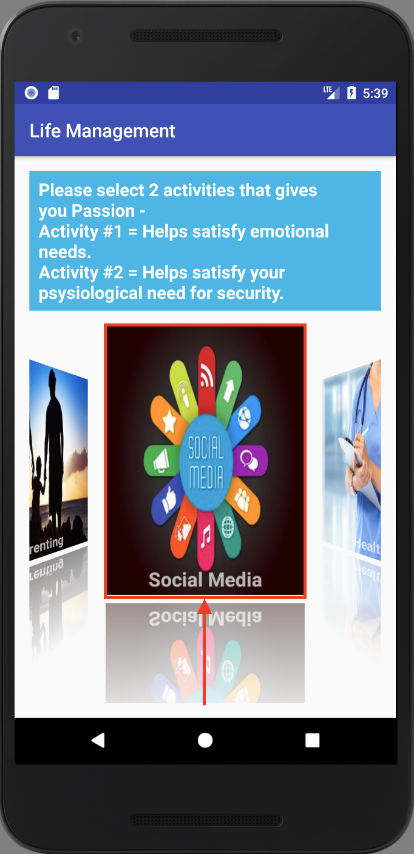

22- Guests confirm the selected activities and click continue.

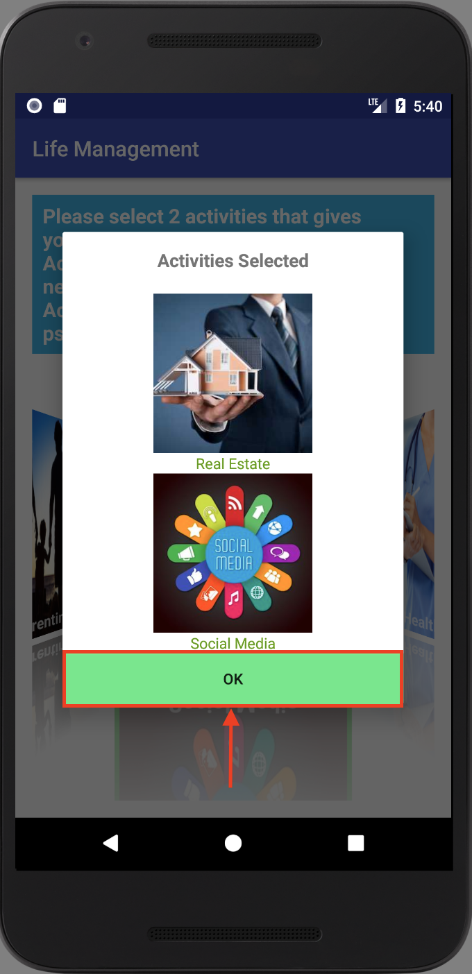

23- Guest selects 2 activities for Contribution by clicking on the image of the activity

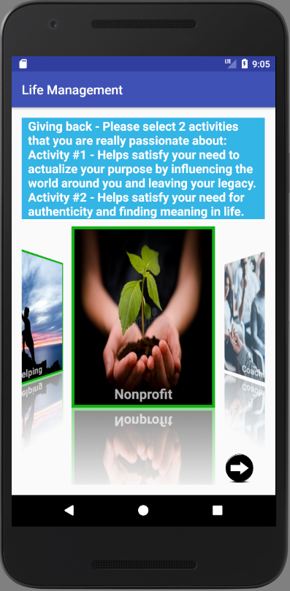

24 - Guest confirms the selected activities and clicks the next arrow to continue.

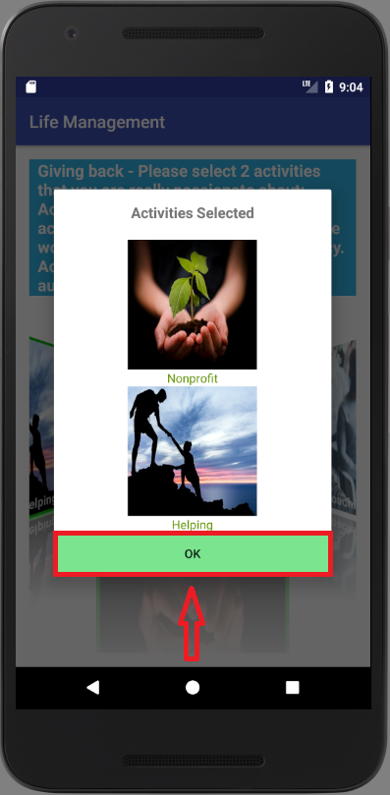

25 - Guest types goal in the sprint goal field

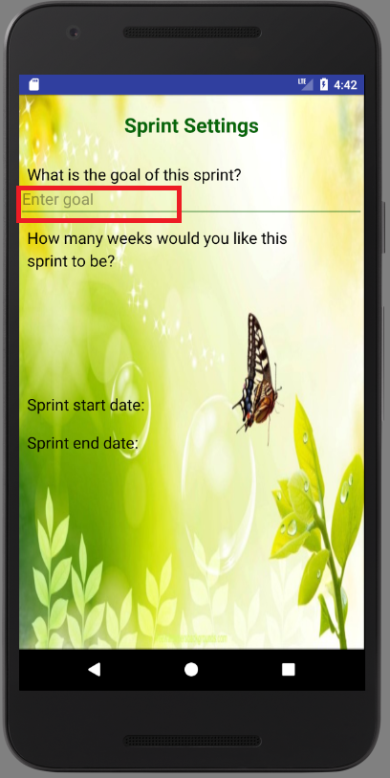

26 - Guest selects sprint duration by clicking on one of the buttons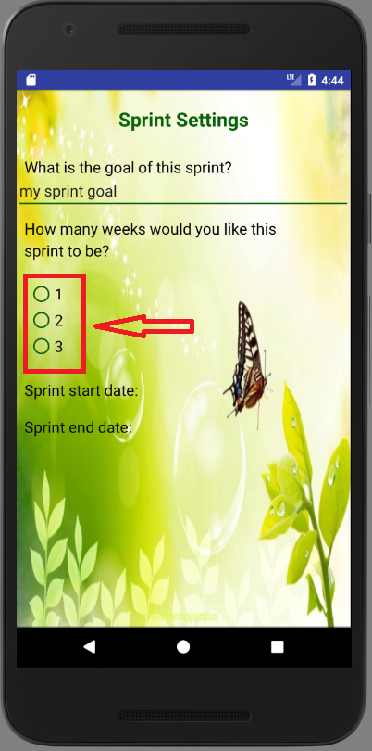

27 - Guest selects sprint start date by clicking on select date text

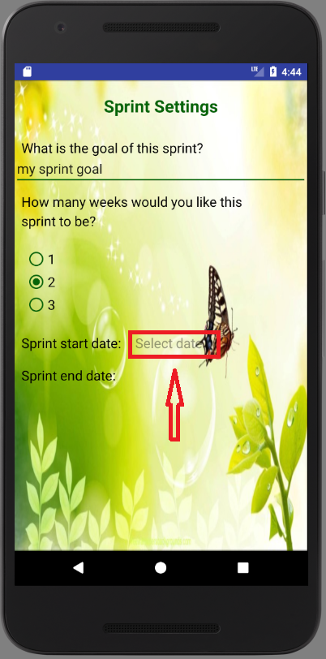

28 - Guest selects start date from the calendar and confirms it by clicking OK

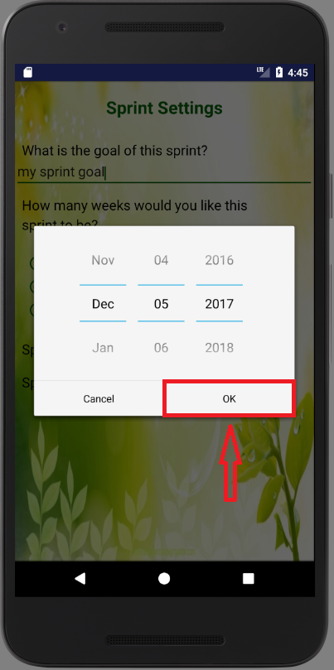

29 - Guest selects sprint end date by clicking on select date text

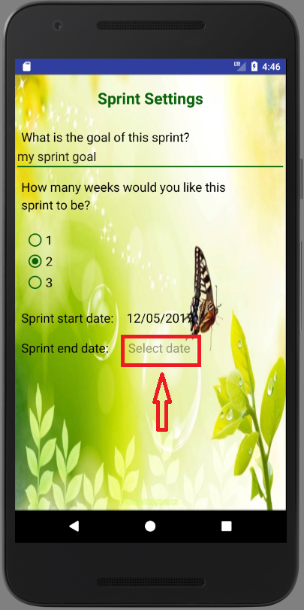

30 - Guest selects end date from the calendar and confirms it by clicking OK

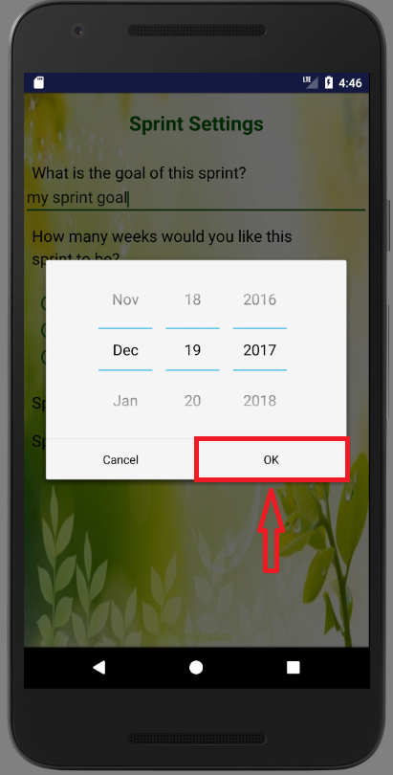

31 - Guest swipes to the next page to continue setting up new sprint

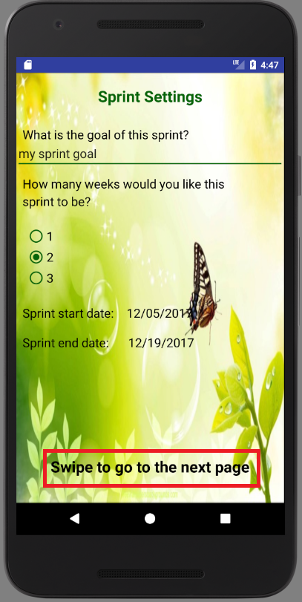

32 - Guest fills out all the fields for activities’ goals and clicks on Submit Sprint Settings button to save new sprint settings

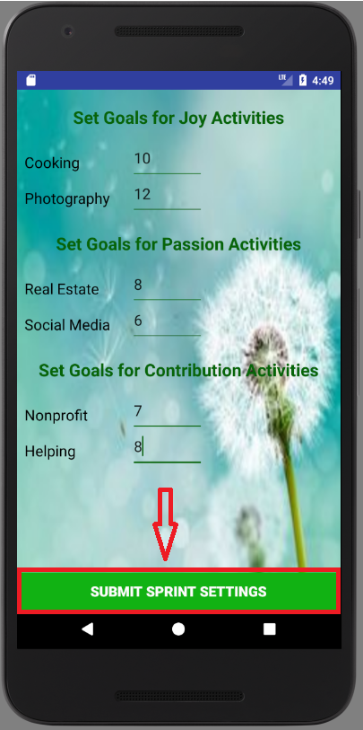

**User**

**Sign in**

User can sign in by entering his/her credentials and clicking on Login button

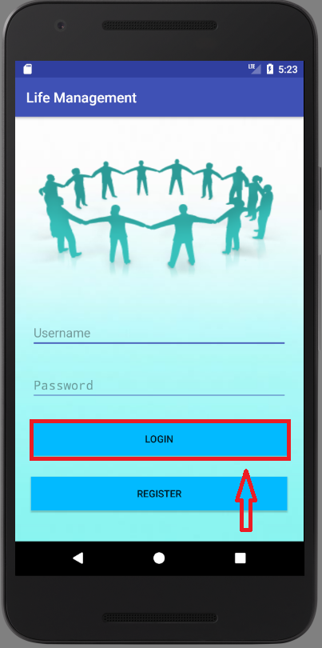

**View user’s dashboard**

Upon signing into the application, user is redirected to his/her dashboard where user can view and update his/her progress for the current sprint.

1 - User can switch between Joy, Passion and Contribution categories by clicking on the corresponding tab on the bottom of the page

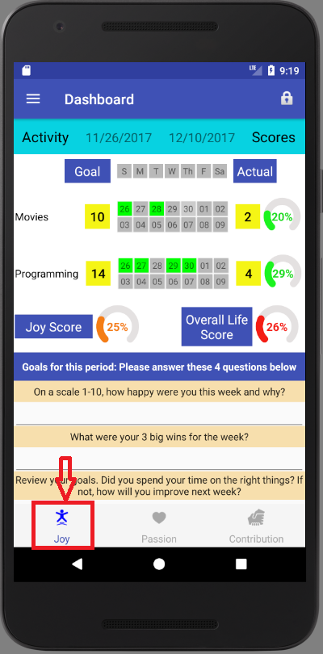

2 - User can update his/her progress for the activity by clicking on one of the buttons corresponding to the calendar day when activity was performed. Green button means that user performed the activity on that day, while grey button means that user did not perform the activity on that day.

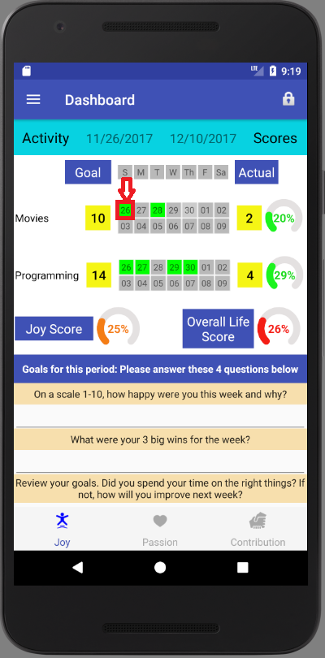

3 - User can see his/her progress for the activity as actual score as well as in percentage. By clicking on one of the buttons corresponding to the calendar day when activity was performed increases activity’s score.

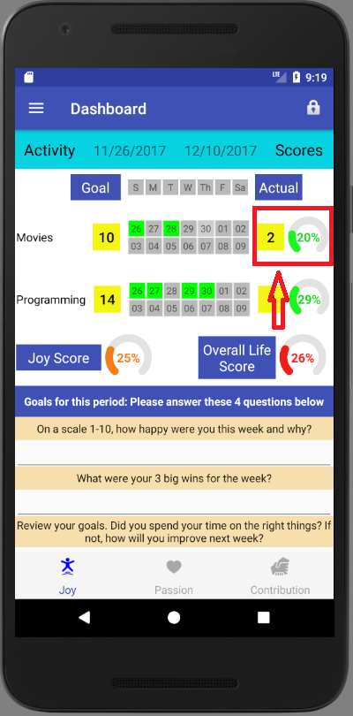

4 - User can see his/her progress for the category in percentage. By clicking on one of the buttons corresponding to the calendar day when activity was performed increases category’s score.

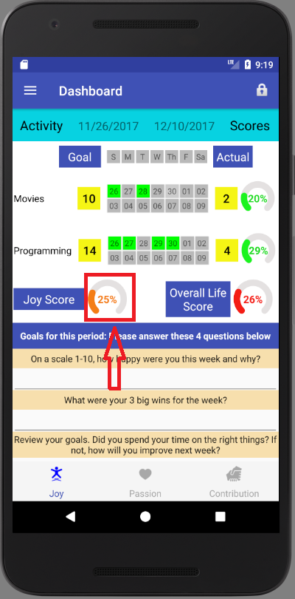

5 - User can see his/her overall life score in percentage. By clicking on one of the buttons corresponding to the calendar day when activity was performed increases overall life score.

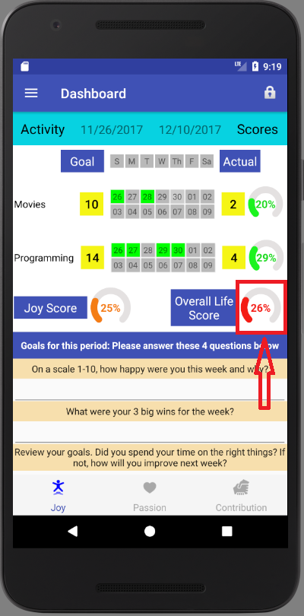

6 - User can update his/her goals for the current sprint period by answering the questionnaire and clicking on Submit Goals button.

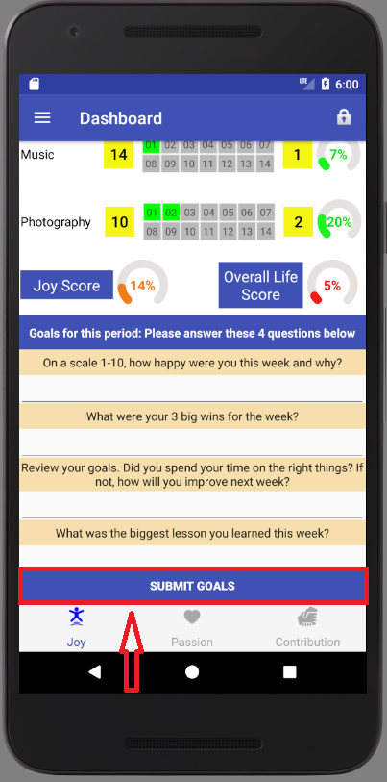

**Start new cycle**

1- User can start new cycle by clicking on the drop-down menu in the top left corner

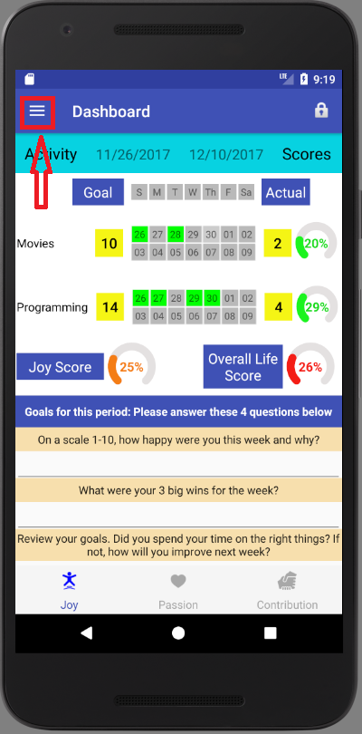

2- User selects New Cycle option by clicking on it from the drop-down menu

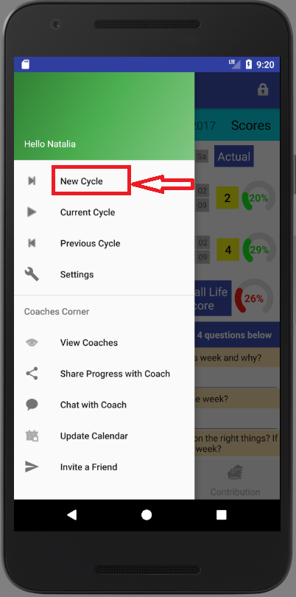

3 - User confirms that he/she wants to start New Cycle by clicking YES, or NO otherwise.

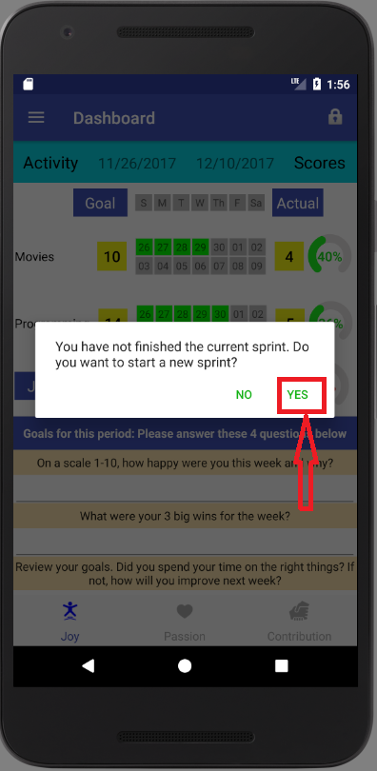

4 - User completes steps 19 - 32 described above in the Guest’s User Manual.

**View Current Cycle**

1- Users can view his/her current cycle by clicking on the Current Cycle button.

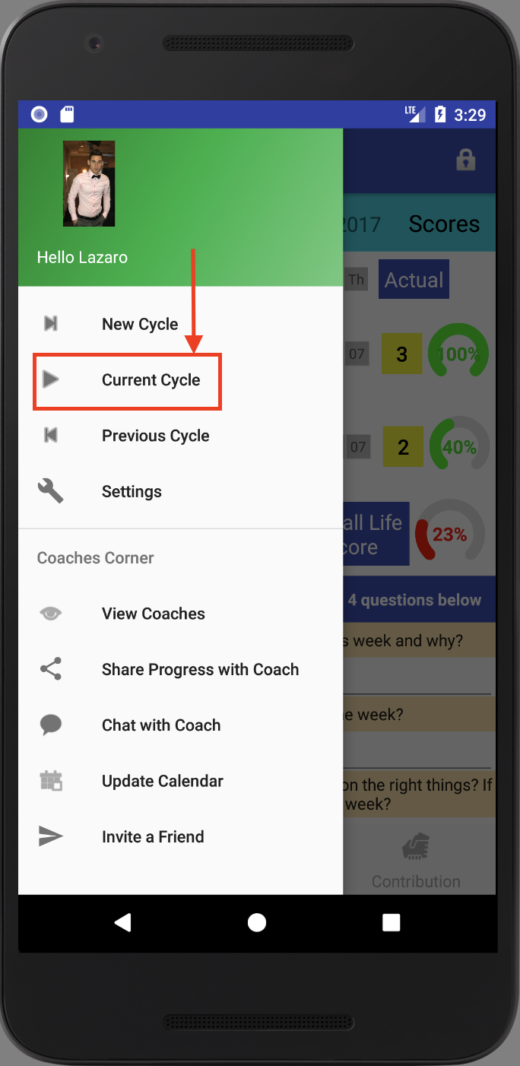

2- Users can go back to Dashboard screen.

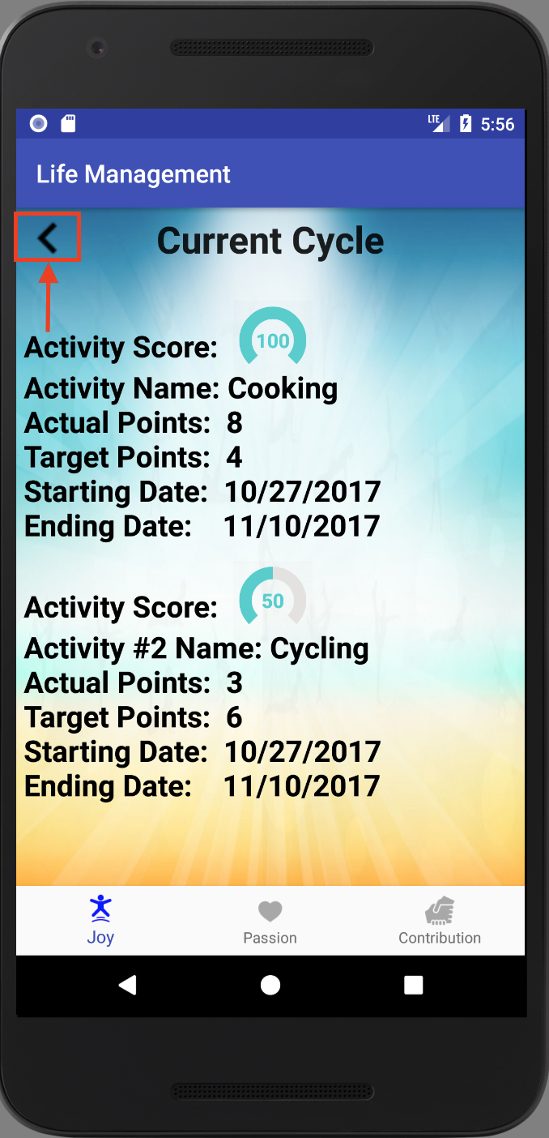

**View Previous Cycle**

1- Users click on the Previous Cycle button

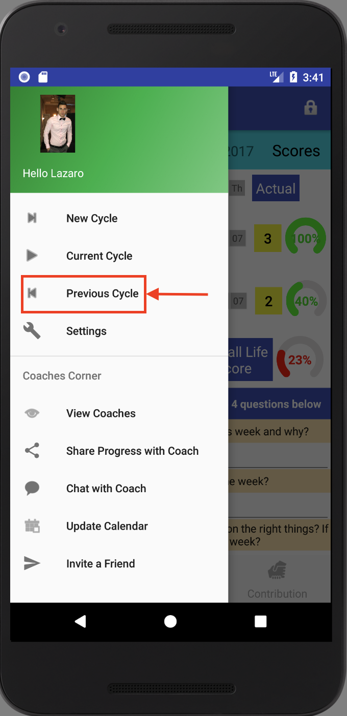

2- Users select any of their previous cycles.

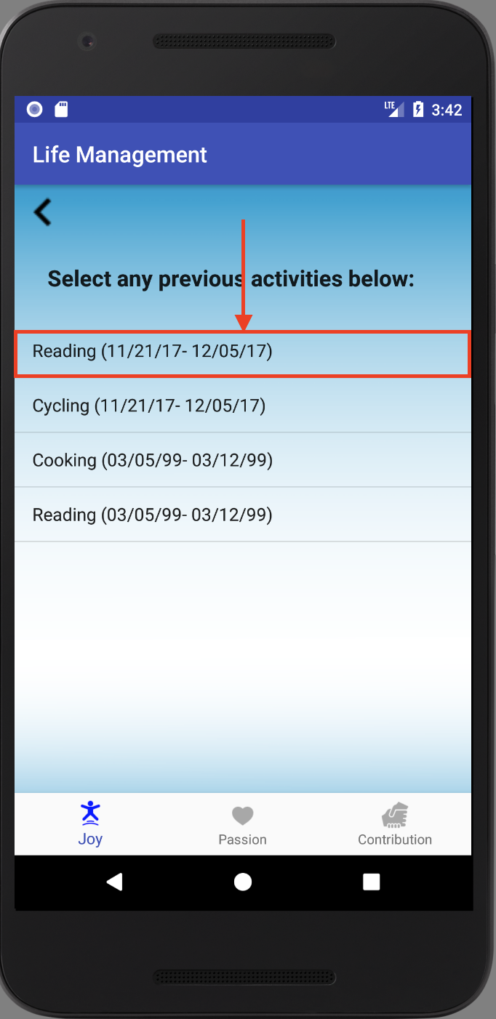

3- Users can view the selected cycle and then can go back.

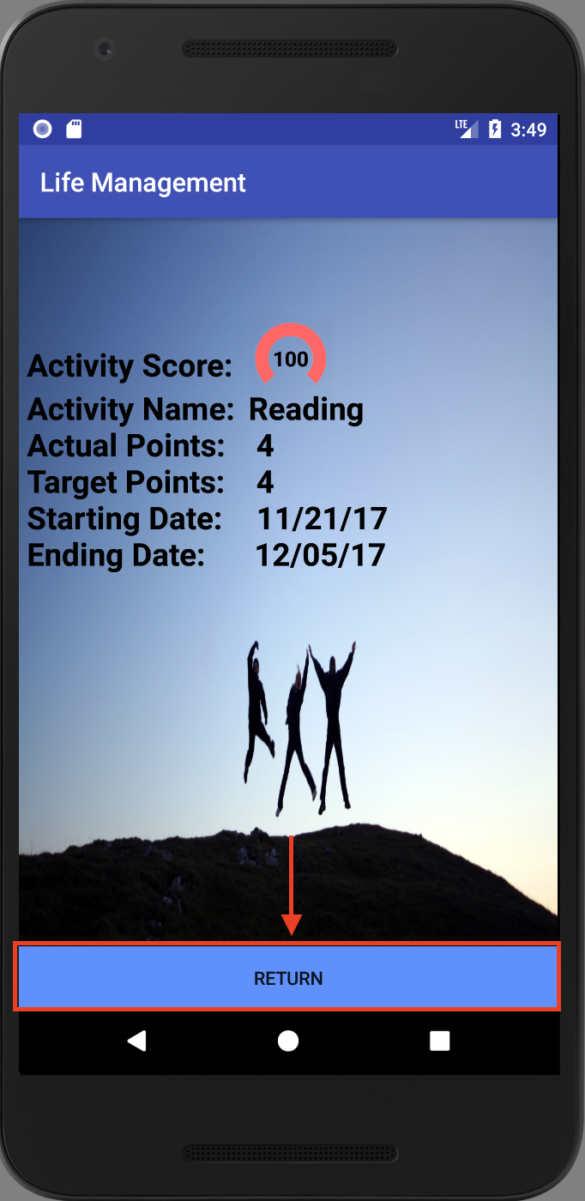

4- Users can return to Dashboard.

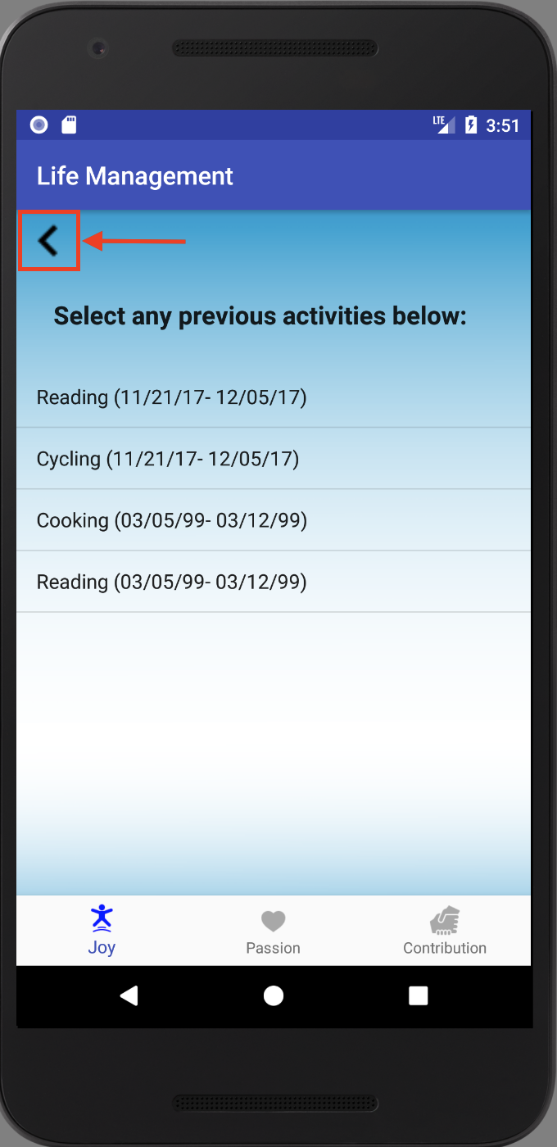

**View Coaches**

1- Users can view current coaches.

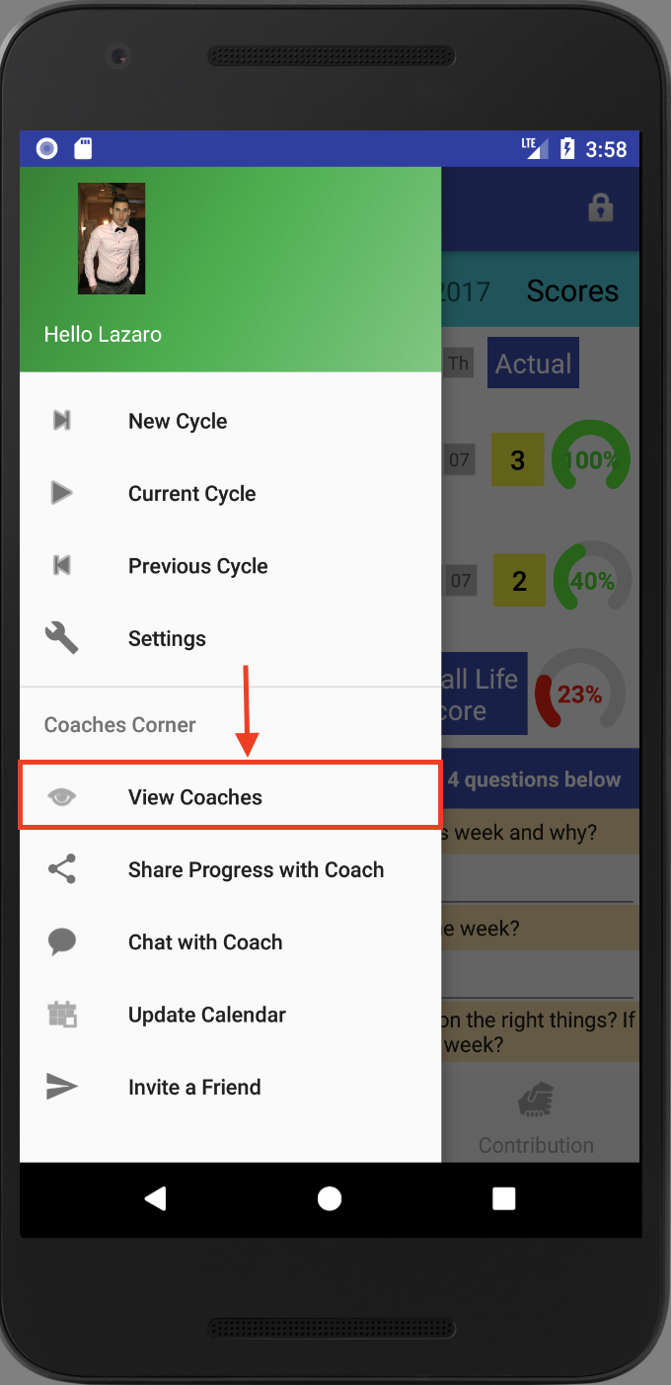

2- Users can return to the Dashboard after seeing the coaches.

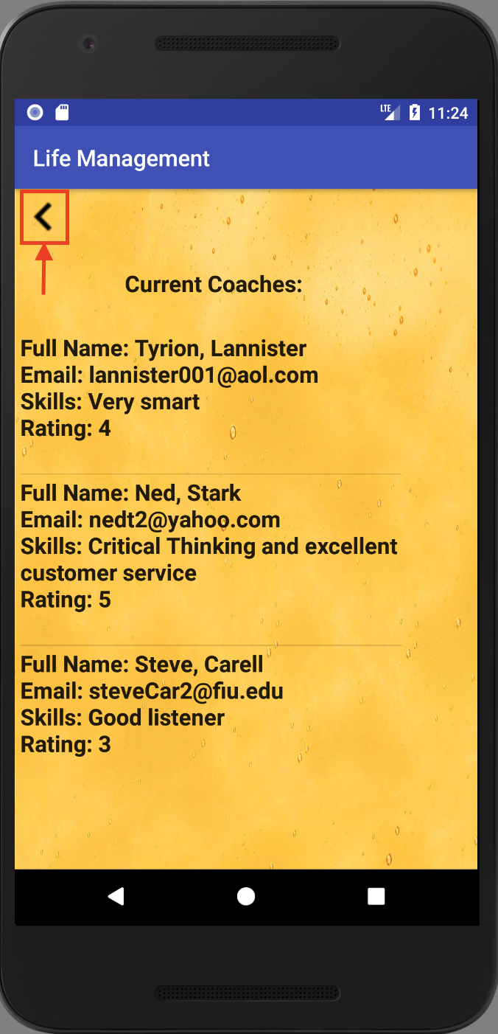

**Chat with Coach**

1 - User can chat with coach by first clicking on the drop-down menu in the top left corner



2 - User selects Chat with Coach option by clicking on it from the drop-down menu

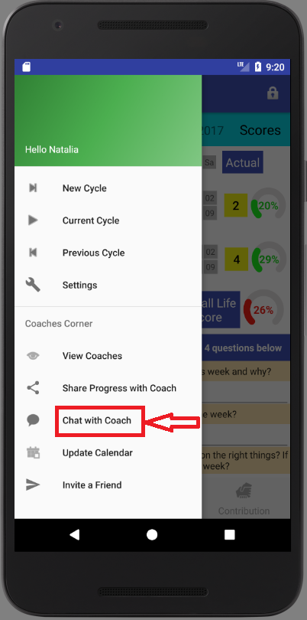

3 - User selects the coach he/she wants to chat with by clicking on coach’s name

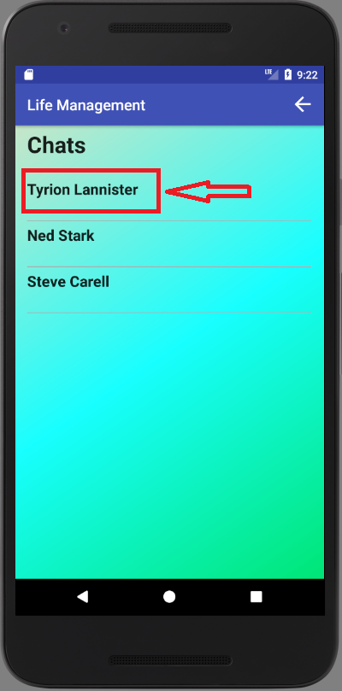

4 - If user would like to go back to the dashboard, user can do so by clicking on the back arrow in the top right corner

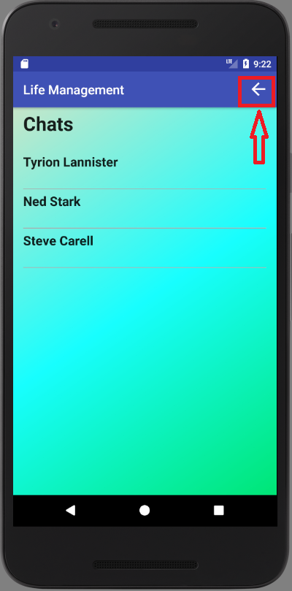

5 - By clicking on the coach’s name user is redirected to the chat page with the selected coach, where user can view history of conversation with that coach by scrolling the page if the previous conversation exists.

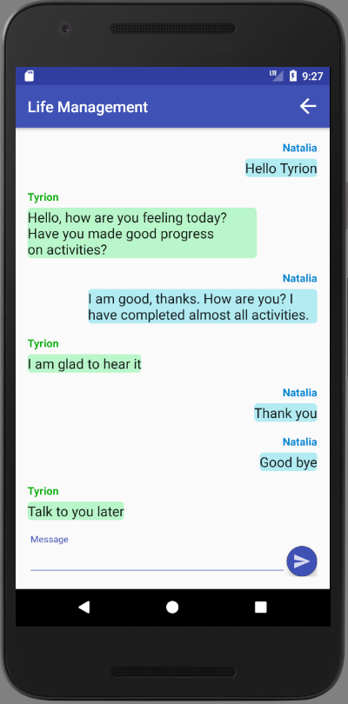

6 - User can send a message to the coach by typing the message in the Message field and clicking on the Send button on the bottom of the page. The user can see the sent message on the bottom of the list of messages.

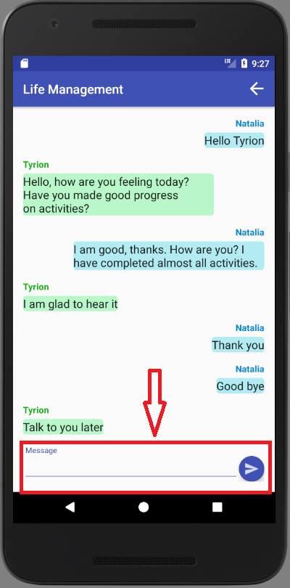

7 - User can return to the previous page to select another coach to chat with by clicking on the back button in the top right corner

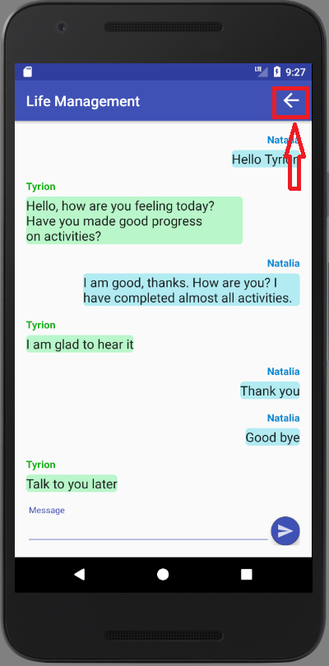

**Sign Out**

1 - User can sign out of the application by clicking on the lock icon in the top right corner of the dashboard

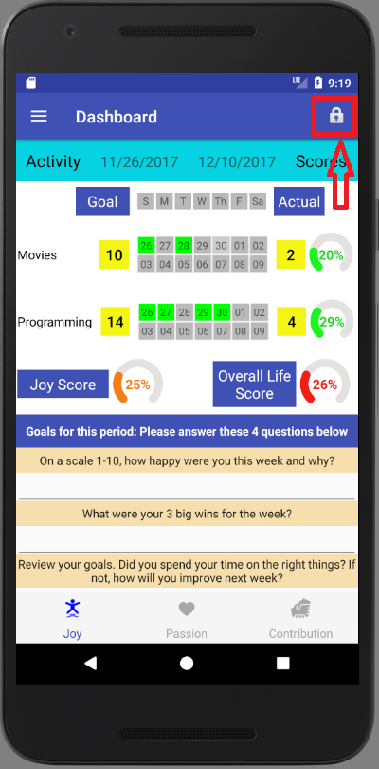

2 - User confirms if he/she wants to sign out by clicking YES, or NO otherwise. If user clicks YES, he/she is redirected to the Login page.

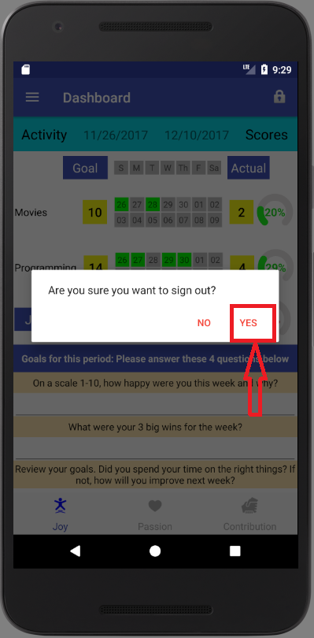

**IOS Manual:**

**Guest**

**Overview of App**

1 - Land on initial guest screen page

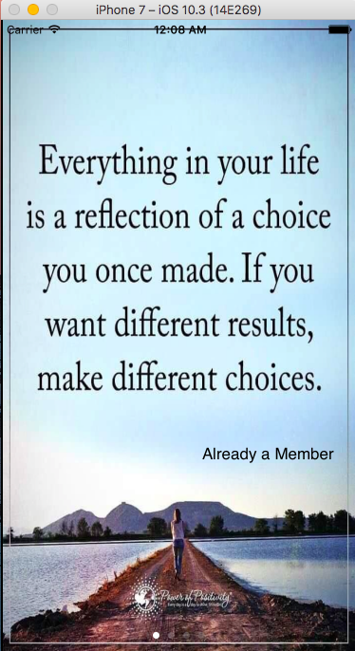

2 - Review the different emotions the app can bring out of you

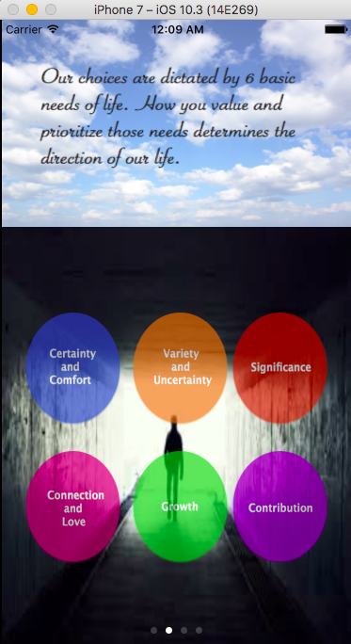

3 - More information and video which encourages to sign up. If convinced press sign up, which takes you to the signup page

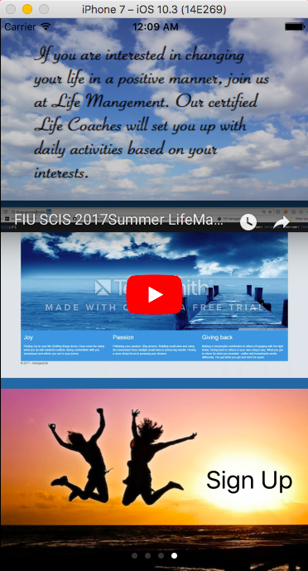

4 - In the registration form, fill out the fields then click “Register” to become a new user of Life Management

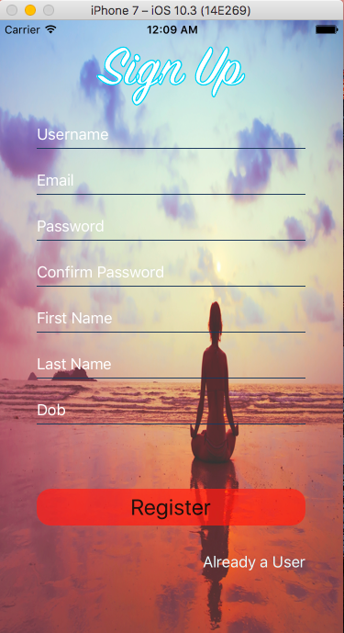

**User**

**Activity Selection**

1 - User selects two activities that brings joys out of him/her

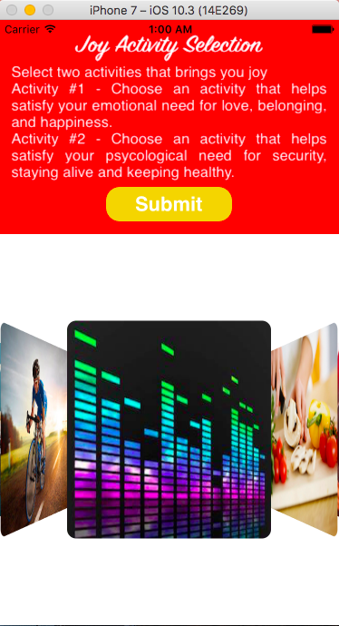

2 - Select two activities that brings out passion

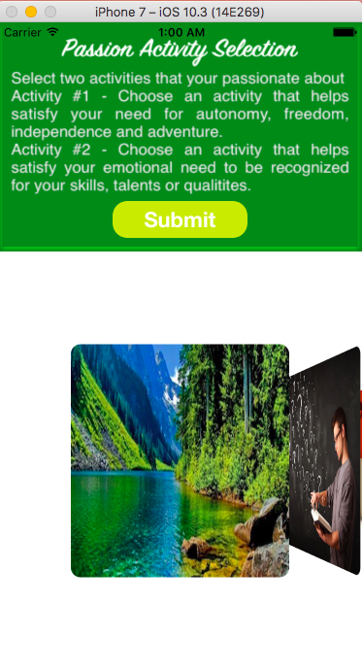

3 - Select two activities that brings out contribution

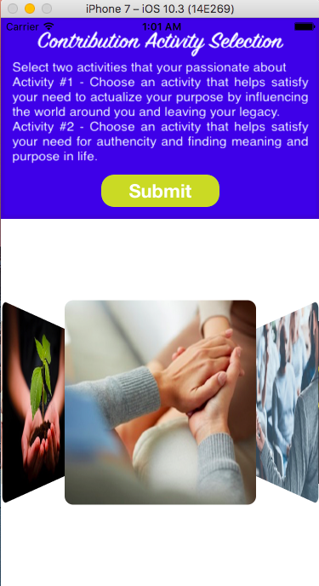

4 - Set the target points the user will try to achieve during the sprint cycle for each activity

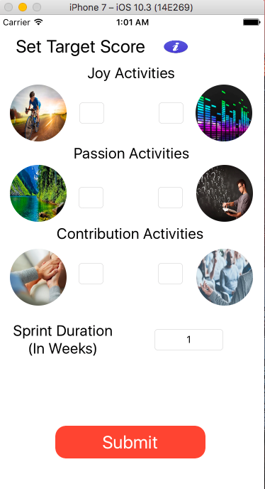

**Sign In**

1 - User can enter their username and password to login into their account

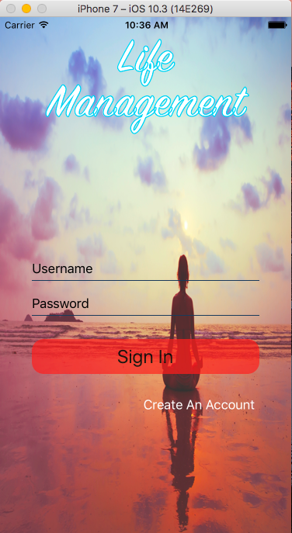

**Dashboard Overview**

1 - Once a user signs in they are redirected to their activity progress dashboard

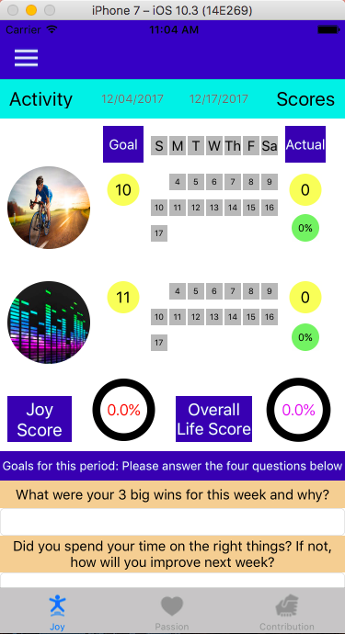

2 - A user can update their activity progress by clicking on a day button in which they engaged in the activity selected. The gray button will turn green to indicate the change.

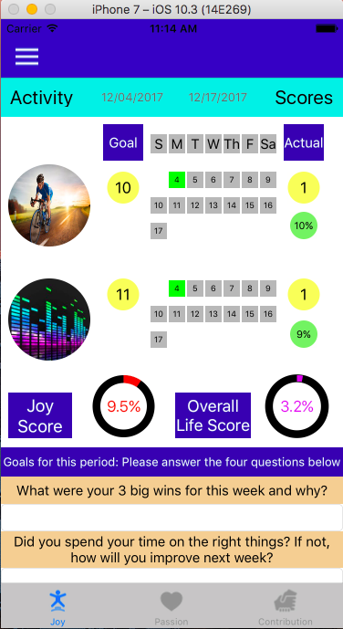

3- Update goals for the current sprint by clicking submit

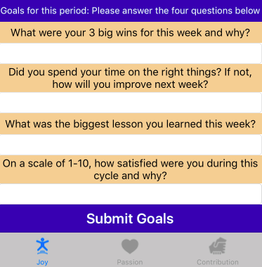

4- If a user wants to see his/her other activities that bring out different emotions click on any of the tabs below

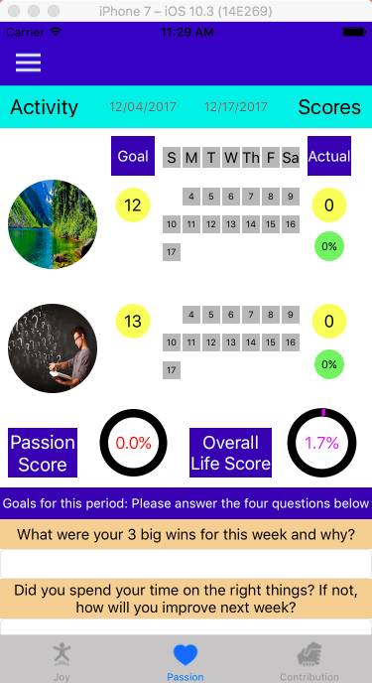

5 - Clicking on the dropdown button gives the user a variety of action they can take

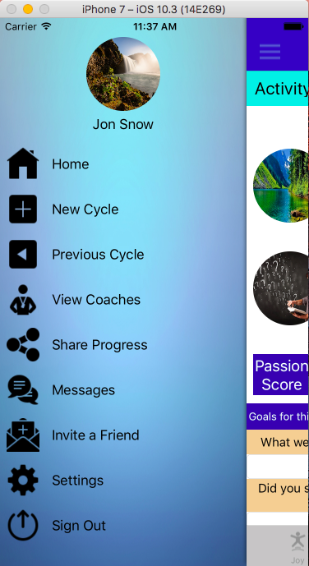

**Previous Cycles**

1 - On the side menu click “Previous Cycle”

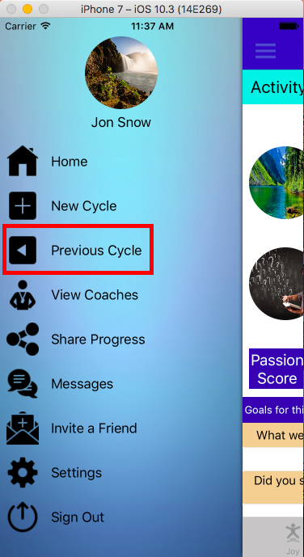

2 - Look through all the previous cycles then select one which the user wants to view more information

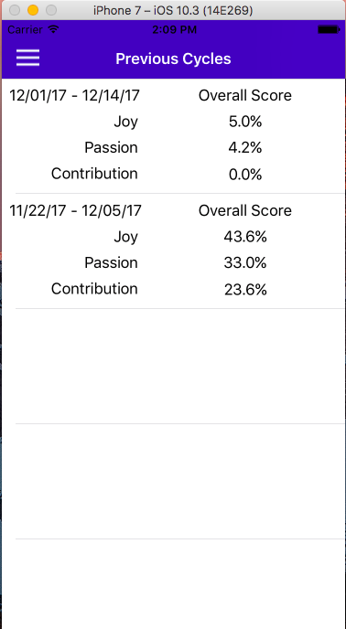

3 - Once there done looking through the information click on the back button

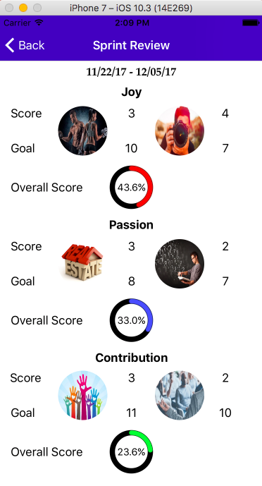

**View Coach List**

1 - On the side menu click “View Coaches”

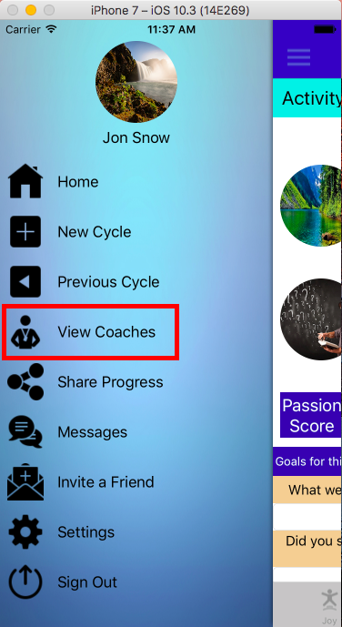

2 - A list of coaches which a user can chat with is displayed

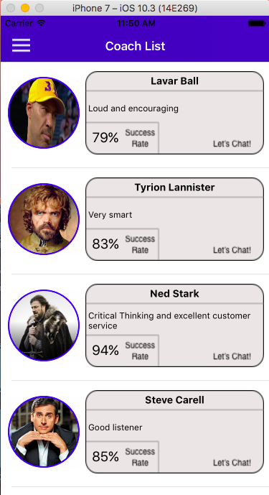

**Start a New Cycle**

1 - On the side menu click “New Cycle”

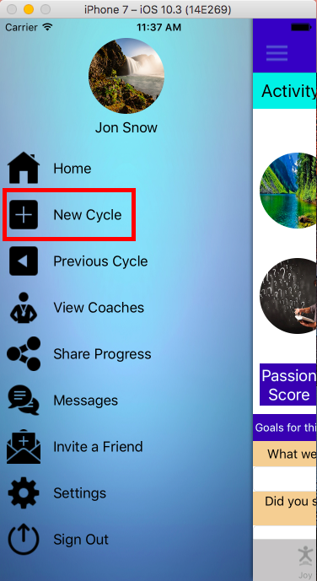

2 - Select activities for the three different emotions

3 - Set target scores for each of the selected activities and set the duration of the sprint

**Upload a User Image**

1 - On the side menu click “Settings”

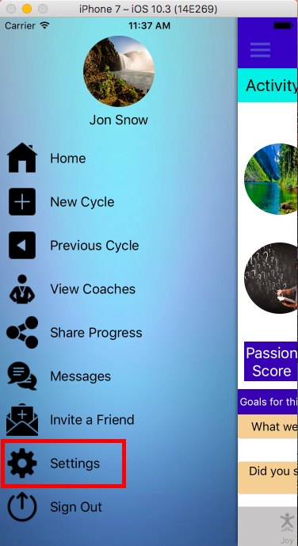

2 - Click on the camera icon

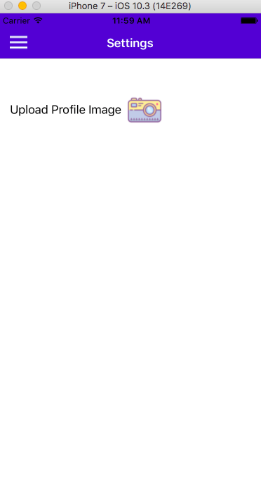

3 - Select an image to upload as user profile picture

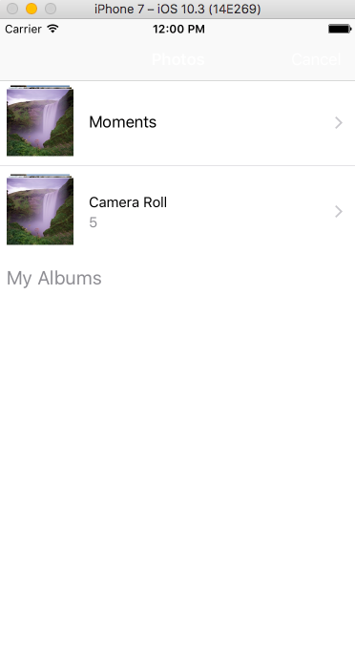

**Chat with a Coach**

1 - On the side menu click “Messages”

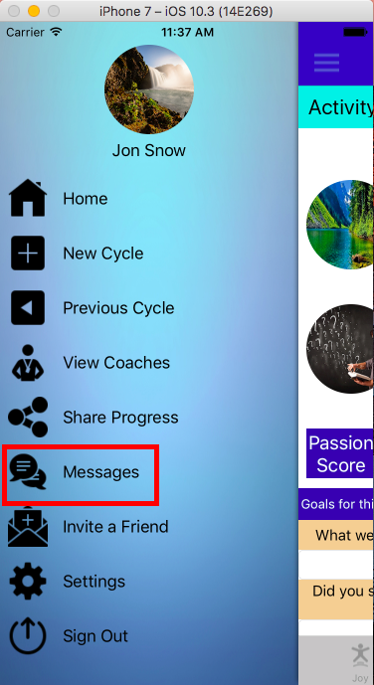

2 - Click on the conversation user wants to engage in

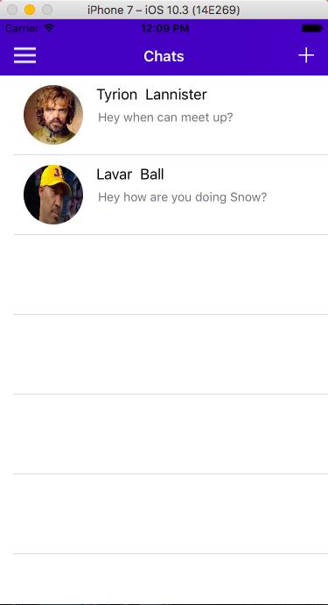

3 - Type a message then press send

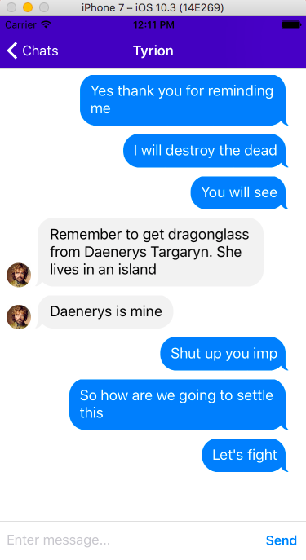

**7.3.2. Installation/Maintenance Document**

**Android:**

**1.** To begin with, you will need a program called ‘Github Desktop’ because you are going to be transferring files that are quite big. Go to https://desktop.github.com and download the latest version (Compatible with macOS and Windows).

Then go to this link:

https://github.com/FIU-SCIS-Senior-Projects/Life-Management-Mobile-App-2.0

Click on the arrow shown below and click on ‘Lazaro-Fernandez’ or ‘Natalia-Filippova’.

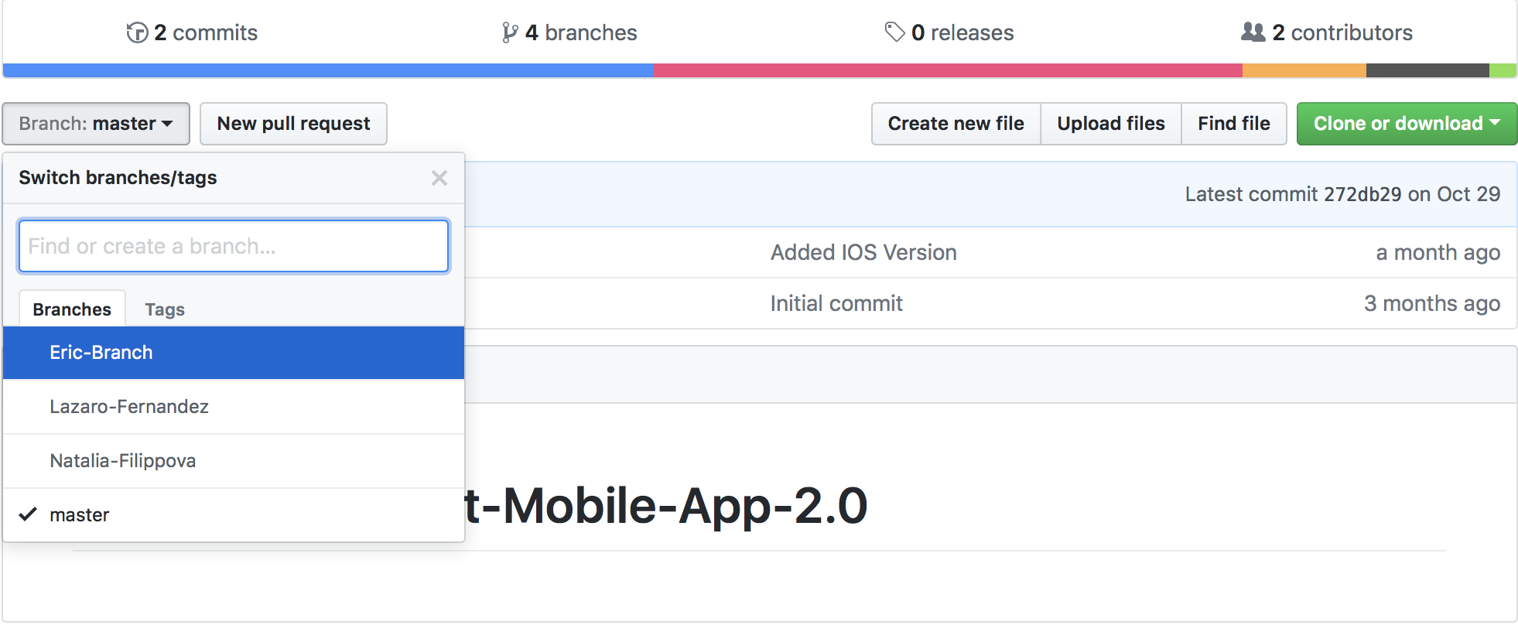

After that, click on the green button ‘Clone or download’ located at the top right hand corner and select ‘Open in Desktop’.

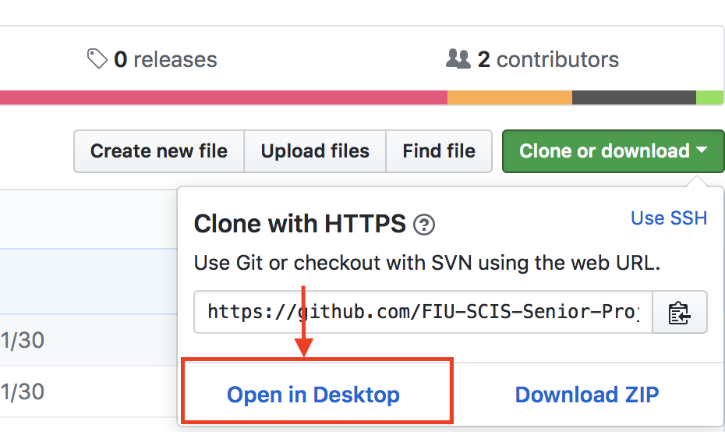

Then, this screen should display. Choose the location Github will clone the project to and click on ‘Clone’ as follows:

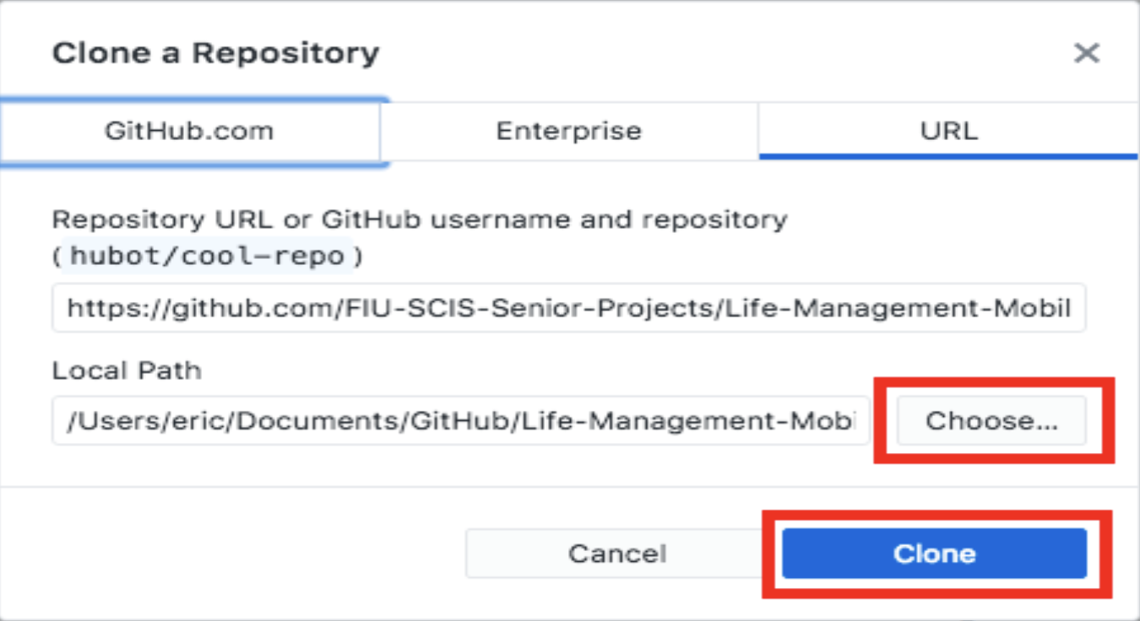

Go to ‘master’ branch and select new Branch. Name it as follows (firstname-lastname)

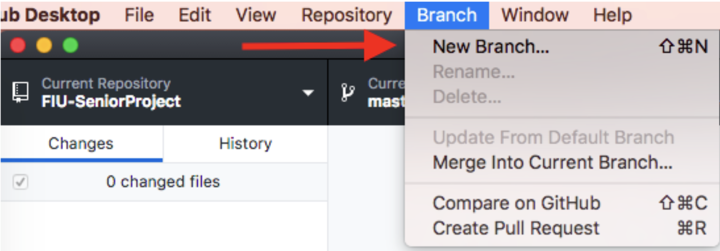

If you want to upload your changes, click on ‘Merge into Current Branch’. Make sure you are in your branch for this. Then click on ‘Fetch Origin’ so that it can process your updates and you should see it in Github.

**2.**  Youtube Android Player API

Go to Google Developers’ Console page in console.developers.google.com. If you are not logged-in, please do so using your google account. When you are logged-in, click on the top arrow to create a new project.

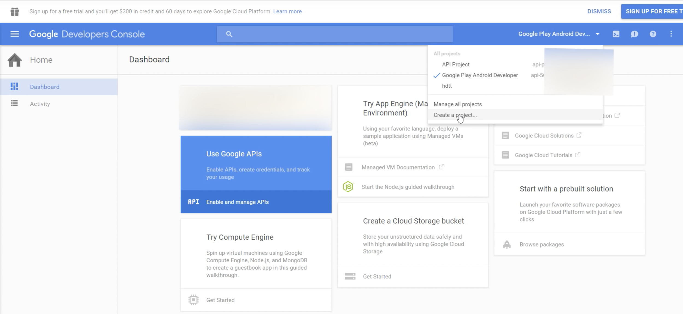

Call it any name and continue

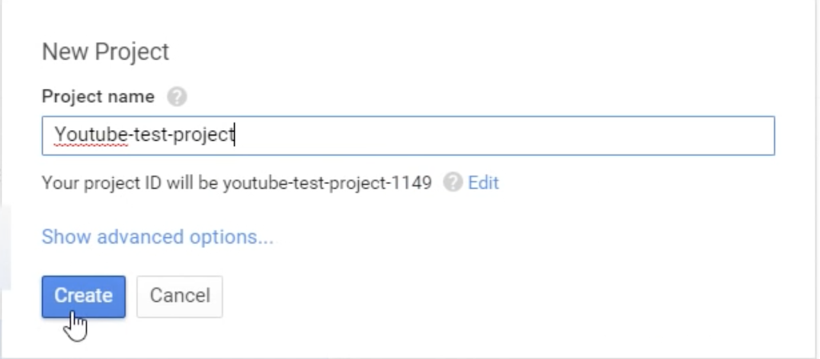

Then on the navigation menu on the left, choose API Manager and select ‘Youtube Data API’.

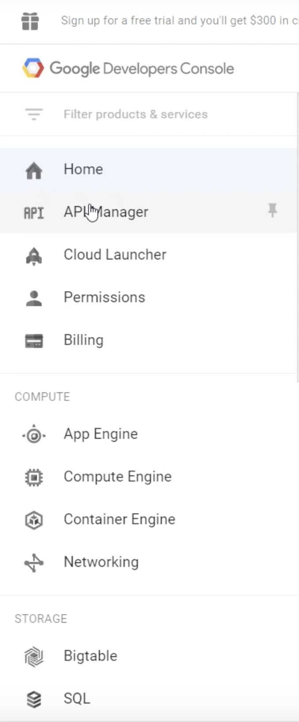

Then click on enable API and click on ‘Go to Credentials’. Click on Add Credentials, you should see a window similar to this:

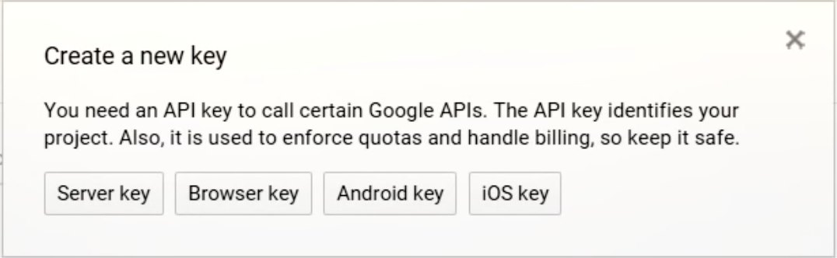

Select Android key and type the following command starting with keytool.. in Android Studio and follow the steps.

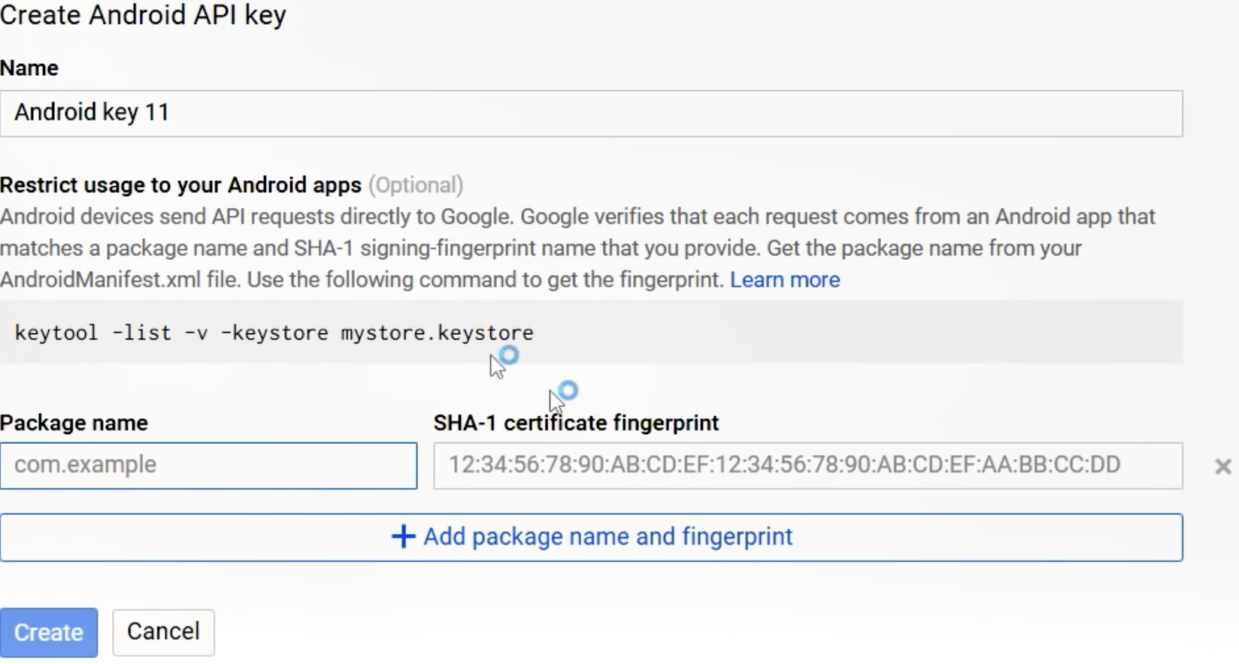

After completing step above, you should see your SHA certificate fingerprint, paste it in the above page along with the package name of your Android Project and click on Create button. You should see a message similar to this.

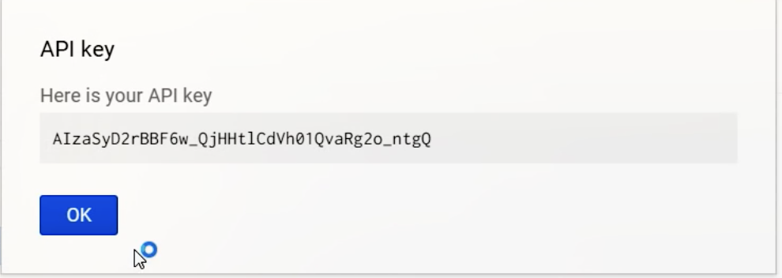

Go to Youtube Player API located at developers.google.com/youtube/android/player/downloads and click on Download

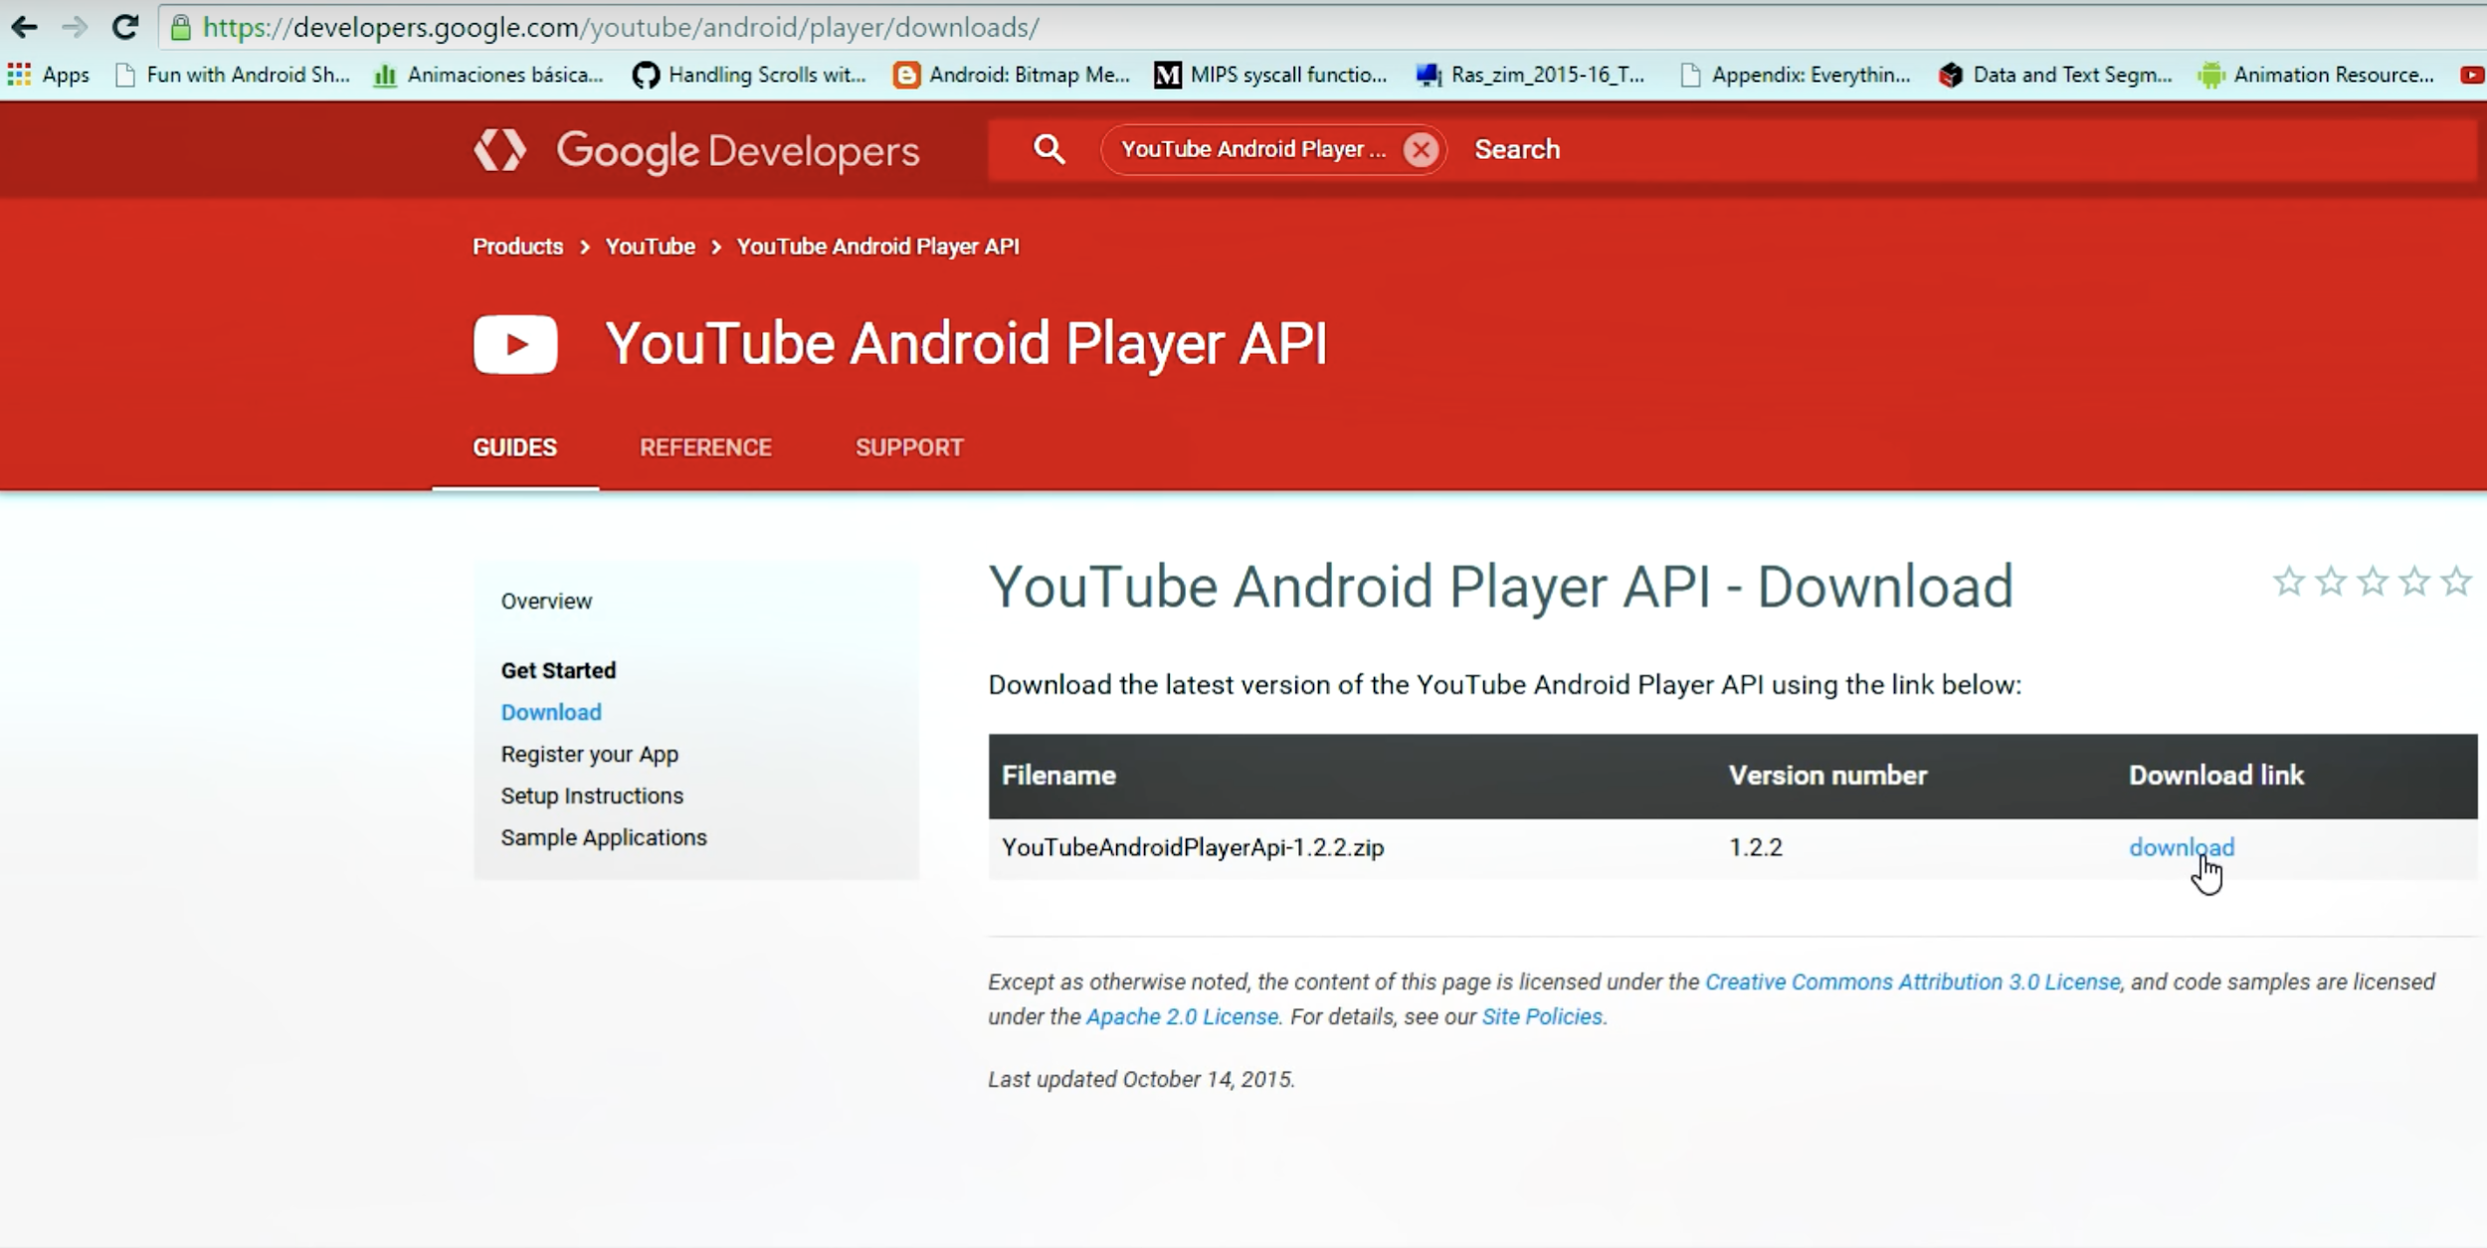

Unzip the file, and open the ‘libs’ folder. You should see a file named ‘YoutubeAndroidPlayerApi.jar’, copy that file and paste it your Android Studio libs folder.

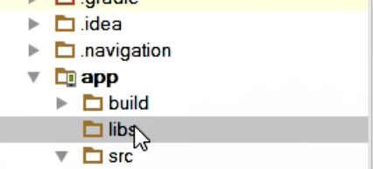

Then go to File->Project Structure. In the pop up, navigate to ‘Dependencies’ and click on Add as follows:

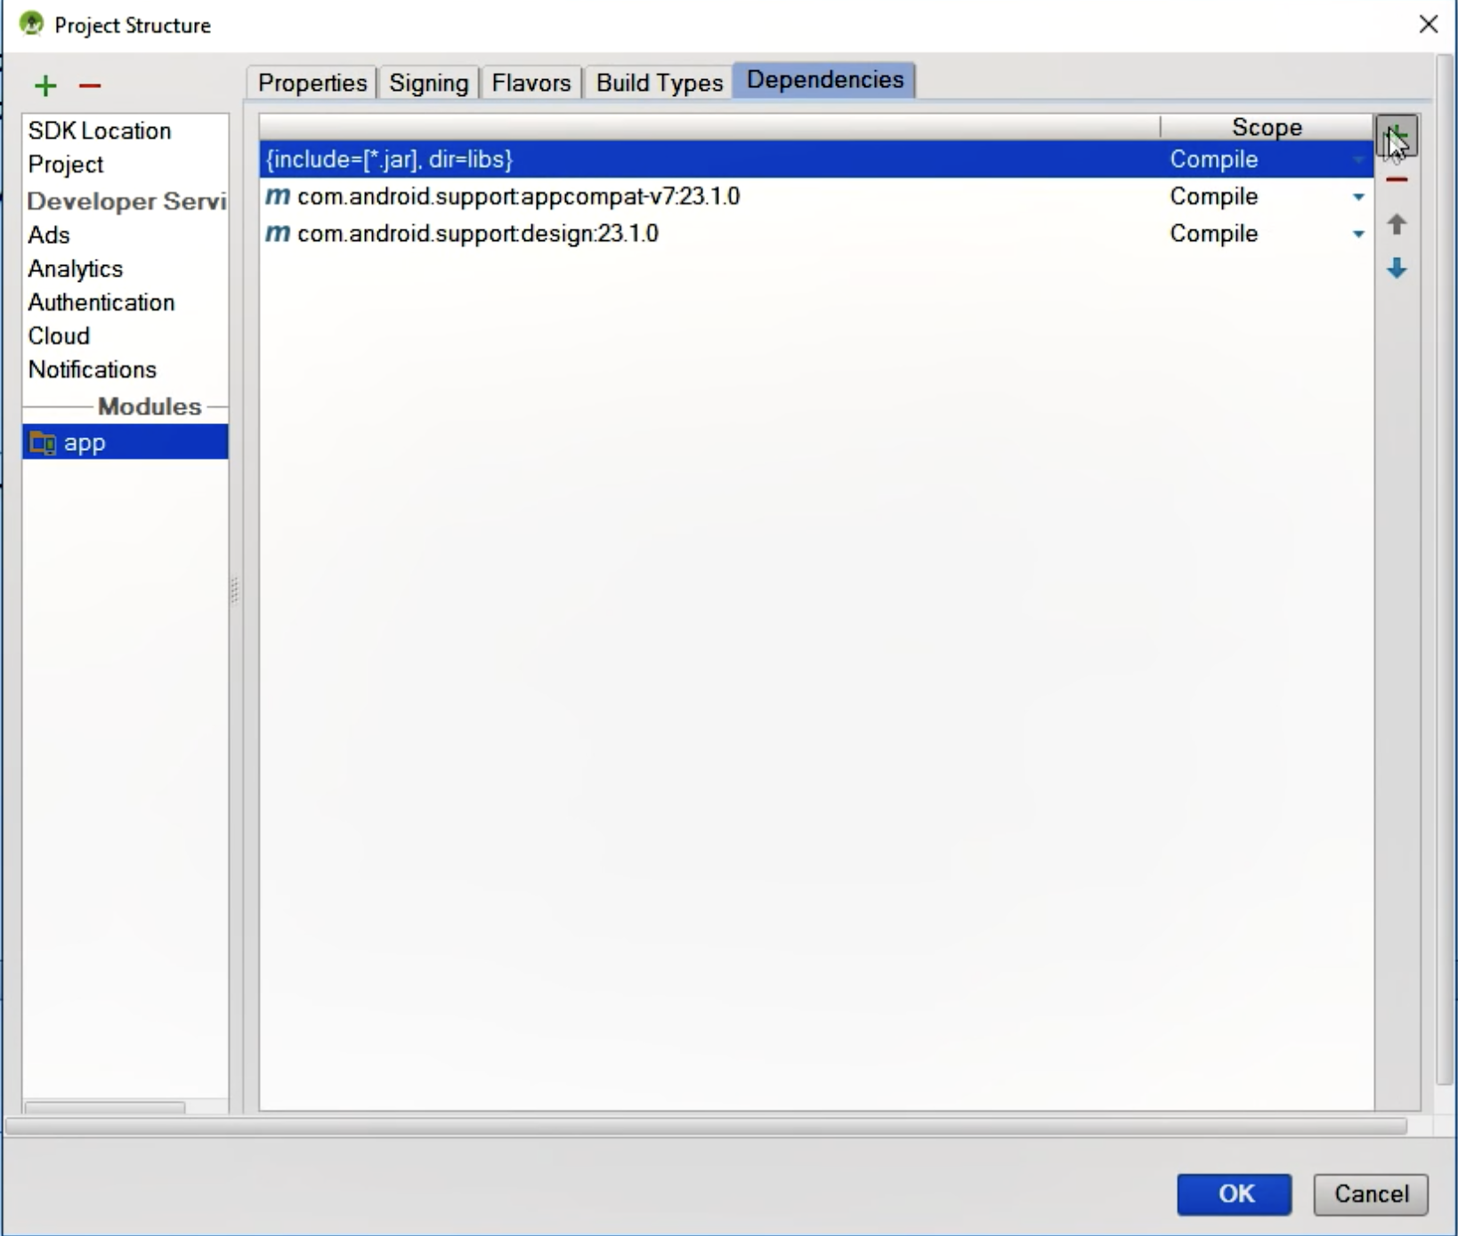

Then click on ‘File Dependency’ and select the downloaded jar file and hit OK. After completing this, you should be able to play any youtube video in your Android Studio project.

**3.** For the **project installation**, the following is required to be installed before continuing:

* Java Development Kit (you can download it from here

<http://www.oracle.com/technetwork/java/javase/downloads/jdk8-downloads-2133151.html> )

* Android Studio 2.3.3 or later version, Android SDK tools and SDK manager

(you can download all it from here

<https://developer.android.com/studio/index.html?gclid=Cj0KEQiAm-CyBRDx65nBhcmVtbIBEiQA7zm8lWCaBd9n9KYYunFXxXsQCPojBVHk5eIH4p9CWM1eLfUaAmd28P8HAQ>)

* Android Emulator – Nexus 5X API 26 virtual device, which was used to test the app (build it by navigating to **Tools > Android > AVD Manager**). 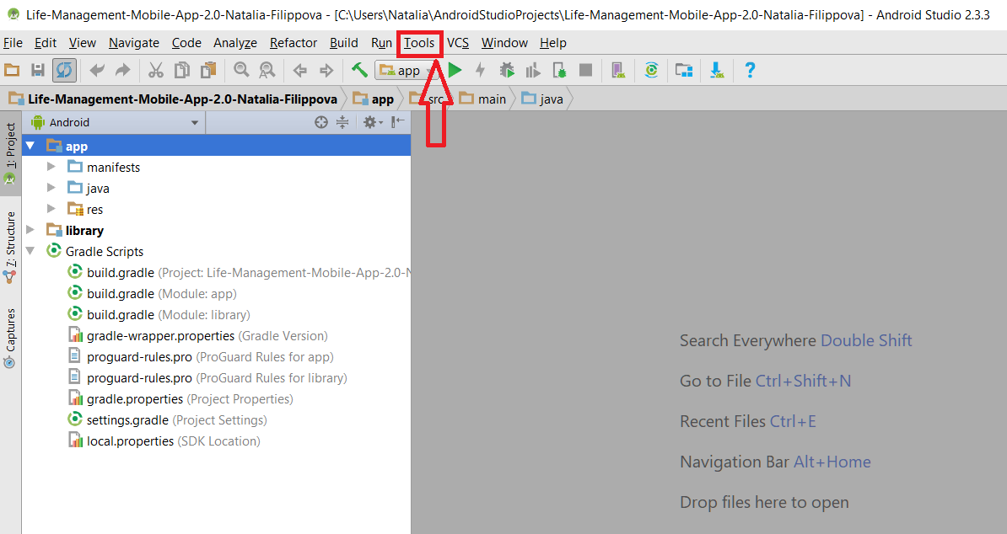

After virtual device has been created, you will be able to see it in Android Virtual Device Manager window.

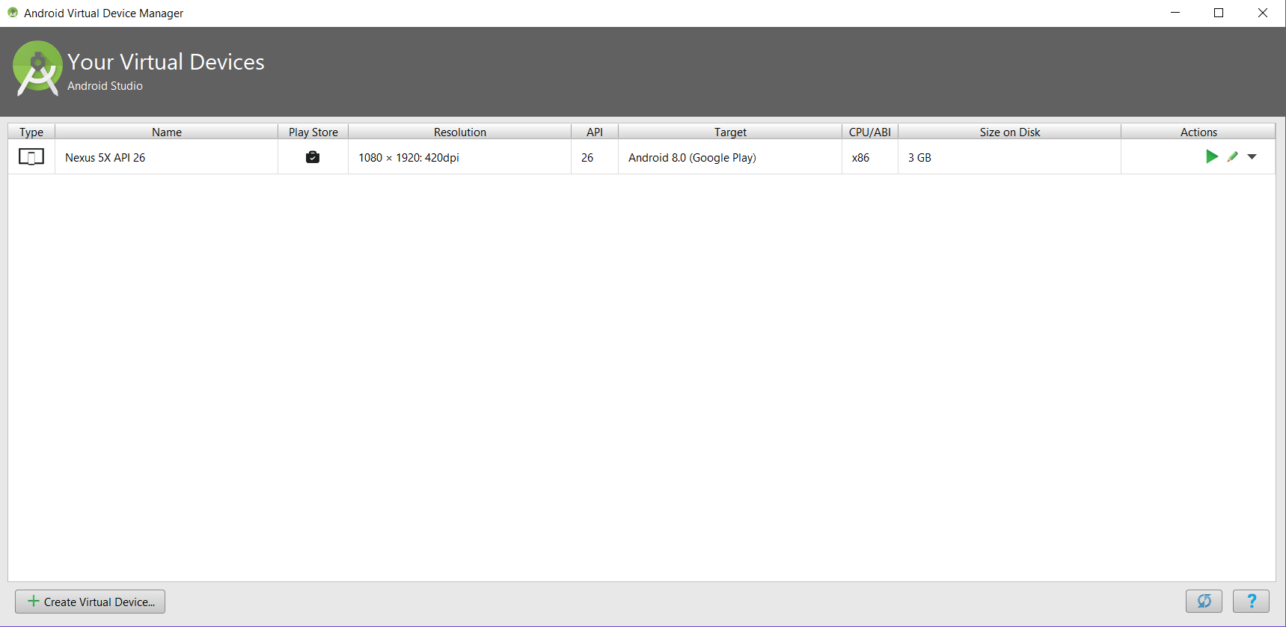

Go to this link <https://github.com/FIU-SCIS-Senior-Projects/Life-Management-Mobile-App-2.0>

And download the project from ‘Lazaro-Fernandez’ or ‘Natalia-Filippova’ branch.

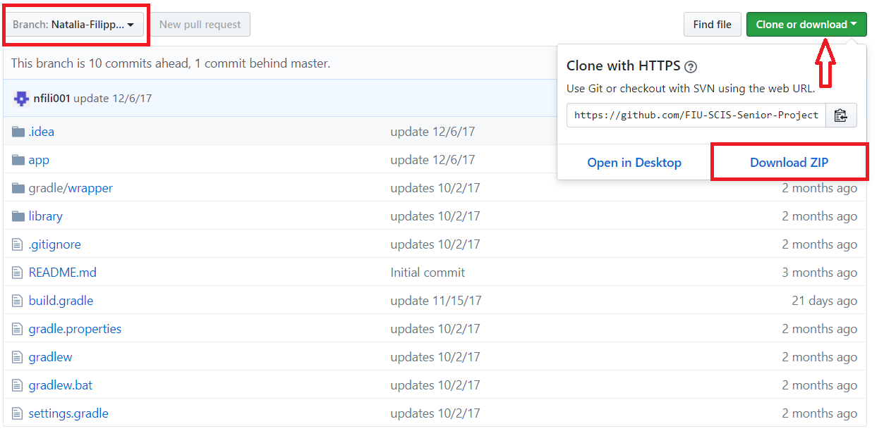

Find the location where you have downloaded and unzipped Life Management Mobile App 2.0 project and copy the whole folder for the project. Go to your **AndroidStudioProjects** folder location and paste the copied project’s folder there:

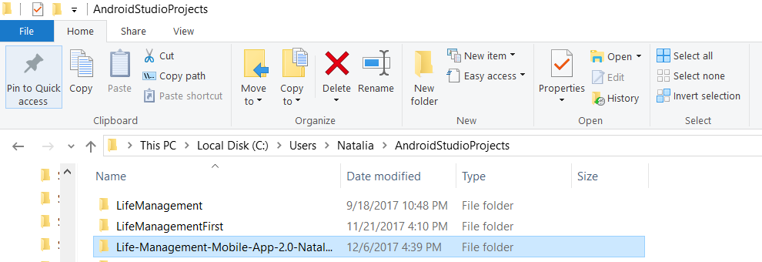

This should be the content of the Life-Management-Mobile-App-2.0 folder:

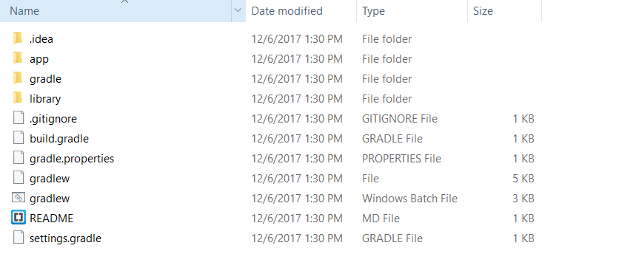

Launch Android Studio and close any open Android Studio projects. From the Welcome screen click **Open an existing Android Studio project**, find the project’s folder, select it and click OK button.

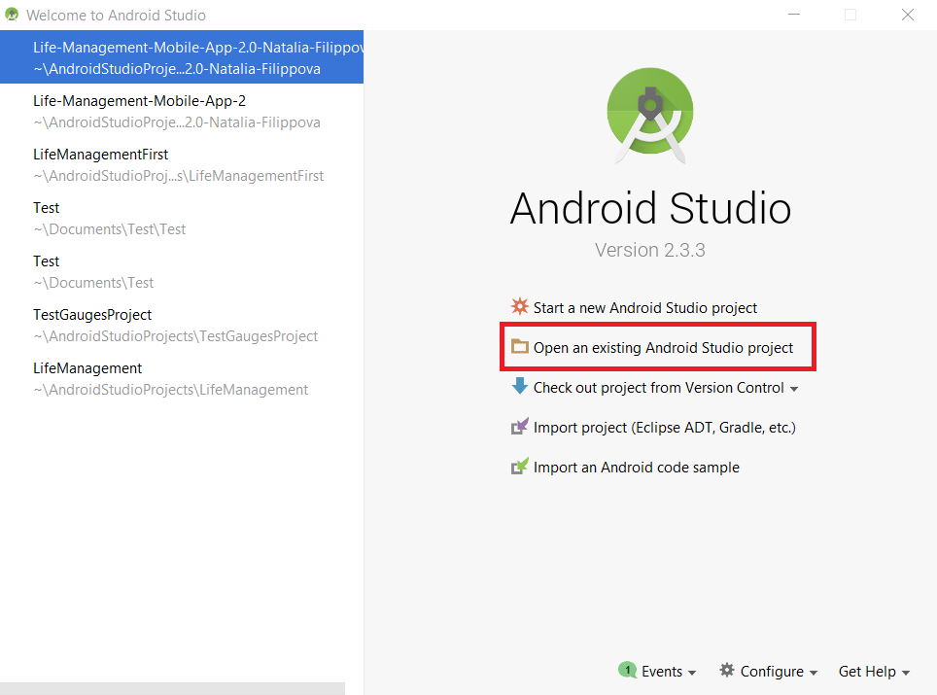

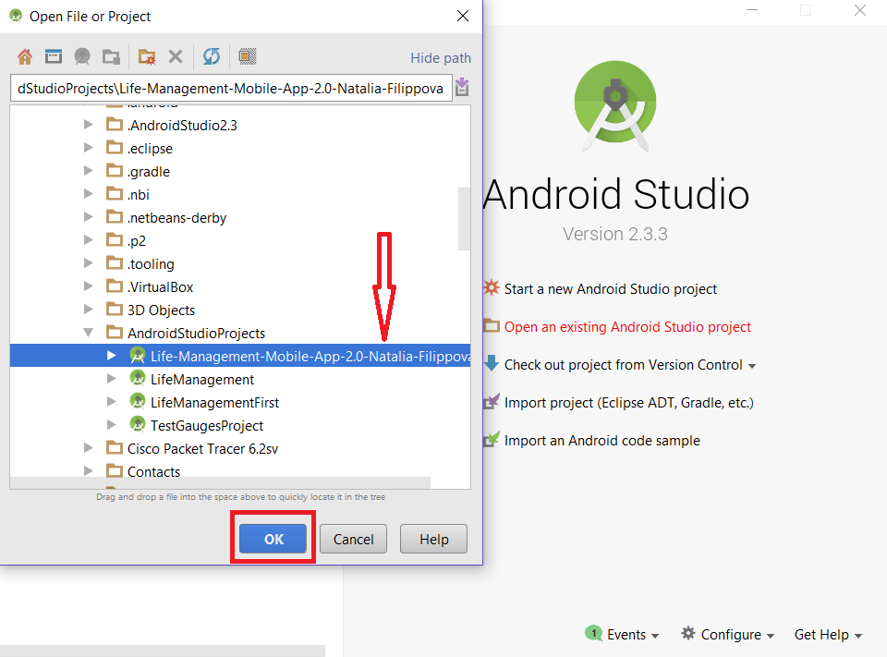

Once the project is opened in the Android Studio, you can click on the **Project** tab to see the project’s structure.

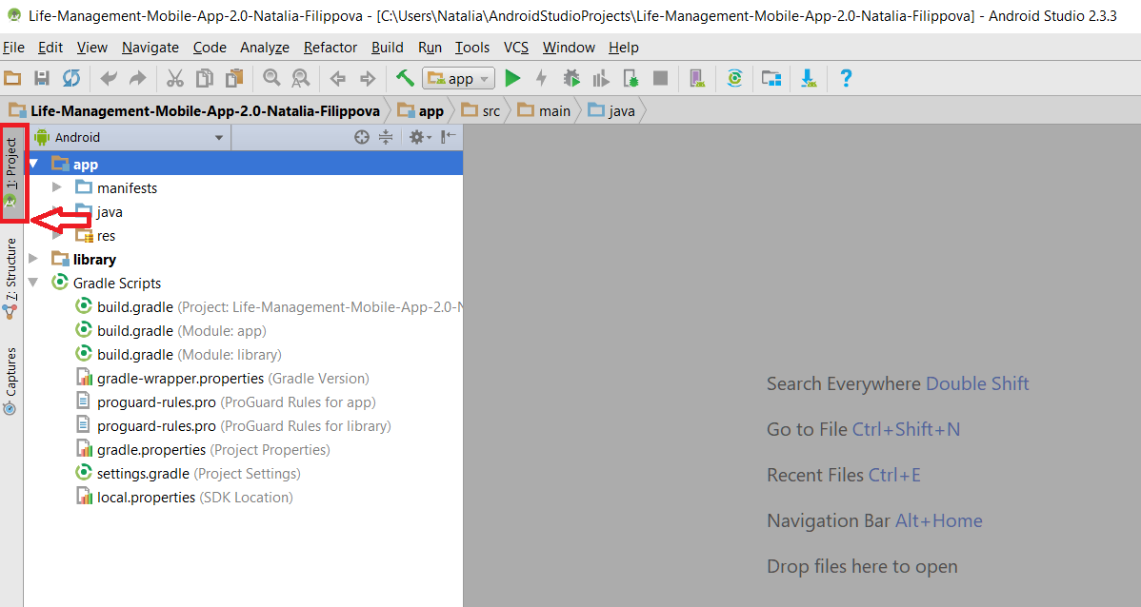

Before continuing, check if the installed versions of your SDK platforms and tools match these by opening the SDK Manager (click the **Android SDK Manager** button in Android Studio welcome screen or **Tools > Android > SDK Manager**). Install the tools that are missing (those that are checked have to be installed).



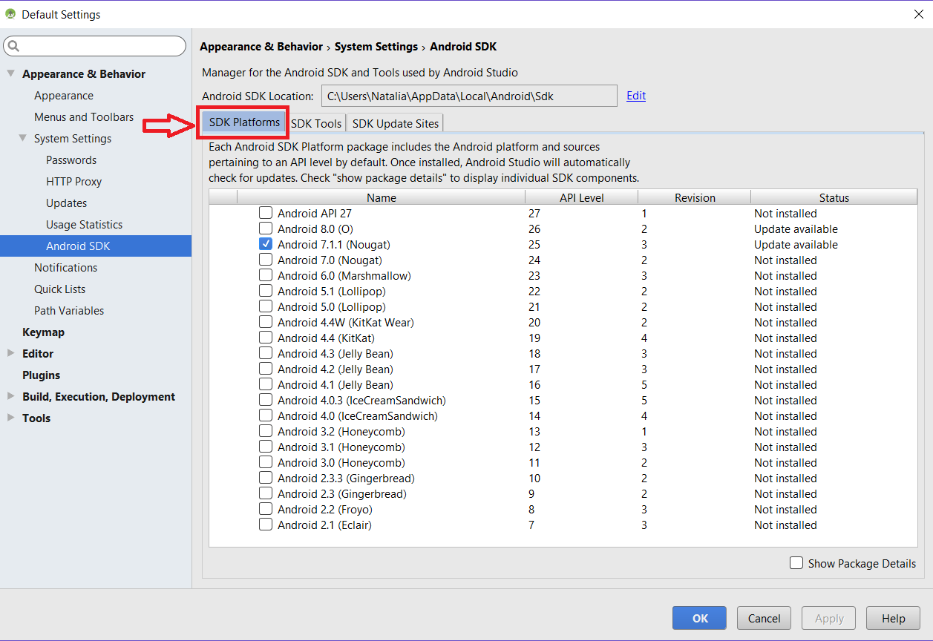

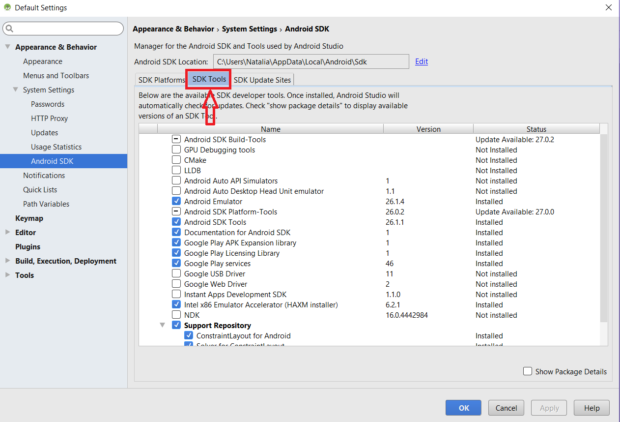

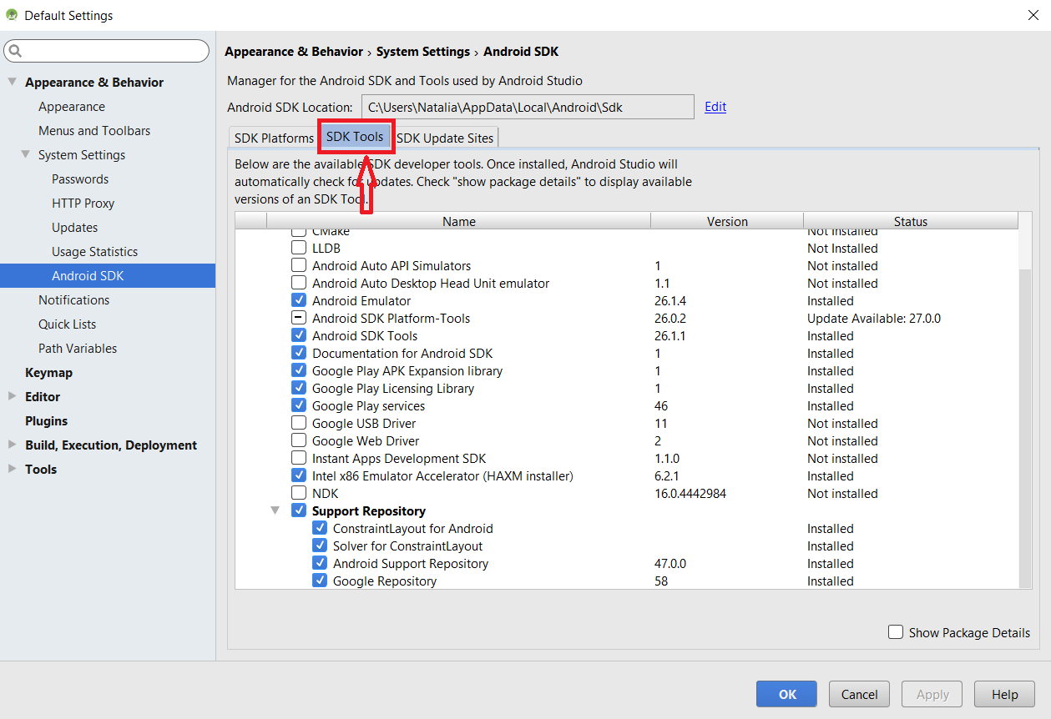

We are using cloud-hosted Firebase database which is located at this link

<https://console.firebase.google.com/project/life-management-f0cdf/database/life-management-f0cdf/data> . If you are not logged-in, please do so using your FIU email account.

Make sure that the project is connected to Firebase database. You can do so by using Firebase Assistant in Android Studio. Click **Tools > Firebase** to open the **Assistant** window.



Click to expand one of the listed features (for example, Analytics), then click the provided tutorial link (for example, Log an Analytics event).

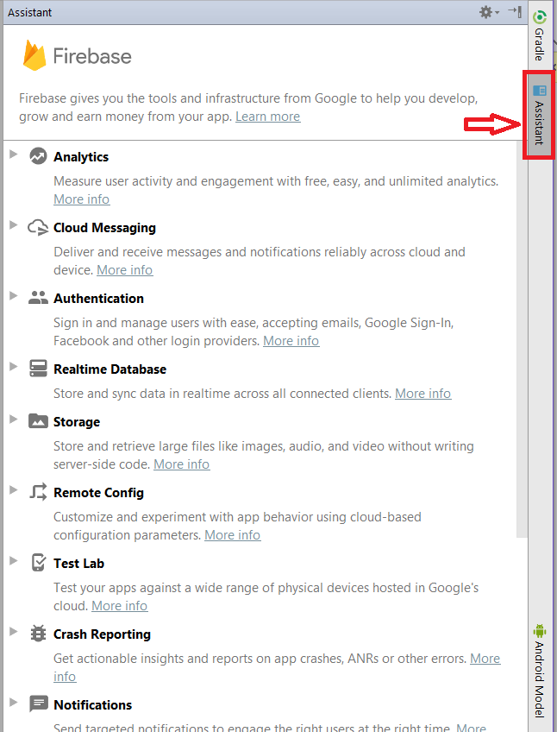

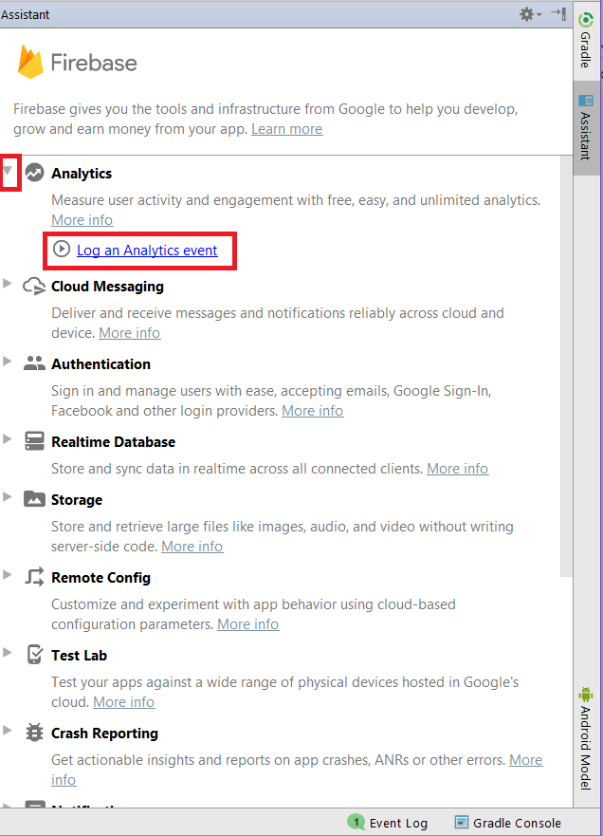

Click **Connect to Firebase** button to connect to Firebase.

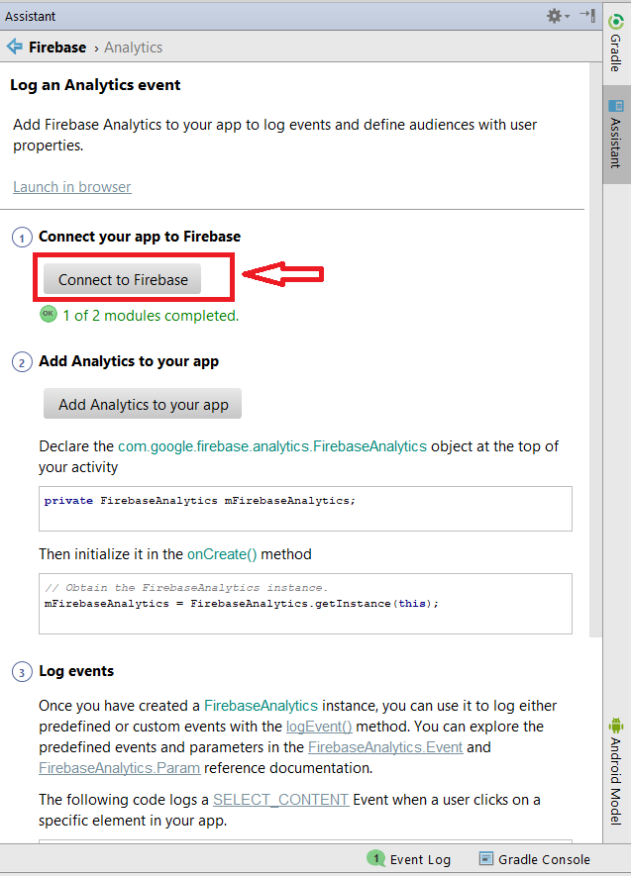

Make sure everything works properly by building and running the project. To build it use the **Build** menu option and click **Make Project**. If the project is not building properly you should resolve the issues before continuing.

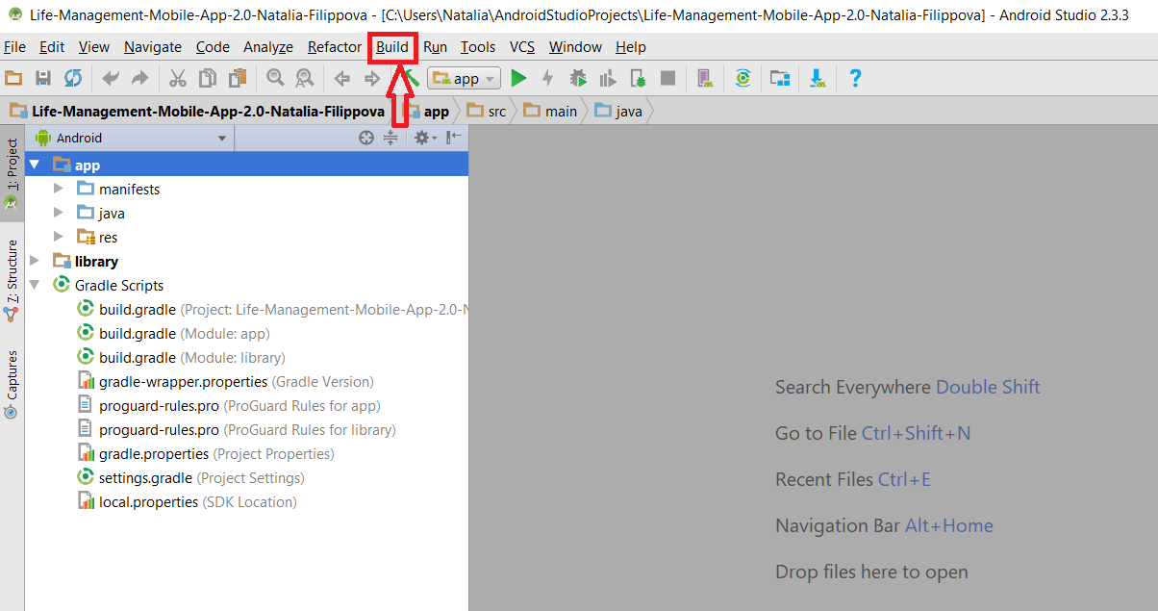

To run the project use the **Run** menu option and click **Run ‘app’**.

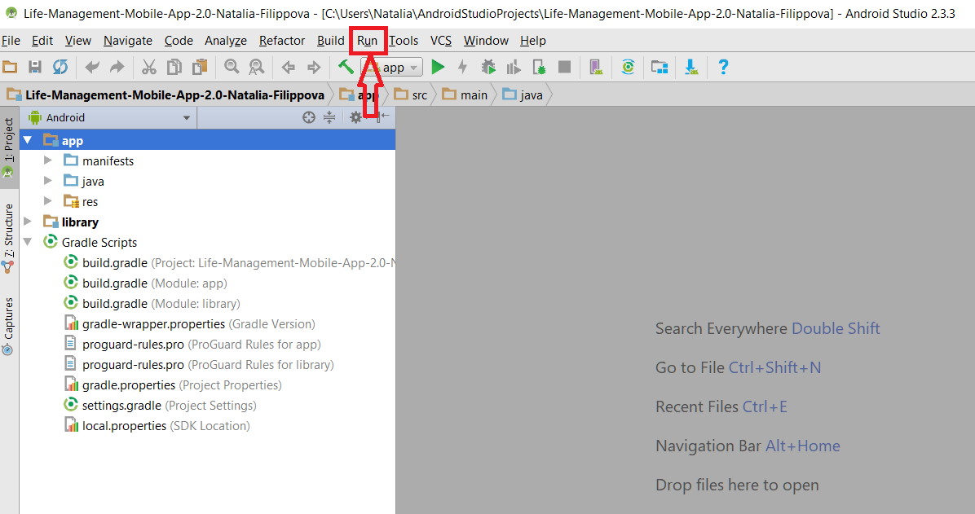

In the window select Nexus 5X API 26 virtual device (it has to be preinstalled) and click OK.

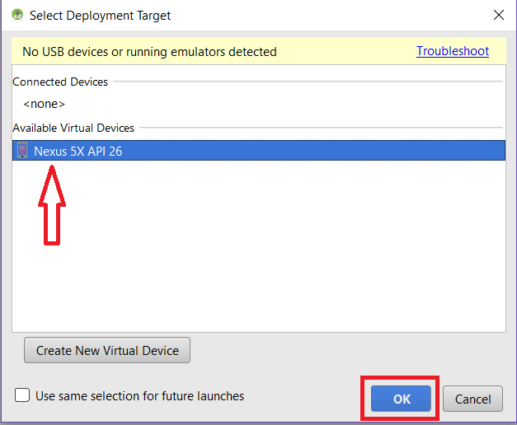

**IOS:**

We recommend to use git source control in the following manner

1. First go to <https://desktop.github.com/> and download Github Desktop which was used by all team members

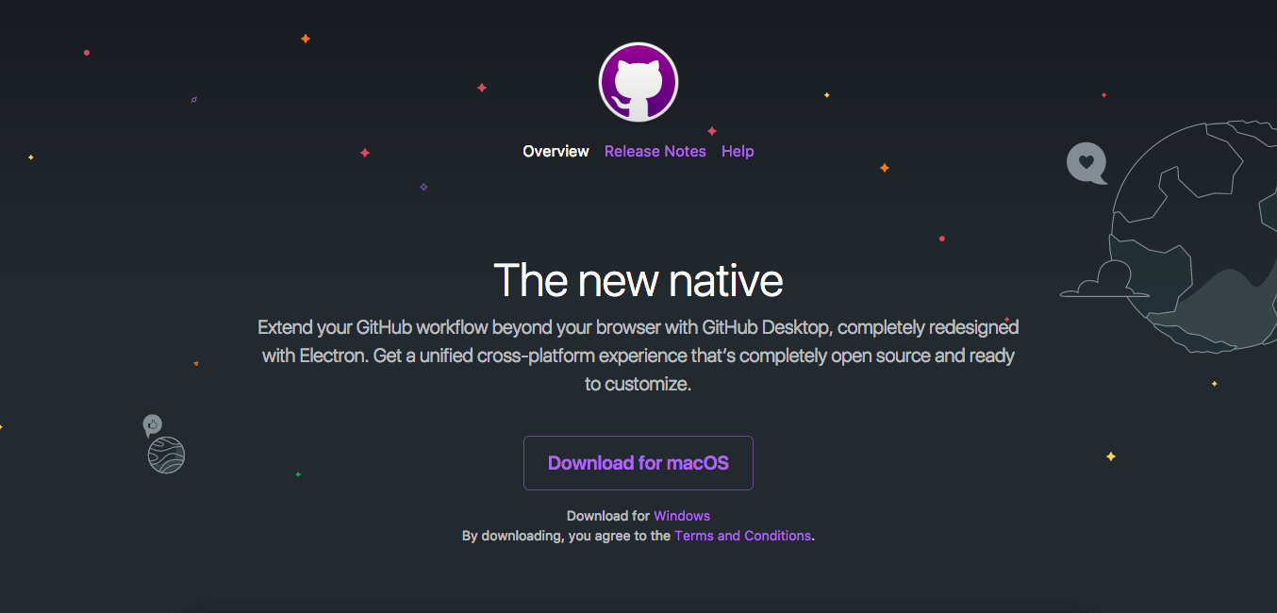

2. Once the download is complete open the application to check if installation was successful.

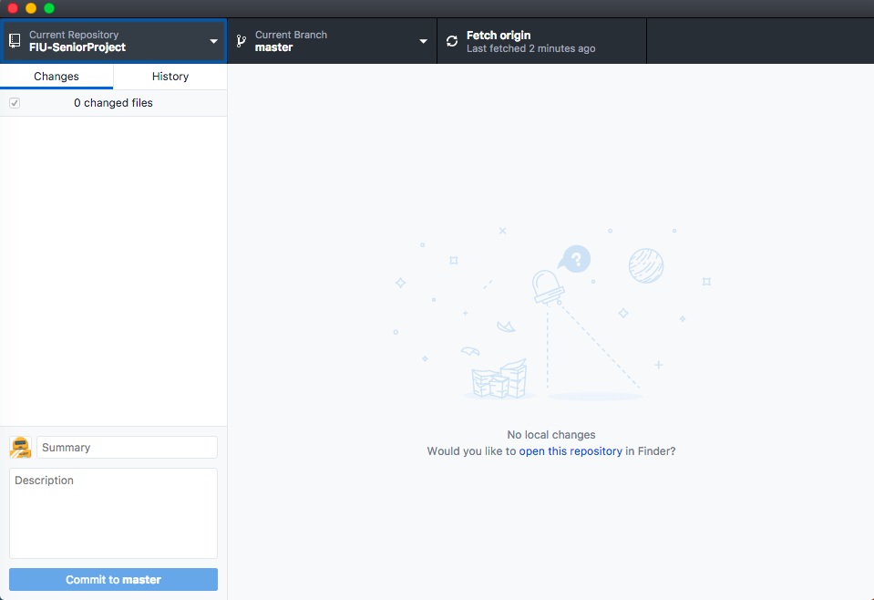

3. Now go to the FIU SCIS Senior Project Github repository and look for Life Management

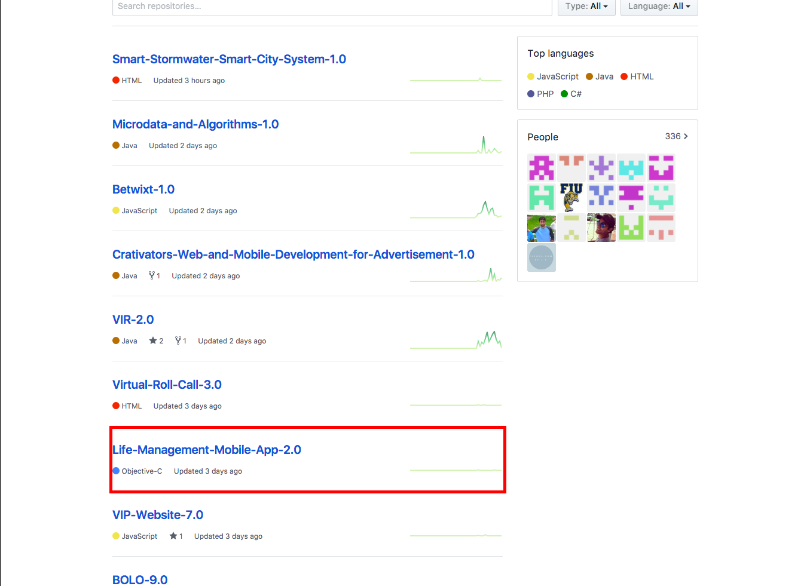

4. Once you're in the repository of Life Management click on Clone or Download and then click on open in Desktop

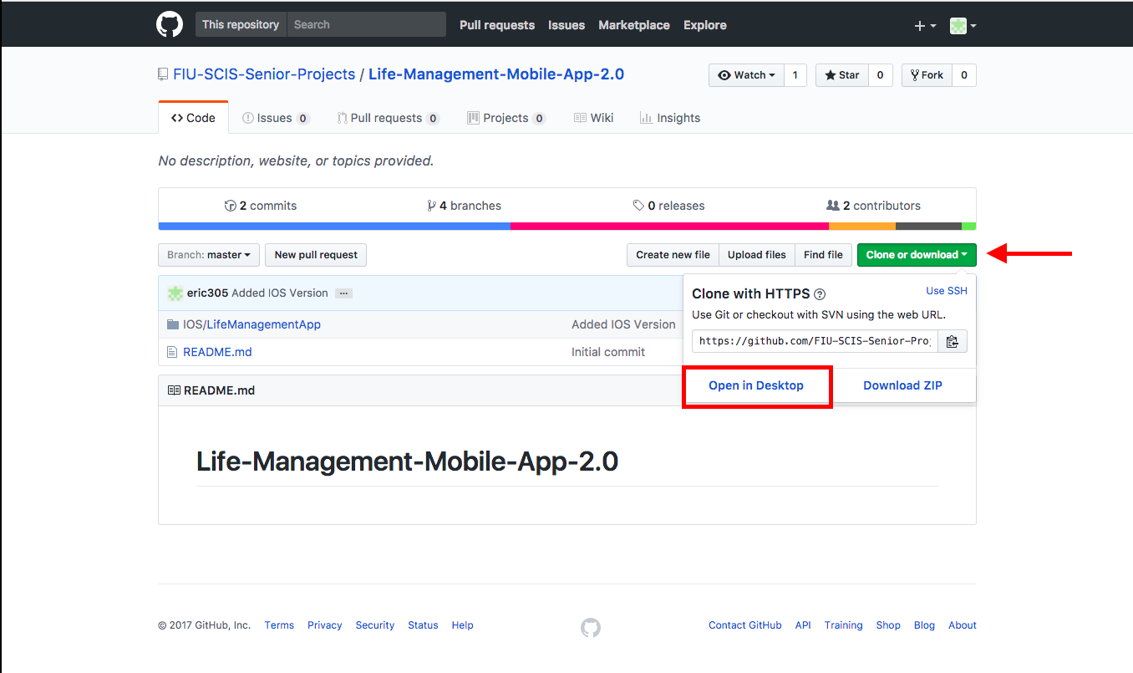

5. The following screen should be displayed. Click on choose to specify the location Github will clone the project too. Then click Clone.

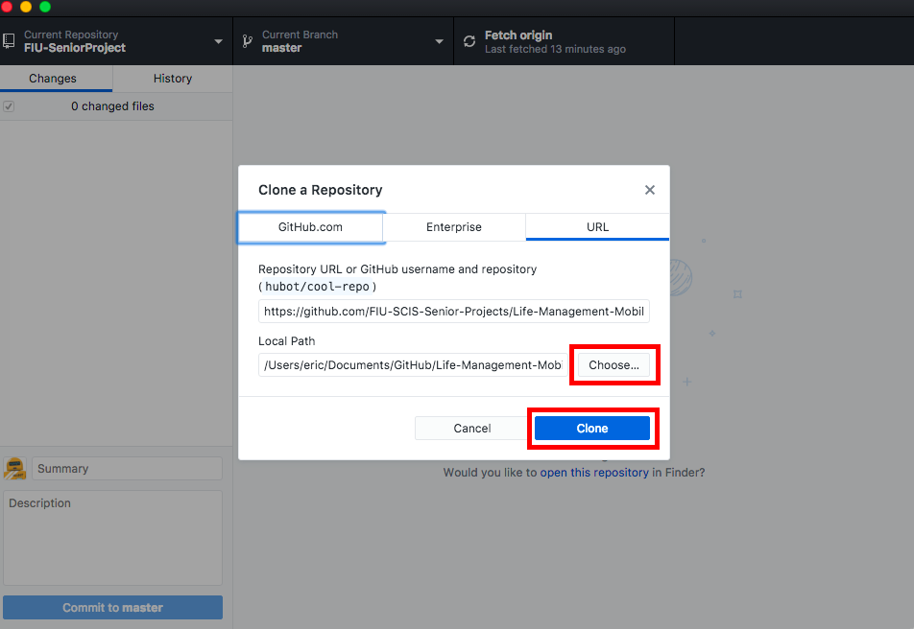

6. Click on new branch when you are in master branch and give your new branch a name

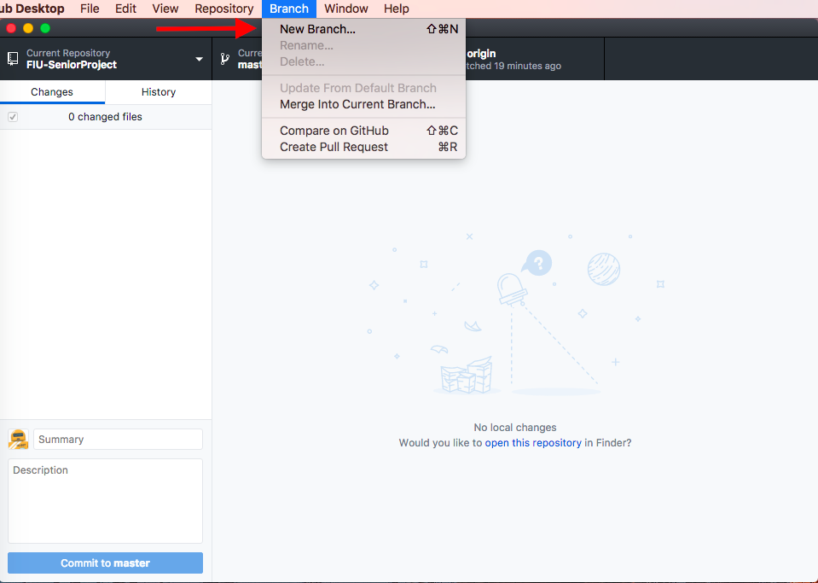

7. Once your done working on your branch go to master branch, then under the branch tab click on “Merge into Current Branch” then select the branch you want to merge to master

8. If you want to delete a branch go to the tab labeled “Branch” then click on Delete.

**7.3.3. Shortcomings/Wishlist Document**

Currently our app does not include the implementation of a Life Coach screens. In addition there is no ways to administer when a life coach is qualified to manage current users registered on our app. This is a crucial implementation for Life Management project. Since a coach cannot login because screens were not made, the current chat implemented only goes one way. A user can send a message but there is no reply because a coach cannot see any messages although they are stored in Firebase.

The user has some limitations which needs to be addressed such as the ability to recover or change his/her password if it is ever forgotten. More options should be available to the user such as change his/her first name, last name, date of birth, etc. When a user is uploading a picture, a progress bar should be displayed to indicate when the picture is done uploading to the database. A user cannot share his/her progress with a coach which needs to be addressed in the upcoming version.

We feel like the activity selection needs a UI overhaul, and an addition of more activities and maybe even different emotions that are not currently implemented.

For version 3.0, the implementation of Coach functionality such as a new home screen once they login, and interacting with users currently registered to Life Management should be the top priority. The user should also be able to login with an email and not just a password. Also there should be an authentication process added to make the app more secure from unwanted hackers.

**8. References**

* Agile Tutorial, <https://moodle.cis.fiu.edu/v3.1/pluginfile.php/107240/mod_resource/content/2/Agile_Tutorial.pdf>
* Object-­Oriented Software Engineering (3rd Edition) by Bernd Bruegge and Allen Dutoit, Prentice Hall, 2010.
* Online diagram software, <https://www.draw.io>
* Tips and guidelines provided in Moodle.